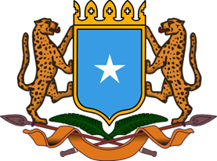

**NATIONAL MATERNAL, INFANT, YOUNG CHILD AND ADOLESCENT NUTRITION OPERATIONAL AND PROGRAMMATIC GUIDELINE TOOLKIT**

**Ministry of Health and Human Services,**

**Federal Republic of Somalia**

**March, 2023**

**Table of Contents**

Table of Contents 2

Overview 3

Chapter 1: Introduction 3

Chapter 2: Maternal Nutrition 6

Chapter 3: Adolescent Nutrition 7

Chapter 4: Infant and Young Child Feeding 7

Chapter 5: Growth Monitoring and Promotion 9

Chapter 6: Infant Young Child Feeding in Emergencies (IYCF-E) 10

Chapter 7: The Code of marketing of Breastmilk Substitutes (BMS) 10

Chapter 8: Counselling 11

Chapter 11: Monitoring Reporting and Evaluation 11

MIYCAN Policies, Documentation, Reporting and Supportive Supervision Tools 12

WHO Growth Monitoring tools for boys and girls 42

Annexes 48

Annex 1: Food Groups for Women as per FAO dietary diversity guidance 48

Annex 2: Ten Steps to Successful Breastfeeding 49

Annex 3: Breastfeeding Observation Job Aid 50

Annex 4: WHO Classification of Food Groups for Children 51

Annex 5: BMS Prescription Referral Form 52

Annex 6. Example of a simple rapid assessment 55

Annex 7: Care Action Plan for Mother/Caregiver and Baby Receiving Skilled Support and BMS 55

Annex 8: BMS Resource Kit 58

Annex 9: BMS Prescription Card 59

Annex 10: Generic BMS Label and Educational Tools 61

Annex 11: Powdered infant formula preparation instructions 64

**Overview**

The toolkit is a compilation of MIYCAN tools and their purpose as well as additional resources for more information as references per chapter for further reading. The target audience is the Ministry of Health and Social Services, MIYCAN TWGs, partners and other nutrition cluster partners.

**Chapter 1: Introduction**

1. UNICEF. *Maternal Nutrition Prevention of Malnutrition in Women before and during Pregnancy and While Breastfeeding*.; 2021. https://www.unicef.org/media/114561/file/Maternal%20Nutrition%20Programming%20Guidance.pdf
2. UNICEF. *UNICEF Technical Brief. Counselling to Improve Maternal Nutrition. Considerations for Programming with Quality, Equity and Scale*. New York; 2021. https://www.unicef.org/media/114566/file/Maternal%20Nutrition%20Counselling%20Brief.pdf
3. Victoria CG, Christian P, Vidaletti LP, Gatica-Domínguez G, Menon P, Black RE. Revisiting maternal and child undernutrition in low-income and middle-income countries: variable progress towards an unfinished agenda. *The Lancet*. 2021;397(10282):1388-1399. doi:10.1016/S0140-6736(21)00394-9
4. Le Torheim, El Ferguson, K Penrose, M Arimond. Women in resource-poor settings are at risk of inadequate intakes of multiple micronutrients. *J Nutr*. 2010;140(11). doi:10.3945/jn.110.123463
5. Gernand, Schulze KJ, Stewart CP, West KP, Christian P. Micronutrient deficiencies in pregnancy worldwide: health effects and prevention - PMC. Accessed December 16, 2022. https://www.ncbi.nlm.nih.gov/pmc/articles/PMC4927329/
6. WHO. Good Maternal Nutrition The best start in life. Published online 2016. https://apps.who.int/iris/bitstream/handle/10665/329459/9789289051545-eng.pdf?sequence=1&isAllowed=y
7. WHO. *Weekly Iron and Folic Acid Supplementation as an Anemia- Prevention Strategy in Women and Adolescent Girls.*; 2018. file:///C:/Users/MKIWA/Downloads/WHO-NMH-NHD-18.8-eng.pdf
8. WHO. WHO recommendation on multiple micronutrient supplementation during pregnancy. WHO - RHL. Accessed December 16, 2022. https://srhr.org/rhl/article/who-recommendation-on-multiple-micronutrient-supplementation-during-pregnancy
9. Global Health Observatory- Prevalence of anaemia in non-pregnant women - Estimates by WHO region. WHO. Accessed December 16, 2022. https://apps.who.int/gho/data/view.main.ANAEMIAWOMENNPWREG
10. Global Nutrition Report | Country Nutrition Profiles - Global Nutrition Report. Accessed December 16, 2022. https://globalnutritionreport.org/resources/nutrition-profiles/africa/
11. WHO. *Preconception Care: Maximizing the Gains for Maternal and Child Health- Policy Brief*.; 2013. https://www.who.int/publications/i/item/WHO-FWC-MCA-13.02
12. UNICEF. Early childbearing and teenage pregnancy rates by country - UNICEF DATA. Accessed December 16, 2022. https://data.unicef.org/topic/child-health/adolescent-health/
13. WHO. Adolescent pregnancy. Accessed December 16, 2022. https://www.who.int/news-room/fact-sheets/detail/adolescent-pregnancy
14. UNICEF. A Rapid Evidence Assessment on Exposure to Gender- Based Violence and Children’s Nutrition. Published 2022. Accessed February 21, 2023. https://www.unicef.org/documents/rapid-evidence-assessment-exposure-gender-based-violence-and-childrens-nutrition
15. World Bank. Gender-Based Violence (Violence Against Women and Girls). Accessed December 16, 2022. https://www.worldbank.org/en/topic/socialsustainability/brief/violence-against-women-and-girls
16. FAO. *Minimum Dietary Diversity for Women*. FAO; 2021. doi:10.4060/cb3434en
17. WHO. Global nutrition targets 2025: policy brief series. Published 2014. https://www.who.int/publications/i/item/WHO-NMH-NHD-14.2
18. WHO, UNICEF. *Global Breastfeeding Scorecard 2022: Protecting Breadsfeeding through Further Investments and Policy Actions*. World Health Organization; 2022. Accessed December 16, 2022. https://apps.who.int/iris/handle/10665/365140
19. Zong X, Wu H, Zhao M, Magnussen CG, Xi B. Global prevalence of WHO infant feeding practices in 57 LMICs in 2010–2018 and time trends since 2000 for 44 LMICs. *eClinicalMedicine*. 2021;37. doi:10.1016/j.eclinm.2021.100971
20. Ministry of Health and Human Services, Federal Republic of Somalia. *Somalia Nutrition Strategy 2020-2025*. https://www.unicef.org/somalia/media/1756/file/Somalia-nutrition-strategy-2020-2025.pdf
21. Federal Republic of Somalia. *Somalia Multisectoral Nutrition Strategy 2019-2024*.; 2019.
22. Directorate of National Statistics, Federal Government of. *The Somali Health and Demographic Survey 2020*. https://somalia.unfpa.org/sites/default/files/pub-pdf/FINAL%20SHDS%20Report%202020_V7_0.pdf
23. Federal Republic of Somalia. *Somali National Micronutrient Deficiency Control Strategy 2014-2016*. https://extranet.who.int/nutrition/gina/sites/default/filesstore/SOM_MN%20Strategy%20-%202014-2016.pdf
24. Somali Federal Ministry of Health. *Reproductive, Maternal, Neonatal, Child and Adolescent Health Strategy 2020-2024*.
25. UNFPA. *Overview of Gender-Based Violence in Somalia; Advocacy Brief, 2020*.; 2021. https://somalia.unfpa.org/sites/default/files/resource.pdf/somalia_gbv_advocacy_brief_05march21.pdf
26. UNICEF. *Evidence on the Linkages between Gender Based Violence and Nutrition: Summary of Findings Specific to Adolescent Girls.*
27. UNICEF. *Intimate Partner Violence and Child Growth: A Summary of the Evidence Base*.
28. IASC. *IASC Guidelines for Integrating Gender-Based Violence Interventions in Humanitarian Action*.; 2015. https://interagencystandingcommittee.org/working-group/iasc-guidelines-integrating-gender-based-violence-interventions-humanitarian-action-2015
29. UNICEF. *Intimate Partner Violence and Breastfeeding: A Summary of the Evidence Base*.; 2022.
30. *Global Nutrition Report*.; 2022. https://globalnutritionreport.org/documents/896/Executive_summary_2022_Global_Nutrition_Report.pdf

**Chapter 2: Maternal Nutrition**

1. WHO. *Preconception Care: Maximizing the Gains for Maternal and Child Health- Policy Brief*.; 2013. https://www.who.int/publications/i/item/WHO-FWC-MCA-13.02
2. UNICEF. *UNICEF Technical Brief. Counselling to Improve Maternal Nutrition. Considerations for Programming with Quality, Equity and Scale*. New York; 2021. https://www.unicef.org/media/114566/file/Maternal%20Nutrition%20Counselling%20Brief.pdf
3. UNICEF. *Maternal Nutrition Prevention of Malnutrition in Women before and during Pregnancy and While Breastfeeding*.; 2021. https://www.unicef.org/media/114561/file/Maternal%20Nutrition%20Programming%20Guidance.pdf
4. WHO. Good Maternal Nutrition The best start in life. Published online 2016. https://apps.who.int/iris/bitstream/handle/10665/329459/9789289051545-eng.pdf?sequence=1&isAllowed=y
5. Somali Federal Ministry of Health. *Reproductive, Maternal, Neonatal, Child and Adolescent Health Strategy 2020-2024*.
6. Ministry of Health and Human Services, Federal Republic of Somalia. *Somalia Nutrition Strategy 2020-2025*. https://www.unicef.org/somalia/media/1756/file/Somalia-nutrition-strategy-2020-2025.pdf
7. Federal Republic of Somalia. *Somali National Micronutrient Deficiency Control Strategy 2014-2016*. https://extranet.who.int/nutrition/gina/sites/default/filesstore/SOM_MN%20Strategy%20-%202014-2016.pdf
8. WHO. *Weekly Iron and Folic Acid Supplementation as an Anemia- Prevention Strategy in Women and Adolescent Girls.*; 2018. file:///C:/Users/MKIWA/Downloads/WHO-NMH-NHD-18.8-eng.pdf
9. Somali Health Authorities; World Health Organisation. *Somali National Treatment Guidelines in Line with the Essential Package of Health Services*.; 2015.
10. WHO. *WHO Guidelines for Malaria*.; World Health Organization. 2021. https://www.who.int/publications/i/item/guidelines-for-malaria

**Chapter 3: Adolescent Nutrition**

1. World Health Organization. Guideline: Implementing Effective Actions for Improving Adolescent Nutrition. World Health Organization; 2018. Accessed February 26, 2023. *https://apps.who.int/iris/handle/10665/260297*
2. UNICEF. Programming Guidance: Nutrition in Middle Childhood and Adolescence. UNICEF; 2021. https://www.unicef.org/media/106406/file
3. Ministry of Health and Human Services, Federal Republic of Somalia. *Somalia Nutrition Strategy 2020-2025*. https://www.unicef.org/somalia/media/1756/file/Somalia-nutrition-strategy-2020-2025.pdf
4. Somali Federal Ministry of Health. *Reproductive, Maternal, Neonatal, Child and Adolescent Health Strategy 2020-2024*.
5. WHO. *Weekly Iron and Folic Acid Supplementation as an Anemia- Prevention Strategy in Women and Adolescent Girls.*; 2018. file:///C:/Users/MKIWA/Downloads/WHO-NMH-NHD-18.8-eng.pdf

**Chapter 4: Infant and Young Child Feeding**

1. WHO; UNICEF. *Global Strategy for Infant and Young Child Feeding*.; 2003.https://www.who.int/publications/i/item/9241562218
2. WHO; UNICEF. *Protecting, Promoting and Supporting Breastfeeding in Facilities Providing Maternity and Newborn Services: The Revised BABY-FRIENDLY HOSPITAL INITIATIVE*.; 2018.
3. Somali Health Authorities; World Health Organization. *Somali National Treatment Guidelines in Line with the Essential Package of Health Services*.; 2015.
4. UNICEF. *Infant and Young Child Feeding Programming Guide*.; 2011.https://www.ennonline.net/attachments/1470/unicef-iycf-programming-guide-may-26-2011.pdf
5. UNICEF. *Breastfeeding Support in the Workplace: A GLOBAL GUIDE FOR EMPLOYERS*.; 2020. https://www.unicef.org/media/73206/file/Breastfeeding-room-guide.pdf
6. WHO. *Infant and Young Child Feeding: Model Chapter for Textbooks for Medical Students and Allied Health Professionals: The Physiological Basis of Breastfeeding*. World Health Organization; 2009. Accessed December 16, 2022. https://www.ncbi.nlm.nih.gov/books/NBK148970/
7. Banginwar A, Toweir A, Goyal R, Ziyo F. Breastfeeding practices: Positioning, attachment (latch-on) and effective suckling - A hospital-based study in Libya. *J Fam Community Med*. 2011;18(2):74. doi:10.4103/2230-8229.83372
8. UNICEF. *The Community Infant and Young Child Feeding Counselling Package*.; 2012.
9. UNICEF. *Procurement and Use of Breastmilk Substitutes in Humanitarian Settings*.; 2021. https://www.unicef.org/media/100911/file/BMS-Procurement-Guidance-Final-June-2021.pdf
10. Federal Government of Somalia. *Draft Bill for the Protection of Infant and Young Child Feeding.*
11. *Management of Breast Conditions and Other Breastfeeding Difficulties*. World Health Organization; 2009. Accessed December 16, 2022. https://www.ncbi.nlm.nih.gov/books/NBK148955/
12. IFE Core Group. *Complementary Feeding of Infants and Young Children in Emergencies*.; 2009. https://www.ennonline.net/attachments/965/cfe-review-enn-ife-core-group-oct-2009.pdf
13. WHO. *Infant and Young Child Feeding Factsheet*. https://www.who.int/news-room/fact-sheets/detail/infant-and-young-child-feeding
14. UNICEF. *UNICEF Nutrition Strategy 2020–2030*.; 2020. https://www.unicef.org/media/92031/file/UNICEF%20Nutrition%20Strategy%202020-2030.pdf
15. *Guiding Principles for Feeding Non-Breastfed Children 6-24 Months of Age (2005)*. World Health Organization; 2009. Accessed December 16, 2022. https://www.ncbi.nlm.nih.gov/books/NBK143674/
16. WHO. Micronutrients. Accessed December 16, 2022. https://www.who.int/health-topics/micronutrients
17. Federal Republic of Somalia. *Somali National Micronutrient Deficiency Control Strategy 2014-2016*. https://extranet.who.int/nutrition/gina/sites/default/filesstore/SOM_MN%20Strategy%20-%202014-2016.pdf
18. WHO. *WHO Guideline: Use of Multiple Micronutrient Powders for Point of Use Fortification of Foods Consumed by Infants and Young Children Aged 6–23 Months and Children Aged 2–12 YEARS*.; 2016.
19. UNICEF. *Somalia: Programmatic Guidance Note on Home Fortification with Micronutrient Powders for Children 6 up to 23 Months*.; 2017.
20. World Health Organization. Guideline: vitamin A supplementation in infants and children 6-59 months of age. Published online 2011. Accessed December 16, 2022. https://apps.who.int/iris/handle/10665/44664
21. WHO. Guideline: Preventive Chemotherapy to Control Soil- Transmitted Helminth Infections in At Risk Population Groups.; 2017
22. WHO; UNICEF. *Guideline Updates on HIV and Infant Feeding*.; 2016.https://www.who.int/publications/i/item/9789241549707
23. The Federal Government of Somalia, the Federal Member States and Somaliland. *Chronic HIV Care: With Antiretroviral Therapy and Prevention*.; 2020.
24. WHO. Preterm birth. Published 2022. Accessed January 21, 2023. https://www.who.int/news-room/fact-sheets/detail/preterm-birth
25. WHO. Low birth weight. Accessed January 21, 2023. https://www.who.int/data/nutrition/nlis/info/low-birth-weight
26. WHO. *WHO Recommendations for Care of the Preterm or Low-Birth-Weight Infant*.; 2022. https://reliefweb.int/report/world/who-recommendations-care-preterm-or-low-birth-weight-infant#:~:text=Throughout%20the%20guidelines%2C%20breastfeeding%20is,risks%20compared%20to%20infant%20formula.
27. WHO. *Kangaroo Mother Care A Practical Guide*.; 2003. https://www.who.int/publications/i/item/9241590351
28. UNICEF. *The Community Infant and Young Child Feeding Counselling Package- Key Messages Booklet*.; 2012.
29. UNHCR, WFP, WHO, UNICEF. Infant and young child feeding in the context of the COVID-19 pandemic Eastern, Central and Southern Africa. Accessed December 16, 2022. https://pmnch.who.int/resources/publications/m/item/infant-and-young-child-feeding-in-the-context-of-the-covid-19-pandemic-eastern-central-and-southern-africa
30. WHO. Cholera. Accessed January 22, 2023. https://www.who.int/health-topics/cholera
31. WHO. Cholera – Somalia. Published 2022. Accessed January 22, 2023. https://www.who.int/emergencies/disease-outbreak-news/item/2022-DON398_1
32. UNICEF. *How to Feed a Baby after 6 Months*. https://www.unicef.org/media/108431/file/Brochure%20Feeding%20After%206%20Months.pdf
33. UNICEF. Key practice: Infant feeding during sickness. Accessed February 2, 2023. https://www.unicef.org/uganda/key-practice-infant-feeding-during-sickness
34. World Health Organization. *Nurturing Care for Early Childhood Development: A Framework for Helping Children Survive and Thrive to Transform Health and Human Potential*. World Health Organization; 2018. Accessed February 5, 2023. https://apps.who.int/iris/handle/10665/272603

**Chapter 5: Growth Monitoring and Promotion**

1. World Health Organization. WHO child growth standards: training course on child growth assessment. Cours Form Sur Lévaluation Croissance Enfant Normes OMS Croissance Enfant. Published online 2008:10.
2. Somali Federal Republic, Ministry of Health and Human Service. Somali Guidelines for Integrated Management of Acute Malnutrition.
3. Ministry of Health and Human Services, Federal Republic of Somalia. Somalia Nutrition Strategy 2020-2025. https://www.unicef.org/somalia/media/1756/file/Somalia-nutrition-strategy-2020-2025.pdf
4. UNICEF. RAPID REVIEW: Screening of Acute Malnutrition by the Family at Community Level. <https://www.unicef.org/documents/rapid-review-screening-acute-malnutrition-family-community-level>

**Chapter 6: Infant Young Child Feeding in Emergencies (IYCF-E)**

1. Technical Rapid Response Teams. *INFANT & YOUNG CHILD FEEDING IN EMERGENCIES (IYCF-E)- STANDARD OPERATING PROCEDURE (SOP) FOR EMERGENCY RESPONSE TEAMS*.; 2020.
2. UNICEF. *Procurement and Use of Breastmilk Substitutes in Humanitarian Settings*.; 2021. https://www.unicef.org/media/100911/file/BMS-Procurement-Guidance-Final-June-2021.pdf
3. CDC. Supporting Families with Relactation. Centers for Disease Control and Prevention. Published June 8, 2022. Accessed January 29, 2023. https://www.cdc.gov/breastfeeding/breastfeeding-special-circumstances/supporting-families-with-relactation.html
4. WHO. *Relactation- A Review of Experiences and Recommendations for Practice*.; 1998. https://www.who.int/publications/i/item/WHO-CHS-CAH-98.14
5. *Reproductive, Maternal, Neonatal, Child and Adolescent Health Strategy 2020-2024*.
6. UNICEF. *The Community Infant and Young Child Feeding (IYCF) Counselling Package- Facilitators Guide*.; 2013. https://www.unicef.org/media/108391/file/Facilitator%20Guide.pdf

**Chapter 7: The Code of marketing of Breastmilk Substitutes (BMS)**

1. *Marketing of Breast Milk Substitutes: National Implementation of the International Code, Status Report 2020*.; 2020. https://www.who.int/publications/i/item/9789240006010
2. *Evidence and Guidance Note on the Use of Cash and Voucher Assistance for Nutrition Outcomes in Emergencies*.; 2020. https://www.nutritioncluster.net/resources/evidence-and-guidance-note-use-cash-and-voucher-assistance-nutrition-outcomes-emergencies
3. WHO; UNICEF. *Acceptable Medical Reasons for Use of Breast-Milk Substitutes*.; 2009. https://www.who.int/publications/i/item/WHO_FCH_CAH_09.01

**Chapter 8: Counselling**

1. UNICEF. *Maternal Nutrition Prevention of Malnutrition in Women before and during Pregnancy and While Breastfeeding*.; 2021. https://www.unicef.org/media/114561/file/Maternal%20Nutrition%20Programming%20Guidance.pdf
2. World Health Organization. Guideline: counselling of women to improve breastfeeding practices. Published 2018. Accessed July 1, 2022. https://www.who.int/publications-detail-redirect/9789241550468
3. Food Security and Nutrition Network Social and Behavioral Change Task Force. *Care Groups: A Training Manual for Program Design and Implementation*.; 2014. https://www.fsnnetwork.org/sites/default/files/Care%20Group_manual_final_508.pdf
4. UNICEF. *Supportive Supervision/ Mentoring and Monitoring for Community IYCF*.; 2013. https://www.unicef.org/media/108436/file/Supervision%20Mentoring%20Monitoring%20Module.pd

**Chapter 11: Monitoring Reporting and Evaluation**

1. UNICEF. Maternal Nutrition Prevention of Malnutrition in Women before and during Pregnancy and While Breastfeeding.; 2021. https://www.unicef.org/media/114561/file/Maternal%20Nutrition%20Programming%20Guidance.pdf
2. WHO; UNICEF. Indicators for assessing infant and young child feeding practices: definitions and measurement methods. Accessed February 26, 2023. https://www.who.int/publications-detail-redirect/9789240018389

**MIYCAN Policies, Documentation, Reporting and Supportive Supervision Tools**

Protocol for micronutrient support

Vitamin A

**Key message for mothers/caregivers: Vitamin A protects immunity, reduces the risk of children dying from common childhood diseases and prevents blindness.**

**Higher doses of Vitamin A supplementation than recommended can result in toxicity**

|  |  |  |
| --- | --- | --- |
| **P R E V E N T I O N** | | |
| **A.TO PREVENT VITAMIN A DEFICIENCY**  **HIGH DOSE OF VITAMIN A SUPPLEMENTATION DURING PREGNANCY SHOULD BE AVOIDED BECAUSE IT CAN CAUSE MISCARRAIGE AND BIRTH DEFECTS.** | | |
| **Age Group** | **Dose** | **Duration** |
| **Infants 6 to 11 months** | **100,000 IU**  3 drops from red capsule or 1 blue capsule | **single dose every 4-6 months** |
| **Children 12 to 59 months** | **200,000 IU**  1 red capsule or 2 blue capsules | **single dose every 4-6 months** |
| **T R E A T M E N T** | | |
| **B. FOR TREATMENT OF CHILDREN WITH PROLONGED OR SEVERE DIARRHOEA, ARI, CHICKEN POX, SEVERE MALNUTRITION** **AND OTHER SEVERE INFECTIONS.**  **DO NOT GIVE IF: IF OEDEMA IS PRESENT OR IF CHILD RECEIVED VITAMIN A WITHIN LAST 4-6 MONTHS.** | | |
| **Infants < 6 months of age (if not breastfed)** | **50,000 IU**  1 white capsule | **single dose** |
| **Infants 6 to 11 months** | **100,000 IU**  3 drops from red capsule or 1 blue capsule | **single dose** |
| **Children 12 months or older** | **200,000 IU**  1 red capsule or 2 blue capsules | **single dose** |
| **C. FOR TREATMENT OF MEASLES.** | | |
| **Infants < 6 months** | **50,000 IU**  1 white capsule | **1 dose immediately (Day 1)**  **1 dose next day (Day 2)**  **1 dose after 2 weeks, if eye signs are present (Day 15)** |
| **Infants 6 to 11 months** | **100,000 IU**  3 drops from red capsule or 1 blue capsule | **1 dose immediately (Day 1)**  **1 dose next day (Day 2)**  **1 dose after 2 weeks, if eye signs are present (Day 15)** |
| **Children 12 months and older** | **200,000 IU**  1 red capsule or 2 blue capsules | **1 dose immediately (Day 1)**  **1 dose next day (Day 2)**  **1 dose after 2 weeks, if eye signs are present (Day 15)** |

Habraaca

TAAGEERIDA NAFAQOOYINKA YAR YAR

##### FITAMIN A

|  |  |  |
| --- | --- | --- |
| **KAHORTAGA** | | |
| **A.KAHORTAGA IN AY QOFKA KUYARAATO FITAMIN A-GA**  **QIYAASTA BADAN EE FITAMIN A-GA XILIYADA UURKA WAA IN LAGAFOGAADAA SABABTOO AH WAXAY KEENI KARTAA ILMAHA OO SOODHACA AMA NUQSAAN KUDHASHAAN** | | |
| **DA’DA** | **QIYAASTA** | **MUDADA** |
| **Dhalaanka jira**  **6 ilaa 11 bilood** | **100,000 IU**  3 dhibcood kaabsool-ka cas ama 1 xabo kaapsool-ka buluuga ah | **hal qiyaas 4-6 dii bil kasta** |
| **caruurta jirta**  **12 ilaa 59 bilood** | **200,000 IU**  1 kaapsool-ka cas ama 2 kaapsool oo buluug ah. | **hal qiyaas 4-6 dii bil kasta** |
| **DAAWEYNTA** | | |
| **B. DAAWEYNTA CARUURTA EE QABA SHUBANKA DABADHEERAADAY AMA DARAN, XANUUNKA NEEFMAREENKA, FURUQA, NAFAQO XUMI AAD U DARAN IYO CAABUQYO DARAN.**  **HASIININ: HADDII UU BARAR JIRO AMA CANUGA HADDII UU SOOQAATAY FITAMIN A 4-6 DII BILOOD EE UGU DAMBEYSAY.** | | |
| **Dhalaanka jira**  **kayar < 6 bilood (waa haddii aan naaska lanuujin)** | **50,000 IU**  1 kaabsool-ka cadaanka ah | **hal qiyaas** |
| **Dhalaanka jira**  **6 ilaa 11 bilood** | **100,000 IU**  3 dhibcood kaabsool-ka cas ama 1 xabo kaabsool-ka buluuga ah | **hal qiyaas** |
| **caruurta jirta**  **12 ilaa 59 bilood** | **200,000 IU**  1 kaabsool-ka cas ama 2 kaapsool oo buluug ah. | **hal qiyaas** |
| **C. KUDAAWEYNTA JADEECADA** | | |
| **Dhalaanka jira**  **< 6 bilood** | **50,000 IU**  1 kaabsool-ka cadaanka ah | **1 qiyaas marka hore (maalinta 1aad)**  **1 qiyaas maalinka xiga (maalinta 2 aad)**  **1 qiyaas 2 isbuuc kadib, waa haddii calaamadaha xanuunka indhaha uu jiro (maalinta 15 aad)** |
| **Dhalaanka jira**  **6 ilaa 11 bilood** | **100,000 IU**  3 dhibcood kaabsool-ka cas ma 1 xabo kaapsool-ka buluuga ah | **1 qiyaas marka hore (maalinta 1aad)**  **1 qiyaas maalinka xiga (maalinta 2 aad)**  **1 qiyaas 2 isbuuc kadib, waa haddii calaamadaha xanuunka indhaha uu jiro (maalinta 15 aad)** |
| **caruurta jirta**  **12 ilaa 59 bilood** | **200,000 IU**  1 kaabsool-ka cas ama 2 kaapsool-ka buluuga ah. | **1 qiyaas marka hore (maalinta 1aad)**  **1 qiyaas maalinka xiga (maalinta 2 aad)**  **1 qiyaas 2 isbuuc kadib, waa haddii calaamadaha xanuunka indhaha uu jiro (maalinta 15 aad)** |

**Fariin muhiim u ah hooyooyinka/xanaaneeyaha: Fitamin A wuxuu dhisaa difaaca jirka, wuxuu yareeyaa halista dhimasho ee caruurta qaba xanuunada ay caruurta u dhintaan iyo kahortagida indha la’aanta.**

**In laqaato qiyaas Fitamin A inkabadan intii lagutaliyey waxay keeni kartaa sumowbid**

Protocol for Micronutrient Support

Multiple Micronutrient Tablets

**Key message for women: These tablets contain a number of vitamins and minerals that will make you and your baby strong and healthy.**

|  |  |  |
| --- | --- | --- |
| **P R E V E N T** | | |
| **A. TO PREVENT MICRONUTRIENT DEFICIENCIES** | | |
| **Age Group** | **Dose** | **Duration** |
| **Pregnant Women** | **1 tablet daily**  . | **For duration of pregnancy** |
| **Lactating Women** | **1 tablet daily** | **Until infant is 6 months old** |
| **Adolescents and other women of child-bearing age** | **1 tablet daily** | **No limit** |
| **Advise women to take the multiple micronutrient tablet with a meal to avoid any side-effects of nausea** | | |

KANIINIYAASHA NAFAQADA YAR YAR KAKOOBAN

|  |  |  |  |
| --- | --- | --- | --- |
| **KAHORTAG** | | | |
| **A. KAHORTAGIDA NAFAQOOYINKA YAR YAR IN UU YARAADO** | | | |
| **DA’DA** | | **QIYAASTA** | **MUDADA** |
| **Haweenka Uurka leh** | **1 kaniini maalintii**  . | **inta lagu guda jiro uurka** |
| **Haweenka nuujinaya** | | **1 kaniini maalintii** | **ilaa dhalaankeeda uu ka gaarayo 6 bilood** |
| **dhalinyarada iyo haweenka kujira da’da dhalida** | | **1 kaniini maalintii** | **xad malahan** |
| **kulatali haweenka in kaniiniyaasha nafaqada yar yar kakooban ay kulaqaataan cunto si ay ogafogaadaan waxyeeladiisa sida lalabada.** | | | |

**Fariimo muhiim u ah haweenka: kaniiniyadaan waxay kakooban yihiin tiro Fitamiino iyo macaadiin ah kaasoo kadhigeysa adiga iyo canugaaga mid xoog leh cafimaadna qaba.**

**ZINC**

**Key messages: Emphasize the need to ensure handwashing with soap or ash after visiting the toilet and before preparing or eating food.**

|  |  |  |
| --- | --- | --- |
| **T R E A T M E N T** | | |
| **A. TO TREAT DIARRHEA**  **Zinc supplementation and ORS are not advised for children with severe acute malnutrition** | | |
| **Age Group** | **Dose** | **Duration** |
| **Infants < 6 months** | **½ tablet (10mg) per day** | **10 to 14 days** |
| **Children > 6 months and beyond** | **1 tablet (20mg) per day** | **10 to 14 days** |
| **Advise the mother on how to prepare and give the zinc. Also provide at least 2 sachets of ORS to take during diarrheal illness.**  **Refer to IMAM guidelines for how to manage cases of diarrhea in children who are severely malnourished** | | |

**Habraaca**

**TAAGEERIDA NAFAQOOYINKA YAR YAR**

**ZINC**

|  |  |  |
| --- | --- | --- |
| **DAAWEYNTA** | | |
| **A. DAAWEYNTA SHUBANKA**  **Zinc iyo ORS lagumatalinayo in lasiiyo caruurta qaba nafaqo yarida aadka u daran.** | | |
| **DA’DA** | **QIYAASTA** | **MUDADA** |
| **Dhalaanka <6 bilood** | **½ haaf kaniini (10mg) maalintii** | **10 ilaa 14 maalmood** |
| **Caruurta > 6 bilood iyo kasiisareeya** | **1 kaniini (20mg) maalintii** | **10 ilaa 14 maalmood** |
| **talo kasiiyo hooyada sida loodiyaariyo loonabixiyo Zinc. Sidoo kale sii uguyaraan 2 xidhmo oo ORS ah oo laqaadanayo xiliga xanuunka shubanka uu jiro.**  **Refer to IMAM guidelines for how to manage cases of diarrhea in children who are severely malnourished**  **ka eeg “Habraac Hagida IMAM” sida loolatacaalo shubanka ee qaba caruurta nafaqo yaridoodu daran tahay.** | | |

**Fariimo muhiim ah: Dhiira gali baahida looqabo in laxaqiijiyo gacmaha in lagudhaqo saabuun ama dambas kadib isticmaalka musqusha iyo kahor diyaarinta ama cunida cuntada.**

**DEWORMING**

**Key messages: To avoid re-infection, emphasize the need to ensure handwashing with soap or ash after visiting the toilet and before preparing or eating food.**

|  |  |  |
| --- | --- | --- |
| **PREVENTION & TREATMENT** | | |
| 1. **TO PREVENT or TREAT INFESTATIONS** | | |
| **Age Group** | **Dose** | **Duration** |
| **Infants < 12 months** | **Do not give any deworming drugs!** | **N/A** |
| **Children 12-23 months** | **½ tablet** of Albendazole (400 mg) | **single dose** |
| **Children 24 months & older** | **1 tablet** of Albendazole (400 mg) | **single dose** |
| **Pregnant Women (from the 2nd trimester ONLY)** | **1 tablet** of Albendazole (400 mg) | **single dose** |

**-GOORYAAN DILID-**

|  |  |  |
| --- | --- | --- |
| **KAHORTAG & DAAWEYN** | | |
| 1. **KAHORTAGA IYO DAAWEYNTA JEERMISKA** | | |
| **DA’DA** | **QIYAASTA** | **MUDADA** |
| **Dhalaanka <12 bilood** | **Hasiin daawooyinka gooryaanka** | **Malahan** |
| **Caruurta 12-23 bilood** | **½ half kaniini** oo Albendazole (400 mg) ah | **Hal qiyaas** |
| **Caruurta 24 bilood & kasiiweyn** | **1 kaniini** oo Albendazole (400 mg) ah | **Hal qiyaas** |
| **Haweenka Uurka leh (lagabilaabo teeramka 2 aad oo KALIYA)** | **1 kaniini** oo Albendazole (400 mg) ah | **Hal qiyaas** |

**Fariimo Muhiim ah: si loogahortago in uu jeermiska soolaabto, dhiira gali baahida looqabo in laxaqiijiyo gacmaha in lagudhaqo saabuun ama dambas kadib isticmaalka musqusha iyo kahor diyaarinta ama cunida cuntada.**

**Infant and Young Child feeding Registration**

This tool will be used in the health facility at child welfare clinic and during outreaches.

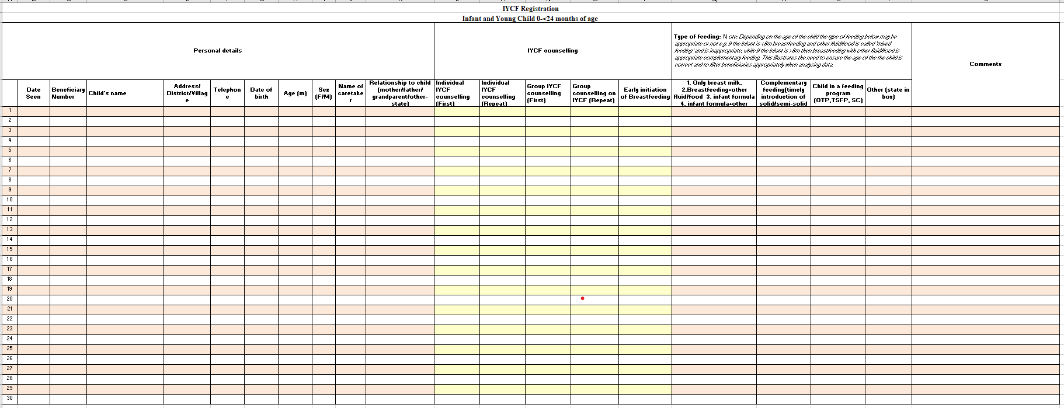

**Pregnant and Lactating women**

This tool will be used in the health facility at ANC service delivery point and during outreaches.

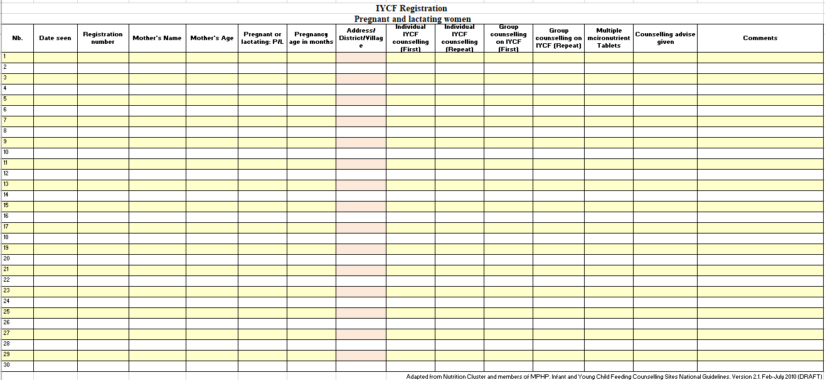

**IYCF Community Worker Tool 1: IYCF Assessment**

|  |  |  |  |  |  |  |
| --- | --- | --- | --- | --- | --- | --- |
|  | Name of Mother/  Father/Caregiver | | Name of Child | | Age of child  (completed months) | Number of  older  children |
|  | |  | |  |  |
| **Observation of**  **mother/**  **caregiver** |  | | | | | |
| **Child Illness** | Child ill | | Child not ill | | Child recovering | |
| **Growth Curve**  **Increasing** | Yes | | No | | Levelling off/Static | |
| **Tell me about**  **Breastfeeding** | Yes | No | When did BF stop? | Frequency: times/day | Difficulties: How is breastfeeding going? | |
|  |  | |
| **Complementary foods** | Is your child getting anything else to eat? | What | Frequency: times/day | | Amount: How much (Ref. 250 ml) | Texture: How thick/consistent |
| Grains and grain products and all other starchy foods |  |  | |  |  |
| Pulses/legumes |  |  | |  |  |
| Dairy and dairy products |  |  | |  |  |
| Flesh foods |  |  | |  |  |
| Eggs |  |  | |  |  |
| Vitamin A rich fruits and vegetables |  |  | |  |  |
| Other fruits and vegetables |  |  | |  |  |
| **Liquids** | Is your child getting anything else to drink? | What | Frequency: times/day | | Amount: How much (Ref. 250 ml) | Bottle use? Yes/No |
| Other milks |  |  | |  |  |
| Other liquids |  |  | |  |  |
| **Other challenges?** |  | | | | | |
| **Mother/caregiver assists child** | Who assists the child when eating? |  | | | | |
|  | Feeds baby  using a clean  cup and spoon | | Washes hands with clean, safe water and  soap before preparing food, before eating, and  before feeding young children | | | Washes child’s hands with  clean, safe water and soap  before he or she eats |

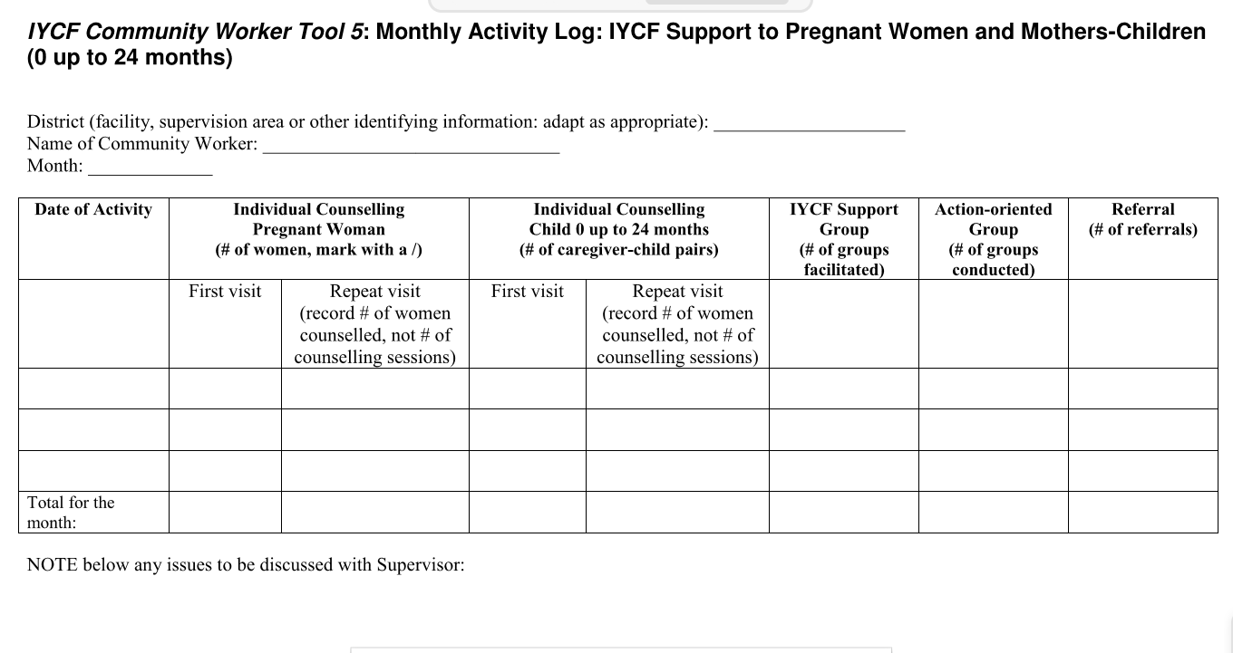

**Supportive Supervision/Mentorship Tool 1: Observation Checklist for IYCF Counselling**

Name of Community Worker: __________________Position: ____________________________

Community/Location: __________________ Name of Supervisor/Mentor: _________________

Date of visit: __________________

|  |  |  |
| --- | --- | --- |
| **Did the Community Worker** | **1=Satisfactory**  **0=Not satisfactory** | **Comments** |
| 1. Communication Skills | | |
| **Use Listening and Learning skills:**   * Use helpful non-verbal communication * Asks open questions * Use responses and gestures which show interest * Reflects back what the mother says * Show empathy shows that she understands how the client feels * Avoids words which sound judging   **Use Building Confidence and Giving Support skills:**   * Accept what mother/father/caregiver thinks and feels * Recognize and praise what a mother and baby are doing right. * Give practical help * Give little, relevant information * Use simple language * Make one or two suggestions, not commands |  |  |
| **SCORE: Communication Skills** |  |  |
| **2. Infant Age** | | |
| * Obtain correct **infant age** |  |  |
| **SCORE: Infant Age** |  |  |
| **3. 3-Step Counselling Process Step I. Assess** | | |
| **Breastfeeding (with mother):**   * Assess the current breastfeeding status * Check for breastfeeding difficulties * Observe a breastfeed (if necessary)   **Complementary feeding** at appropriate age:   * Assess AFATVRH * Assess ‘other fluid’ and ‘other food’ intake * Assess use of bottle feeding   **Complete Assessment** before going on to Analyze |  |  |
| **SCORE: Assessment Skills** |  |  |
| **4. 3-Step Counselling Process Step II. Analyze** | | |
| Identify and prioritize any difficulties stated by  mother/caregiver or deviation from age-appropriate  recommended practices |  |  |
| **SCORE: Analysis Skills** |  |  |
| **5. 3-Step Counselling Process Step III. Act** |  |  |
| Praise the mother/father/caregiver for positive  practices   * Discuss limited and relevant information * Encourage mother/caregiver to try new practice; Agree upon action |  |  |
| **SCORE: Act Skills** |  |  |
| **Did the Community Worker** | **1=Satisfactory**  **0=Not satisfactory** | **Comments** |
| **6. Appropriate Use of Materials & Content** according to age and situation of child | | |
| Appropriate use of **materials (CC)** |  |  |
| **Breastfeeding: Explain to and support a mother to:**   * Practice recommended breastfeeding practices * Position and attach at breast * • Help mother determine effective suckling |  |  |
| **Counsel a pregnant woman about breastfeeding**   * Explain how to initiate and establish breastfeeding * Sensitize and encourage the pregnant woman of * unknown HIV status to be tested for HIV |
| **Help a mother initiate breastfeeding within the first**  hour:   * Skin-to-skin contact immediately after birth * Help mother with positioning and attachment |
| **Other skills: Explain how to**   * Express breast milk by hand * Identify, prevent, determine causes and overcome difficulties |
| **Complementary Feeding: Help implement**  **complementary feeding (CF), following the**  **characteristics of CF for age group:**   * Show how to add micronutrient supplements for home fortification (country specific) |
| **Women’s Nutrition -- Help a mother achieve**  **adequate nutrition during pregnancy and lactation:**   * Implement other supporting interventions: malaria; other parasites: deworming, footwear, faeces disposal; rest/decreased workload |
| **Infant Feeding in the Context of HIV**  **Help an HIV-infected woman:**   * Breastfeed exclusively and optimally (according to * national protocol) * Refer for additional help, as appropriate |
| SCORE: Appropriate Use of Materials &  Content |  |  |
| **TOTAL SCORE: Individual Counselling** | _________________ (of 6 Possible points) |  |

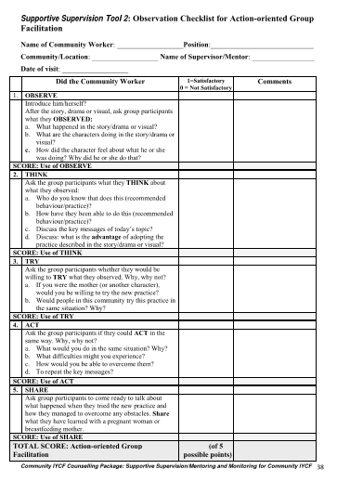

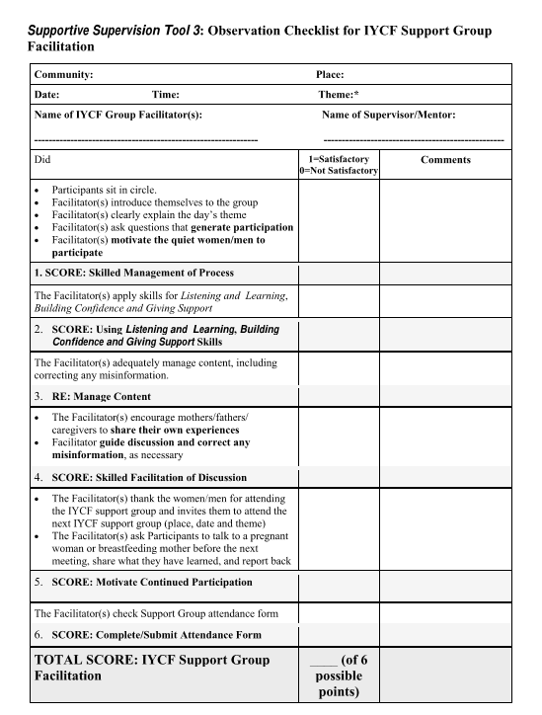

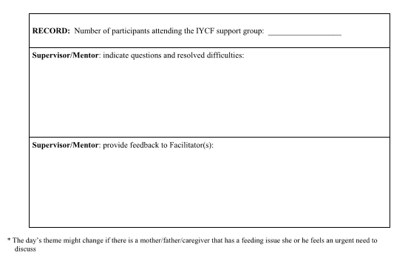

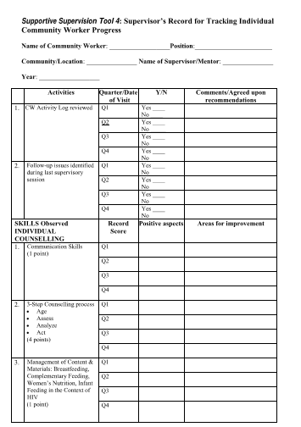

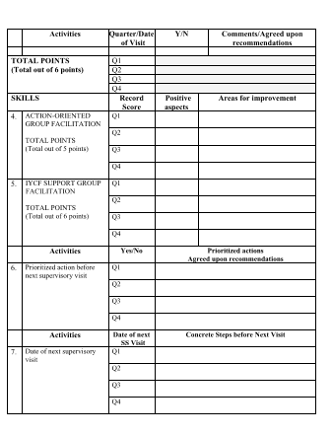

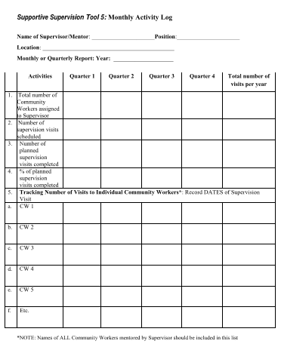

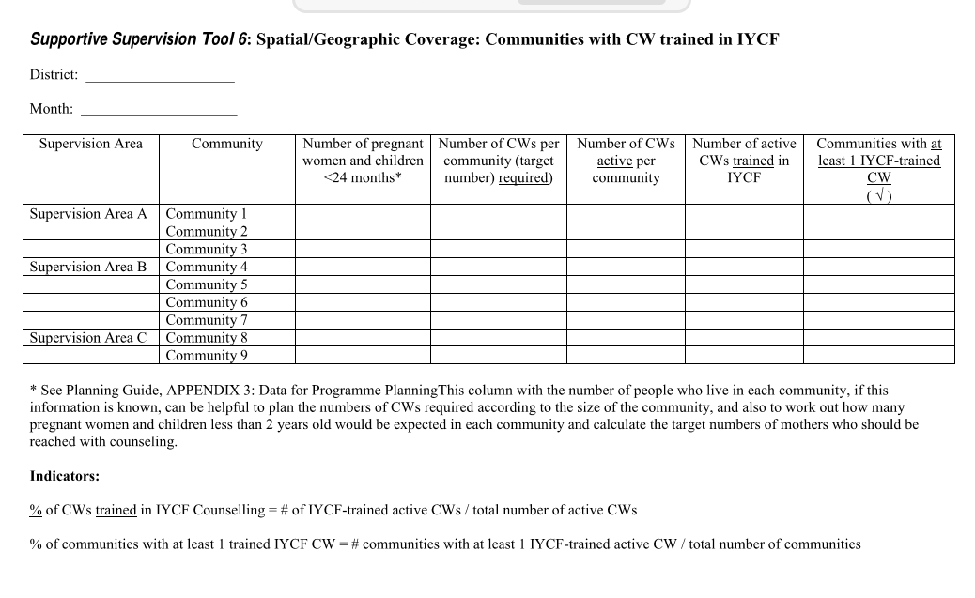

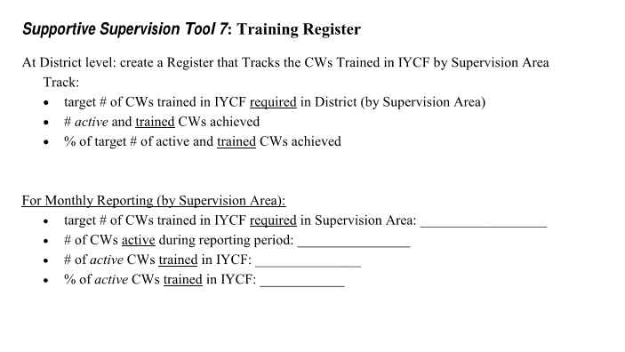

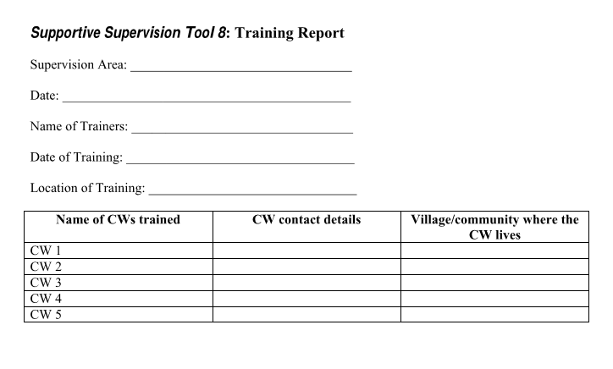

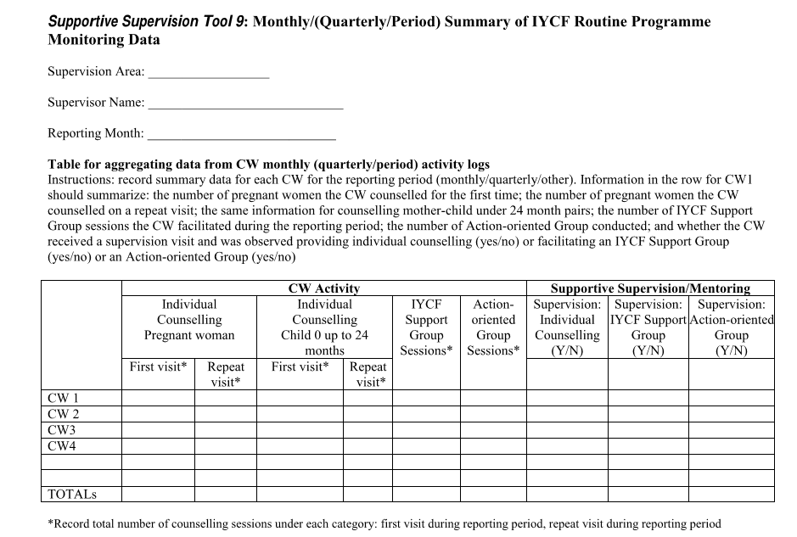

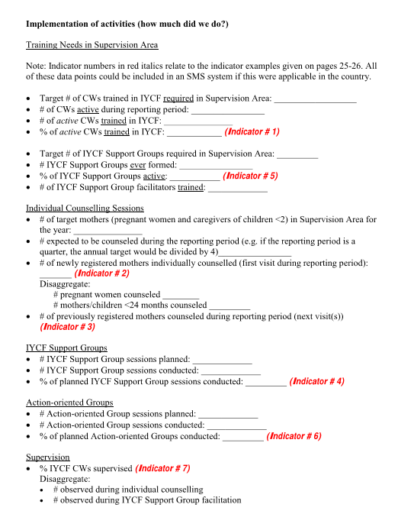

##### 

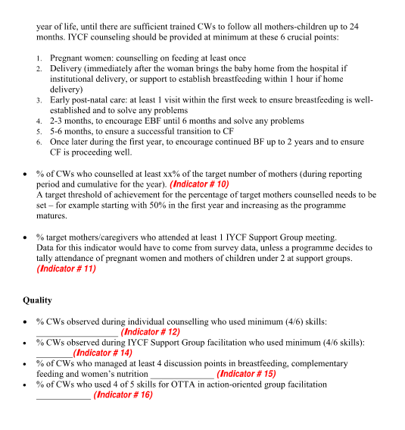

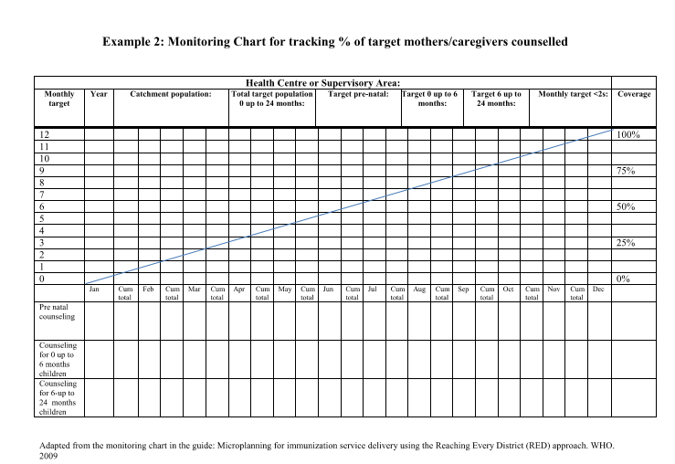

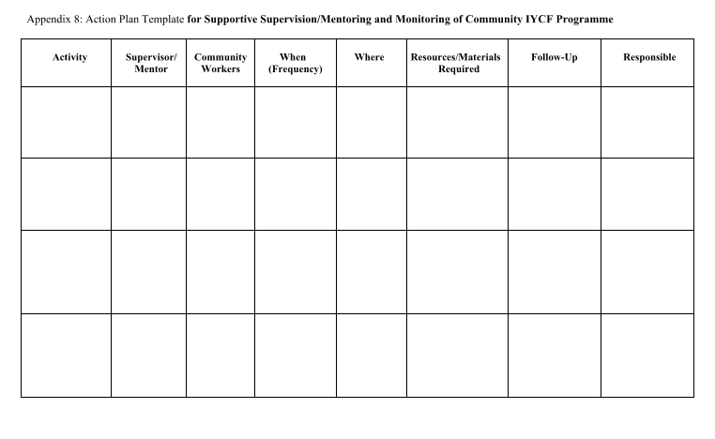

**WHO Growth Monitoring tools for boys and girls**

**Weight for Age Growth chart for girls**

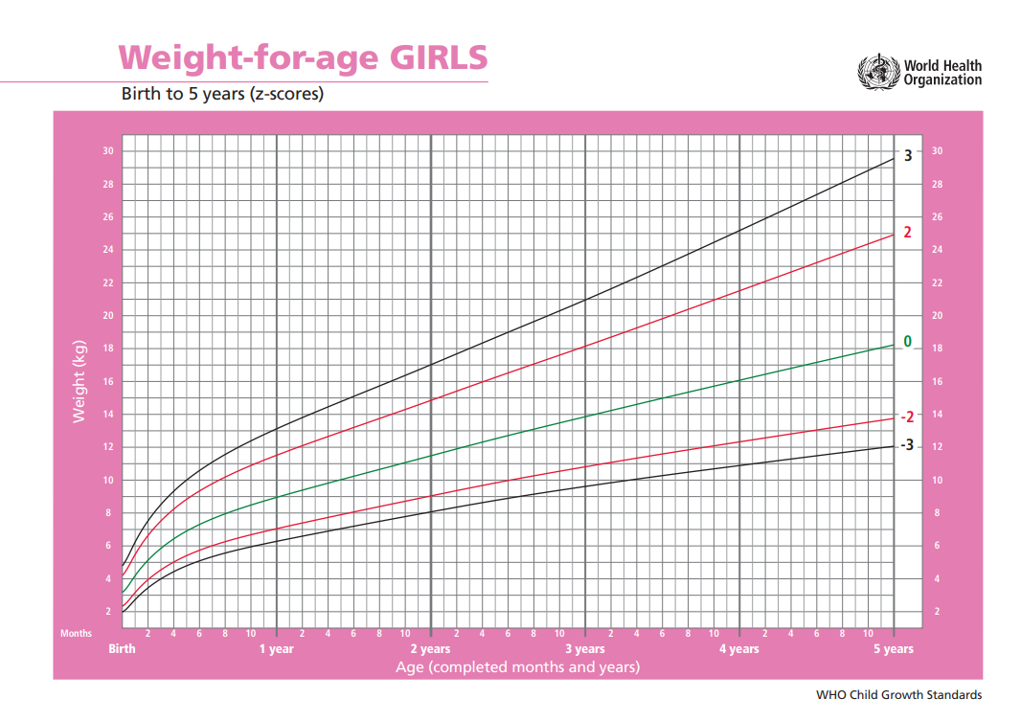

**Weight for Age Growth chart for boys**

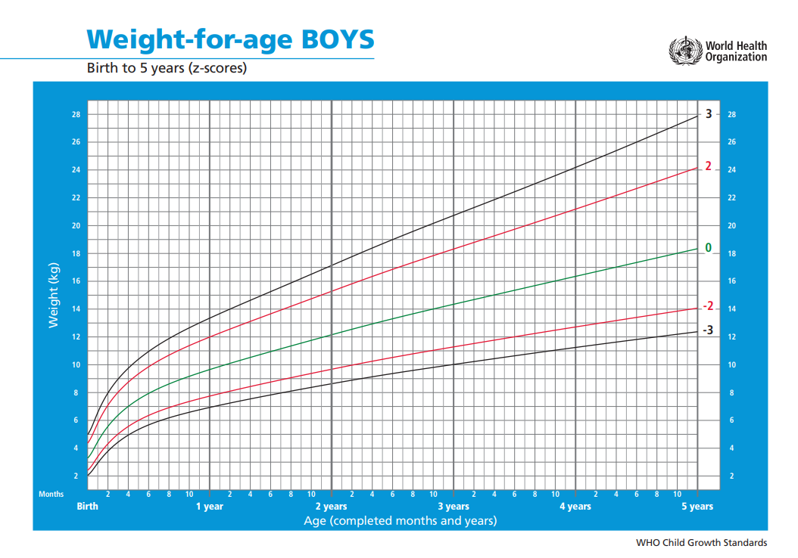

**Height/Length for Age Growth chart for girls**

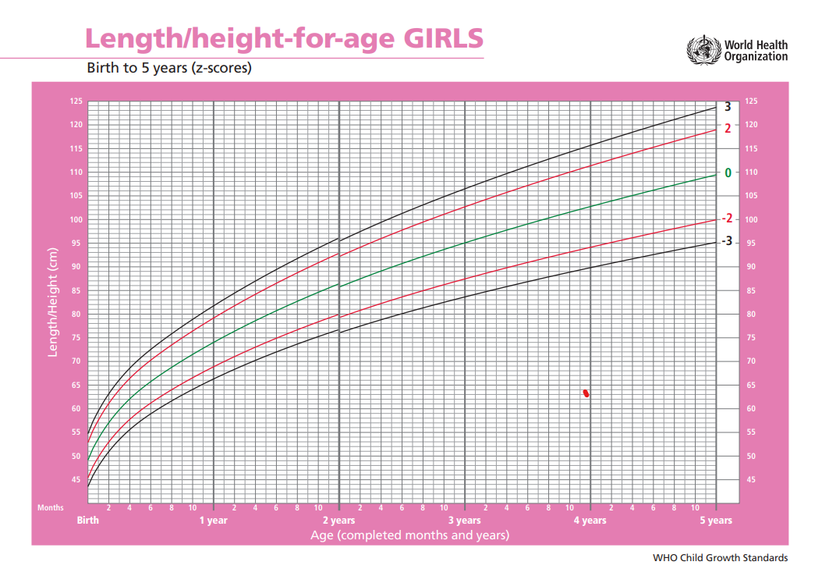

**Height/Length for Age Growth chart for boys**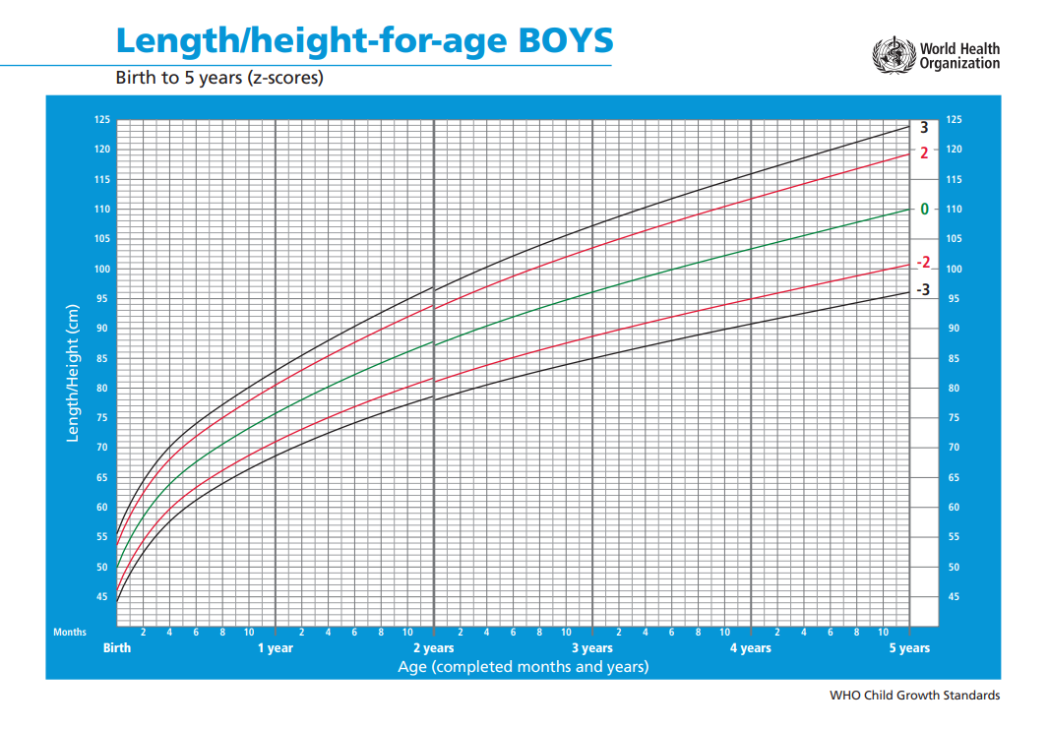

**Weight for length/height Growth chart for girls**

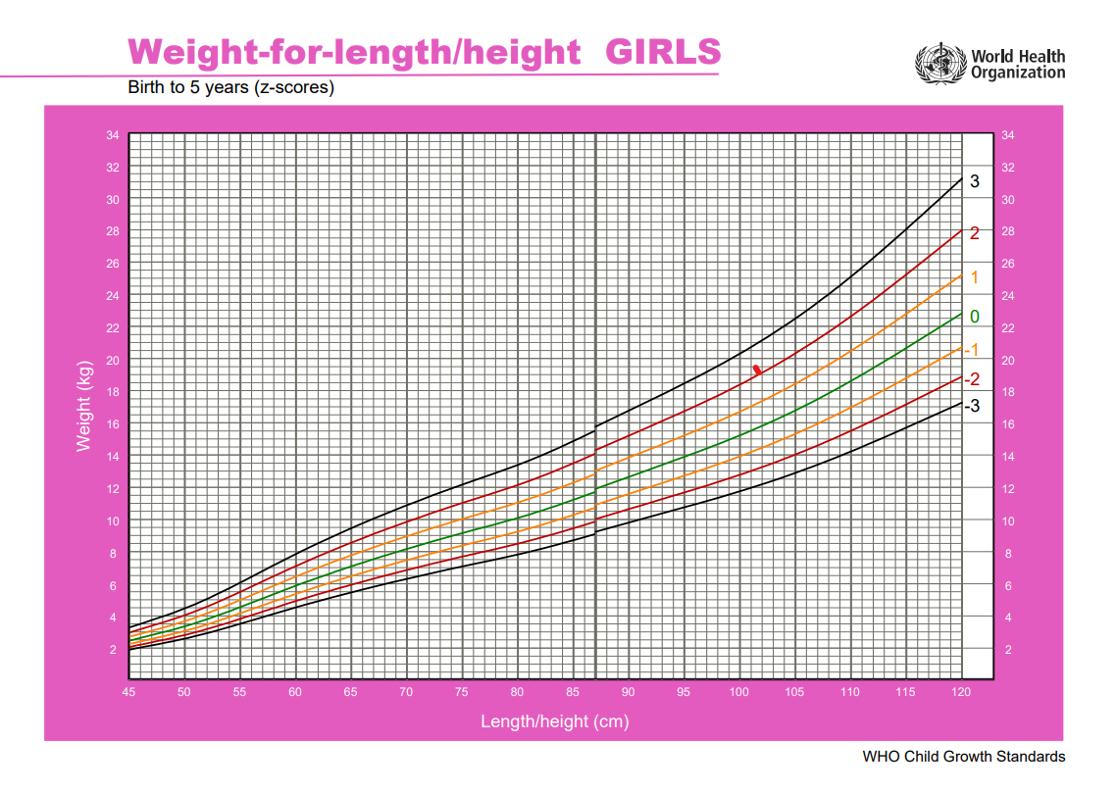

**Weight for length/height Growth chart for boys**

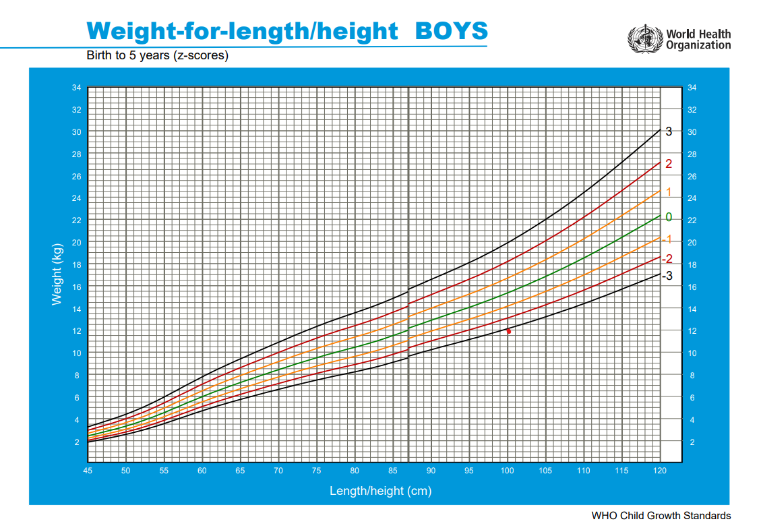

**Annexes**

**Annex 1: Food Groups for Women as per FAO dietary diversity guidance**

This is targeted for pregnant and lactating women to improve dietary diversity and increased micronutrient adequacy

|  |  |
| --- | --- |
| **Food groups** | **Examples** |
| Grain, grain products and other  starchy foods | *Whole grains:* rice, maize, millet, sorghum,  *Starchy roots*: white fleshed sweet potato, unripe bananas, arrowroots, cassava, yam among others  *Products:* wheat flour, maize flour, spaghetti, Weetabix, cornflakes, porridge flours among others |
| Legumes /Pulses | Dried beans any variety, dried peas, cow peas, green grams, lentils among others |
| Nuts and seeds | Macadamia, peanuts/ ground nuts, cashew nuts,  Baobab seeds, Simsim, pumpkin seeds, chia seeds, poppy seeds |
| Flesh foods | Red meat variety, white meat varieties, insects, canned meats |
| Eggs | Any type available and consumed by community |
| Dairy and dairy products | Fresh milk, processed milk, fermented milk, yoghurt, cheese |
| Green leafy vegetables | Any green vegetables available and consumed in the region |
| Other vitamin A rich fruits and  vegetables | Fruits: mangoes, pawpaw, purple skin passion fruit, peaches, loquats, yellow or orange fleshed sweet potatoes  Vegetables: carrots, pumpkin |
| Other fruits | Ripe bananas, guavas white and red fleshed, tree tomatoes, water melon red color, oranges, pineapples, apples among others |
| Other vegetables | Tomatoes, Coriander, Capsicum, onions, cabbage,  cucumber, green peas, green beans, green maize  among others available in the market |

**Annex 2: Ten Steps to Successful Breastfeeding**

This provides guidance to all health facilities offering maternity and newborn services.

**Critical management procedures:**

**1a.** Comply fully with the *International Code of Marketing of Breast-milk Substitutes* and relevant World Health Assembly resolutions.

**1b.** Have a written infant feeding policy that is routinely communicated to staff and parents.

**1c.** Establish ongoing monitoring and data-management systems.

**2.** Ensure that staffs have sufficient knowledge, competence and skills to support breastfeeding.

**Key clinical practices:**

**3.** Discuss the importance and management of breastfeeding with pregnant women and their families.

**4.** Facilitate immediate and uninterrupted skin-to-skin contact and support mothers to initiate breastfeeding as soon as possible after birth.

**5.** Support mothers to initiate and maintain breastfeeding and manage common difficulties.

**6.** Do not provide breastfed newborns any food or fluids other than breast milk, unless medically indicated.

**7.** Enable mothers and their infants to remain together and to practise rooming-in 24 hours a day.

**8.** Support mothers to recognize and respond to their infants’ cues for feeding.

**9.** Counsel mothers on the use and risks of feeding bottles, teats and pacifiers.

**10.** Coordinate discharge so that parents and their infants have timely access to ongoing support and care

**Annex 3: Breastfeeding Observation Job Aid**

This provides guidance to check if breastfeeding is going on well or not.

|  |  |
| --- | --- |
| **Breastfeeding Observation Job Aid** | |
| **Mothers Name** | **Date** |
| **Baby's Name** | **Baby's Age** |
| **Signs that breastfeeding is going on well** | **Signs of possible difficulty** |
|  |  |
| **Mother** | **Mother** |
| Mother looks healthy | Mother looks ill or depressed |
| Mother looks relaxed and comfortable | Mother looks tense and uncomfortable |
| Signs of bonding between mother and baby | No mother/ baby eye contact |
|  |  |
| **Baby** | **Baby** |
| Baby looks healthy | Baby looks sleepy or ill |
| Baby looks calm and relaxed | Baby is restless or crying |
| Baby reaches for or roots to breast if hungry | Baby does not reach or root |
|  |  |
| **Breasts** | **Breasts** |
| Breasts look healthy | Breasts look red, swollen or sore |
| No pain or discomfort | Breasts or nipple painful |
| Breast well supported with finger | Breast held with fingers on areola away from nipple |
|  |  |
| **Baby's Position** | **Baby's Position** |
| Baby's head and body in line | Baby's neck and head twisted to feed |
| Baby held close to the mother’s body | Baby not held close |
| Baby's whole body supported | Baby supported by head and neck only |
| Baby approaches breast, neck to nipple | Baby approaches breast, lower lip/chin to nipple |
|  |  |
| **Baby's attachment** | **Baby's attachment** |
| More areola seen above baby's top lip | More areola seen below bottom lip |
| Baby's mouth wide open | Baby's moth not wide open |
| Lower lip turned outwards | Lip pointing forward or turned in |
| Baby's chin touching breast | Baby's chin not touching breast |
|  |  |
| **Suckling** | **Suckling** |
| Slow, deep sucks with pauses | Rapid shallow sucks |
| Cheeks round when suckling | Cheeks pulled in when suckling |
| Baby releases breast when finished | Mother takes baby off breast |
| Mother notices signs of oxytocin reflex | No signs of oxytocin reflex noticed |

**Annex 4: WHO Classification of Food Groups for Children**

Guidance on dietary diversity for complementary feeding for children aged 6-23 months.

|  |  |  |
| --- | --- | --- |
|  | **Food group classification for children by WHO** | **Food sources** |
| 1 | Grains and grain products and all other starchy foods | Cassava, millet, sorghum, maize, rice, wheat, potatoes |
| 2 | Pulses/legumes | Dried beans, lentils, dried peas, nuts and seeds |
| 3 | Dairy and dairy products | milk, yogurt, cheese |
| 4 | Flesh foods | Camel, beef, goat, fish, poultry, liver or other organs |
| 5 | Eggs | Chicken eggs |
| 6 | Vitamin A rich fruits and vegetables | Pawpaw, watermelon, carrots, pumpkins, orange fleshed sweet potatoes |
| 7 | Other fruits and vegetables | Pineapple, oranges, cabbage, bananas |

**Annex 5: BMS Prescription Referral Form**

Guidance on a prescription after a full assessment has been completed and all options have been exhausted then a referral must be created and sent to the Trained Health Worker using this BMS Referral Form

|  |  |  |  |  |
| --- | --- | --- | --- | --- |
| Referral Information  Referral Date: _____/_____/______ Referral Follow-up Completed: Yes / No | | | | |
| Referring health facility/Agency: ________________________________  Referred by (name): ______________________________  Job Title/Designation: _____________________________  Location: ________________________________________  Contact Information/Phone Number: _________________ | | | Referral to Service/ Facility: ______________________________  Location: _____________________________________________  Contact Information/ Phone Number: ______________________ | |
| When to Attend: Immediately/ Date: ________________________________  Referral Transportation Plan: Self/ Referring Agency Supported Transport. | | | | |
| Person of Concern Details | | | | |
| Child Name: ______________  Sex: ☐ Male ☐ Female  Child Age in Months:________ | Mother/Caregiver Name:  ___________________________________  Contact Details/Telephone Number: ___________________________________ | | | Mother/Caregiver location/address:  _____________________________________________________  _____________________________________________________  _____________________________________________________ |
| IYCFE/OTP/SC or Health Facility Identification Number#:___________________________ | | | | |
| Is the Full Assessment form Included with this referral form? Yes / No  *Always ensure that the Full Assessment is sent along with this form to the SC in charge and follow-up in completed between the referring and receiving agencies and that a transportation is in place for the referral.* | | | | |
| REFERRAL CRITERIA | | | | |
| Temporary BMS indication:  During relactation  Transition from mixed feeding to exclusive breastfeeding  Short-term separation of infant and mother  Short-term waiting period until wet nurse or donor human milk is available | | Longer-term BMS indication:  Infant not breastfed pre-crisis  Mother not wishing or unable to relactate  Infant established on replacement feeding in the context of HIV  Orphaned infant  Infant whose mother is absent long-term  Specific infant or maternal medical conditions[1]  Very ill mother  Infant rejected by mother  A survivor of Gender Based Violence not wishing to breastfeed. | | |
|  | | | | |

Part One: To be completed at referring site and sent to the referral agency (SC in charge) as well as kept in referring agency records for follow-up

---------------------------------------------------------------------------------------------Cut here -------------------------------------------------------------------------------------------------

*Part Two: To be completed at referring site and given to caretaker (as record of next steps and to show the referral facility)*

Child’s Name________________________ Caregiver Name:________________________________

Referring Agency:______________________ Referring Agency Contact Details: __________________

Name of Referral Facility: _______________________________ Location: _________________________

Contact Details: _________________________________________________

When to Attend: Immediately/ Date: ________________________________

Referral Transportation Plan: Self / Referring Agency Supported Transport.

**Reason for Referral:**

* Temporary BMS indication:
* During re-lactation
* Transition from mixed feeding to exclusive breastfeeding
* Short-term separation of infant and mother
* Short-term waiting period until wet nurse or donor human milk is available
* Longer-term BMS indication:
* Infant not breastfed pre-crisis
* Mother not wishing or unable to re-lactate
* Infant established on replacement feeding in the context of HIV
* Orphaned infant
* Infant whose mother is absent long-term
* Specific infant or maternal medical conditions[2]
* Very ill mother
* Infant rejected by mother
* A survivor of Gender Based Violence not wishing to breastfeed.

Recommendations for Follow-up: --------------------------------------------------------------------------------------------------------------------------------------------------------------------------------------------------------------------------------------------------------------------------------------------------------------------------------------------------------------------------------------------------------------------------------------------------------------------------

**Annex 6. Example of a simple rapid assessment**

Mother/Caregiver name: ____________________  
**Ask:**   
• How old is the baby? _________ Months  
• How is the baby being fed?  
Please list all liquids and foods the baby received since yesterday.  
• Note if baby is breastfed � yes � no  
• If not:  
a. Has the baby ever been breastfed? � yes � no  
b. Is the baby able to suckle the breast? � yes � no  
• If yes:  
c. Have you had any difficulties with breastfeeding?  
� yes ___________ � no ____________ (indicate)  
**Look:**  
• Does the baby look very thin? � yes � no  
• Is the baby lethargic, perhaps ill? � yes � no  
**Reasons to refer for full assessment:**   
� Not breastfed  
� Breastfed but feeding is not age-appropriate (e.g., under 6 months  
and not exclusively breastfed; over 6 months and given no  
complementary foods)  
� Baby unable to suckle the breast  
� Mother has difficulties with breastfeeding  
� Mother requests breastmilk substitutes  
� Baby visibly thin, lethargic or ill; mother visibly thin or ill.  
� Baby lethargic, perhaps ill

**Annex 7: Care Action Plan for Mother/Caregiver and Baby Receiving Skilled Support and BMS**

Care Action Plan for Mother/Caregiver And Baby Receiving Skilled Support And BMS

(Note: This form is to be completed after a Full Assessment. This care plan may be used for temporary BMS use as well as full BMS use)

Name of designated IYCF-E counselor/HCW ________________________

Location: ________________________________________________

IYCF-E Registration Number: ________________________________

Child’s name ____________________________________________

Child’s Sex M/F

Child’s DoB __________ Age/months ___________

Mother/ Caregiver’s name ____________________

Relationship to child__________________________

Address_____________________________________

Telephone: ___________________________________

Date of initial full assessment of mother-baby pair:___________

Main findings of assessment:

Recommendations for feeding:

* Continuing Supportive Care
* Basic Aid
* Further Help Baby refusing the breast
* Further Help Restorative care for the mother (needs emotional / extra support)
* Further Help Wet nursing
* Further Help Relactation
* Further Help Breast conditions
* Further Help Supported artificial feeding
* Further Help Complementary Feeding

Referral / Specialized Support:

Medical treatment/Therapeutic feeding

Other – specify ____________

IYCF-E Reg. No. ___________________ Child’s name: ___________________Date of birth_______

Mother/Caregiver’s name: ______________________Relationship to child________________

FOLLOW UP / MONITORING FOR EACH CONTACT:

***Choose frequency of follow up according to each child/carer’s situation, start more frequently and then aim for weekly contacts. Add new card if necessary, e.g if continuing support to an artificially fed infant. For a fully artificially fed child this form MUST be used until BMS support is completed, until relactation or wet nursing is fully established or until the child graduates from the BMS prescription programme (at 6 months of age).***

|  |  |  |  |  |  |  |
| --- | --- | --- | --- | --- | --- | --- |
| Date |  |  |  |  |  |  |
| Health & Weight of child (kg) (if part of programme) |  |  |  |  |  |  |
| Date / time / place of next contact |  |  |  |  |  |  |
| Notes and Agreed Actions for next visit (1 or 2 |  |  |  |  |  |  |
| Progress from last visit |  |  |  |  |  |  |

**Checklist for counselling on BMS** (ensure that information from the Full Assessment of Mother-Baby Pair is used to inform the discussions below and to highlight any additional issues):

|  |  |
| --- | --- |
| **Item to discuss (initially and to ensure on subsequent visits if needed)** | **Check**  **(date)** |
| What BMS will be given, when and where to receive it. |  |
| What extra resources they will need to prepare BMS and how they will obtain these ***(Always ensure a plan is in place for ALL resources required for artificial feeding use)*** |  |
| How much and how often to feed BMS |  |
| How to keep feeding utensils clean and safe |  |
| How to prepare and store the feeds |  |
| The advantages of cup feeding and how to cup feed |  |
| Warning of the potential hazards of using BMS. |  |
| **Demonstrate** |  |
| Care worker should demonstrate appropriate preparation of a BMS feed in the home |  |
| **Check that** |  |
| The caregiver has been observed making a feed |  |
| The caregiver has been observed cup feeding |  |

**Checklist for follow up visits (write findings in visit notes)**

|  |
| --- |
| **Check and discuss** |
| Infant health status, weight, and MUAC |
| Observe feed preparation: Check hygiene and it is as safe as possible |
| Observe a feed: Check feeding is appropriate including cup feeding |
| Find out any difficulties the caregiver may be facing and discuss practical solutions and/or refer for appropriate support |
| Check for warning signs of misuse of infant BMS (e.g. over concentration, over-dilution, formula being shared, etc) |

**Annex 8: BMS Resource Kit**

**How to use a BMS Resource Kit**

The items in the BMS Resource Kit are essential when supporting caregivers to make infant formula using powder at home. Powdered infant formula needs to be made using a specified amount of formula and boiled water no less than 70 degrees centigrade and then cooled rapidly before feeding to the infant.

**Cup feeding is safer in an emergency. Feeding bottles should not be used.**

**Things to avoid**

Breastfeeding saves lives, especially in emergencies and therefore any activities that may undermine breastfeeding such as providing a BMS Resource Kit must be undertaken sensitively and in a way that minimises this risk e.g. discretely. Providing breastfeeding mothers with something of equivalent or greater value to support breastfeeding should be seriously considered (see below).

Care should be taken when cup feeding – this can take time to learn but is very successful. Using the spoon to feed the baby can also be successful but is slower and the spoon should NOT be used to force open the baby’s mouth and may hurt the baby. Cup feeding following the guidelines is recommended.

**Consider purchasing at the same time**

Provision of powdered infant formula (PIF) should be carefully considered**.** PIF should be provided with the scoop from the manufacturer.

In order to ensure that breastfeeding is not undermined in emergencies by providing PIF to support caregivers of infants that have no possibility to be breastfed, then breastfeeding mothers should receive something of greater or equal value. The nature of this will depend on programming and what is valued by mothers in that context but may be vouchers, food, clothes.

**BMS Resource Kit Items**

|  |  |  |
| --- | --- | --- |
| **Item Description** | **Unit** | **QTY** |
| **General Equipment & Supplies** |  |  |

|  |  |  |
| --- | --- | --- |
| High quality thermos flask (Optional – depending on the situation) | Pce | 2 |
| Large cup (or jar with wide opening) for infant formula | Pce | 1 |
| Measuring scoop for water (Note: This can be a steel cup or glass with a line etched on it to indicate the exact amount of water to be mixed with one scoop of formula powder, as indicated by the manufacturer.) | Pce | 1 |
| Paper napkins (approximately 2 per feed x 8 feeds a day =16 + 5 extra a day to clean preparation area = 21 a day) | Pce | 21 paper napkins a day |
| Water Purification Treatment (Aquatab) if necessary | Tablet | N/A |
| Shallow bowl (to contain safe cold water for cooling the feed) | Pce | 1 |
| Small pot/kettle (for boiling water) | Pce | 1 |
|  |  |  |
| Small spoon | Pce | 1 |
| Small cup/medicine cup for cup feeding infant | Pce | 1 |
| Small basin (for washing equipment) | Pce | 1 |
| Soap (for washing hands and equipment) – when runs out it should be replaced. | Pce | 2 |
| Solid plastic box with lid (for storage. Preferably with a smooth flat lid which can be used as a washable preparation surface. If it does not have a smooth flat lid then plastic sheeting will be needed as a preparation surface) | Pce | 1 |
| Jerry can (20L) | Pce | 1 |
| Water (approx. 3 litres per day if using PIF) | Pce | N/A |
| Fuel (wood, charcoal, electricity) for boiling water | Pce | N/A |
| Guidelines for caregivers on using infant formula (BMS) (in Annex Nigeria MICYN-E Guidance) | Pce | 1 |

**Annex 9: BMS Prescription Card**

**Prescription Card for infant milk formula[3]**

Date: _____/_____/______

|  |  |  |  |
| --- | --- | --- | --- |
| POC INFORMATION | | | |
| Child Name: ____________ ___________  First Name Last Name  Sex: ☐ Male ☐ Female | Mother Name: ____________ ______________  First Name Last Name  Address: __________________________ | | DOB: _____/_____/______ Tel. No. _______________________  DD MM YYYY  Programme #:________________ |
| REFERRAL CRITERIA | | | |
| ☐ Social – No need for breast examination: For permanent infant condition no breast examination is needed (Only prescription). | | ☐ Medical – Breast examination (For temporary infant conditions and mother conditions). | |
| PRESCRIPTION CRITERIA | | | |
| NON-MEDICAL – NO breast EXAMINATION | | MEDICAL – *(To Be Filled by Health Provider, Midwife or Pediatrician )* | |
| ☐ Child is orphaned - wet-nursing is not possible.  ☐ Child is temporarily or permanently separated from mother.  ☐ Mother has stopped breastfeeding and re-lactation is:  ☐ ongoing or ☐ failed.  ☐ Infant rejected by mother  ☐ Infant refuse breast milk | | **Infant conditions (permanent – special formula needed):**  ☐ Galactosemia ☐ Maple syrup urine disease  ☐ Phenylketonuria  ☐a syndrome or an inborn error in metabolism  **Infant conditions (Temporary):**  ☐ low birth weight (1.5 < gm)  ☐ pre-term infant (< 32 weeks of gestational age)  ☐ Newborn at risk of hypoglycemia  **Mother conditions - with Breast Feeding (Temporary):**  ☐ Breast abscess ☐ Hepatitis B ☐ Hepatitis C  ☐ Mastitis ☐ TB ☐ Substance use ☐Engorged breast, flat/inverted nipples  **Mother conditions- No Breast Feeding (Temporary):**  ☐ Severe illness  ☐ Medication contra indication[4]  ☐ Herpes simplex virus type 1 (HSV-1) | |
| Prescription (to Pharmacy) | | | | |
| Date of Prescription: _____/_____/______  DD MM YYYY  Child Name : ____________ ___________ DOB: _____/_____/______ Sex: ☐ Male UNHCR #:________________  First Name Last Name DD MM YYYY  ☐ Female  Qty in Ml/ Day: _____ Number of Days: _____ Total Qty (tin): _______    Date of follow up: _____/_____/______  DD MM YYYY  IYCF counselor name: __________________________ Staff Name: ____________________(pediatrician/midwife)  Signature: __________________ Signature: __________________ | | | | |
| **SC Manager or LGA Nutrition Manager Approval**   |  | | --- | | Official Stamp  Date: _________________________________________________  Name: ________________________________________________  Organisation:_________________________________________  Job Title: _____________________________________________ | | | | | |
|  | | | | |

**Annex 10: Generic BMS Label and Educational Tools**

**Example of a Generic Label for Powdered Infant Formula**

*The details will need to be changed according to the size of the powdered infant formula tin and the manufacturer’s details. The label MUST be in the local language.*

**INFANT FORMULA**

Suitable from birth

**IMPORTANT NOTICE – WARNING!**

A mother’s breastmilk is always the best food for her infant.

**Only use this milk if there is a medical reason to do so or if it is not possible for the baby to have breastmilk.**

The milk in this tin is similar to all the brands of infant formula on sale. It is made from dried cow’s milk and is suitable for babies from birth. When mixed with clean boiled drinking water it will provide all the food a baby needs until about six months of age. There is no need to add other foods unless this is advised by a health worker. However, like all artificial formulas it does not contain the living antibodies which are in mother’s milk. It will not protect your baby against infections (such as diarrhoea, coughs or colds).

Consult an independent* health worker before you stop breastfeeding or before you give any infant formula to your baby. This product should be used only after following the advice or a health agent who should also give you instructions on the proper methods to use this product. Once you start using this milk it might not be easy to start breastfeeding again. (*People working for baby food and feeding bottle companies should not give you advice on how to feed your baby).)

This product must not be used after date printed at the bottom of the tin/pack. Keep in a cool, dry place with the lid (or seal) tightly closed. (Production date, batch no, etc.)

[*Address of factory manufacturing and packing this product, in 6 point type, no logo*]

**IMPORTANT WARNING**

**USE THIS MILK ONLY IF YOU CAN SAY YES TO ALL THESE QUESTIONS:**

✓ Is there a medical reason why you should not breastfeed?

✓ Can you understand all the instructions on this tin?

✓ Do you have everything you need to make this milk up properly? For example, it will be very difficult if you do not have a water supply to your home.

✓ Will you be able to get enough powder to last your baby until she/he is about six months old? You will need about forty 500 gram tins for six months.

• **UNBOILED WATER AND UNCLEAN CUPS CAN MAKE YOUR BABY ILL.**

**DO NOT KEEP LEFTOVER MILK** – Drink it yourself or give it to an older child. It will become unclean and unsafe for your baby if you try to keep it for another feed.

• If you use **TOO MUCH** powder your baby could become dehydrated and sick. If you do not use **ENOUGH** your baby will not get enough food.

**NUTRITIONAL INFORMATION**

**INGREDIENTS**: dried cow’s milk, lactose, vegetable oil, whey, calcium citrate, potassium citrate, sodium chloride, calcium carbonate, potassium carbonate, vitamin C, L-arginine, calcium chloride, magnesium carbonate, ferrous lactate, vitamin E, niacin, zinc sulphate, pantothenate, copper sulphate, vitamin A, vitamin B6, vitamin B1, follacin, potassium iodide, vitamin K1, biotin (vitamin H), vitamin D3, vitamin B12.

Analysis per 100 ml prepared feed [*details to be added by manufacturers*]

**Energy**

**Protein**

**Carbohydrate**

**Fat**

**Fibre**

**Sodium**

|  |  |  |  |  |
| --- | --- | --- | --- | --- |
| **BMS needs**  **The table shows approximately how much prepared formula (commercial or home-prepared) an infant needs at different ages in the first six months, based on a requirement of 150ml/kg/d.** | | | | |
| **Amount of prepared formula an infant needs per day** | | | | |
| **Age of infant in months** | **Weight in Kilos\*** | **Amount of formula per day** | **Number of feeds per day** | **Size of each feed in mls\*\*** |
| 0-1  1-2  2-3  3-4  4-5  5-6 | 3  4  5  5  6  6 | 450ml  600ml  750ml  750ml  900ml  900ml | 8  7  6  6  6  6 | 60ml  90ml  120ml  120ml  150ml  150ml |

* Always use the actual weight of the infant to calculate feed amounts, even if the infant’s weight is very different to what you expect for their age

**Amounts rounded for ease of measurements, and therefore approximate. Differences between columns amounts to plus or minus 30ml per day variation

|  |  |  |
| --- | --- | --- |
| Approximate amounts of milk needed to make formula per month* | | |
| Age of infant in months | Prepared formula ml/day | Commercial formula  powder needed** |
| 0-1 | 450ml | 2 kg |
| 1-2 | 600ml | 3 kg |
| 3-5 | 750ml | 3.5 kg |
| 5-6 | 900ml | 4 kg |

*In addition, specified amounts of water are needed according to manufacturer’s instructions.

**Amounts are rounded for ease of measurement, and are therefore approximate

**HOW TO FEED A BABY WITH A CUP**

* Hold your baby sitting or half sitting on your lap.
* Keep a small cup of milk near the baby’s lips. Tilt the cup until the milk touches his lips. The cup should rest gently on the baby’s lower lip and the edges of the cup should rest on the outer edge of the upper lip of the baby.
* This will alert the baby, who will open his mouth and eyes. A baby born too small will begin to lick the milk with his tongue. A baby born at term or older will suck up the milk, but a little milk will fall from his lips.
* Do not pour the milk into the baby's mouth. Continue to hold the cup near the lip of the baby, allowing him/her to drink.
* When the baby has had enough, he/she closes his mouth and refuses to take more. A baby who has not drunk enough during a meal may take more the next, or you can increase the frequency of meals.
* Measure the consumption of the baby per day rather than per meal

**Annex 11: Powdered infant formula preparation instructions**

***Follow these carefully***



1. Wash your hands with soap and water



2. Boil safe water until it reaches a rolling boil. Allow it to boil for 2 Minutes



**3**. Pour boiling water over mixing cup, smaller feeding cup and mixing spoon. Do not use a feeding bottle.



4. Pour the correct amount of boiled water into the cup. This water should not be less than 70°C so do not leave it for more than 30 minutes after boiling



5. Fill the small scoop with powder. Add to the water. Mix thoroughly.



6. Cool the feed quickly by placing the cup into a shallow bowl of safe cold water. Ensure the water level is below the rim of the cup. When the cup feels just warm, dry the outside of the cup



**7.** Check the temperature of the feed before giving it to the child



8. Hold your baby close to you and give as much milk as he/she wants. Do not pour milk quickly into his/her mouth – let him/her sip slowly

1.
2.
3.
4.