Joint National Action Plan
Nutrition Cluster Afghanistan

INTRODUCTION

Humanitarian Context
The nutritional status of children under five continues to deteriorate in most parts of Afghanistan. Major events occurred in 2021 that sought to aggravate the nutrition situation and impede emergency nutrition programming, limiting supply and demand of nutrition services. Those include the emergence of a large wave of COVID-19, unprecedented severe drought, escalated armed conflict and extreme winter weather. The Nutrition Cluster estimates that 4.7 million children under five and pregnant and lactating women (PLW) will suffer from acute malnutrition in 2022, a 21% increase from the previous year. Afghanistan’s Public Nutrition Strategy identifies inadequate IYCF practices as a major, direct cause of the country’s high levels of malnutrition. Food insecurity is the major issue that will affect the malnutrition rates over the next few months. The estimated 55% population in IPC Phase 3 or above in the November 2021 – March 2022 projection is the highest ever recorded in the country; all 34 provinces are classified as in food crisis or emergency. It is to be observed that up to 49% of districts had treatment coverage below 50% in 2021.
A recent analysis of SMART survey data from Afghanistan has shown that 15.3% of infants under 6 months are wasted (WHZ<-2.0), 6.2% of which are severely wasted.² Poor maternal mental health and maternal malnutrition, with 1 in 5 PLWs underweight, are likely contributing factors. However, the findings show that a prevalence of wasting with medical complications is observed in infants 5 months of age, with about one third of admissions in IPD being infants below 6 months of age, and therefore there are likely other factors at play such as poor IYCF practices. Although exclusive breastfeeding was found to be 73.5% at 0 months, this decreased to 45.4% by 5 months. There is little new data so the situation is somewhat unclear.

Poor complementary feeding practices are a particular concern in Afghanistan. The national average for Minimum Acceptable Diet (MAD) is just 16%, with figures as low as ≤ 2% reported by the DHS 2015 for Kandahar province. This is far below the MAD target of 40% set by the National Public Nutrition Strategy. The prevalence of diarrhoea rises rapidly after the first 6 months of life, indicating poor complementary feeding hygiene practices (DHS 2015). In Afghanistan, inadequate dietary diversity was associated with 34% increased odds of stunting among children 6–23 months.³ Afghanistan’s stunting rate of 36.6 % in under five children is one of the highest in the world.⁴ With food insecurity up more than fivefold from 2015 (42% are within crisis or emergency levels of food insecurity),⁵ maternal nutrition and complementary feeding practices are at risk of worsening even further.

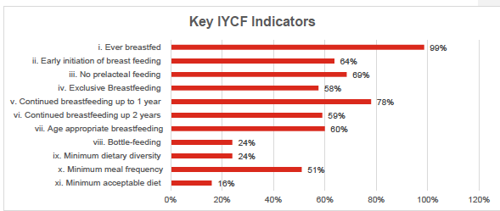

Figure 1 – IYCF practices in Afghanistan. Sources: Afghanistan Health Survey 2018 (i – iv) and Demographic and Health Survey 2015 (v – xi). The National Public Nutrition Strategy’s 2020 targets for early initiation and exclusive breastfeeding are 80% and 70% respectively.

Within Afghanistan the IYCF work has focused on development needs within a stable government delivery context supporting broader community level programming, while within humanitarian programs the focus still remains largely on SAM services. Though IYCF-E training has been rolled out to partners, capacity remains very weak.

OVERVIEW OF PLAN
This action plan outline step moving forward for the Nutrition Cluster, the MIYCN Technical Working Group, and their partners. For this action plan to have its intended impact, all stakeholders must come together as part of a coordinated effort.
This Joint Action Plan has six strategic objectives that are aligned with the Afghanistan Maternal Infant and Young Child Nutrition Strategy and Operational Guidance.
All partners are asked to commit to working together in the following areas:
- Develop, endorse, and disseminate policies
- Train staff
- Coordinate operations
- Assess and monitor
- Integrated multi-sectoral Interventions
- Minimization of the risk of artificial feeding

