Foreword by the HC |  | -
0. Executive Summary:  0.1 Response Plan Overview | - Response Plan Overview  - This summary should be drafted on the basis of Part 1 of the HRP and at the very end of the drafting process.  This part provides a summary of the following:  - Response plan (or adjustments) and strategic objectives, based on the humanitarian conditions and underlying factors identified in the HNO and subsequent response analysis determining the scope of response: which response, covering what needs, for what type and number of population groups, and where.  - Rationale for selected strategic objectives based on Part 1 of the HRP, including linkages with HCT Protection Strategies, and with development responses such as national plans and the United Nations Sustainable Development Cooperation Framework (UNSCDF) as well as with collective outcomes that may be formulated as part of visuals and infographics of people in need, people targeted, funding requirements, and number of humanitarian partners participating in the HRP | 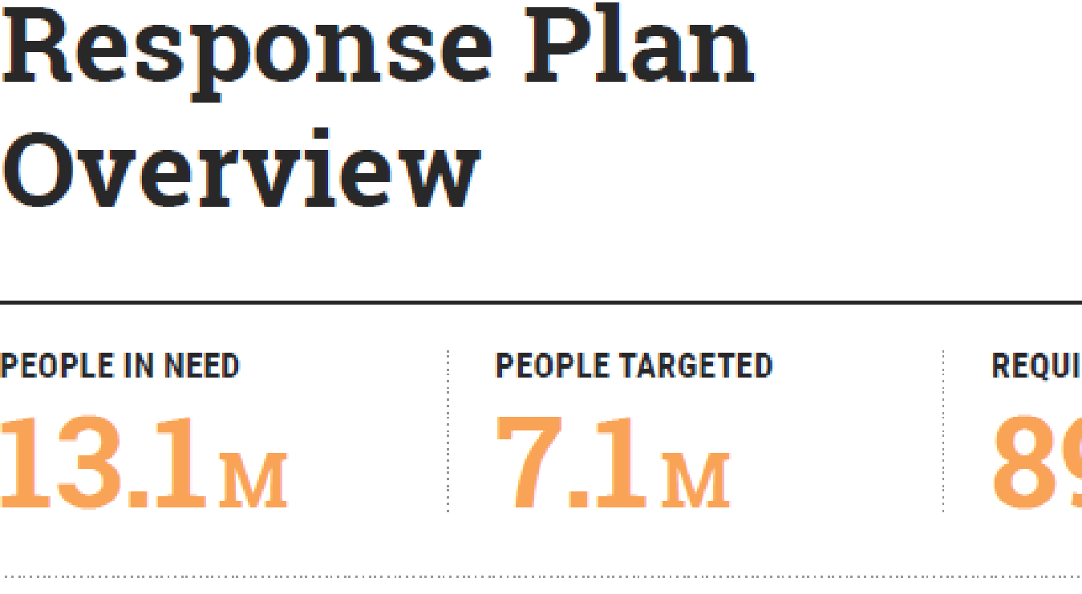
0. Executive Summary  0.2 Summary Crisis Context | 0.2 Summary of the Crisis Context and Impact  - Extract from the summary of the HNO (or from a monitoring update) a succinct description of the crisis, including main drivers, evolution, affected populations and geographical areas, vulnerabilities, gender inequalities, root causes, and risks, including protection risks.
0 Executive Summary  0.3 Summary Response by Strategic objective | 0.3 Summary Response by Strategic Objective  - Reproduce the 3-5 strategic objectives formulated using the SMART approach based on the HNO, scoping and response analysis discussions.  - Summarise the rationale for a possible difference between the HNO PiN and number of people targeted in the HRP  - Articulate the coordinated response approach for each strategic objective (or for various priorities if the same approach applies to more than one), based on response analysis and specific objective discussions.  Based on the above considerations;  - Present a crisp summary of the coordinated response approaches | 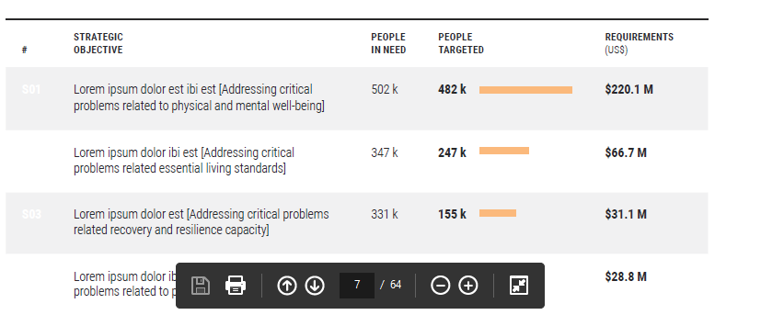
0. Executive Summary  0.4 Visualised Planned Response | 0.4 Visualised Planned Response  - Visualise/overlay People in Need map with intended inter-sector response targets at the same admin level to allow for comparison.  - Names of neighboring countries should be referenced in the map. | 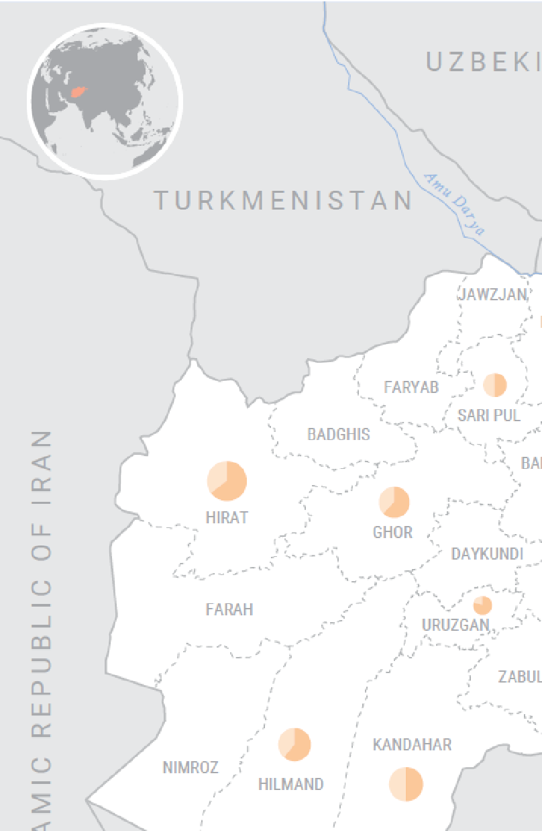
0 Executive Summary  0.5 Summary HRP Key Figures | 0.5 Summary HRP Key Figures  - Compile and present People in Need and people targeted figures by population groups and according to specific vulnerabilities identified in HNO (IDPs, residents, refugees, persons with disabilities, children under five years old etc.) in appropriate visuals.  - Disaggregate People in Need and people targeted figures by sex, age and disability and other vulnerability characteristics, as appropriate.  - Collate and provide a breakdown of funding requirements by sector/AoRs. | 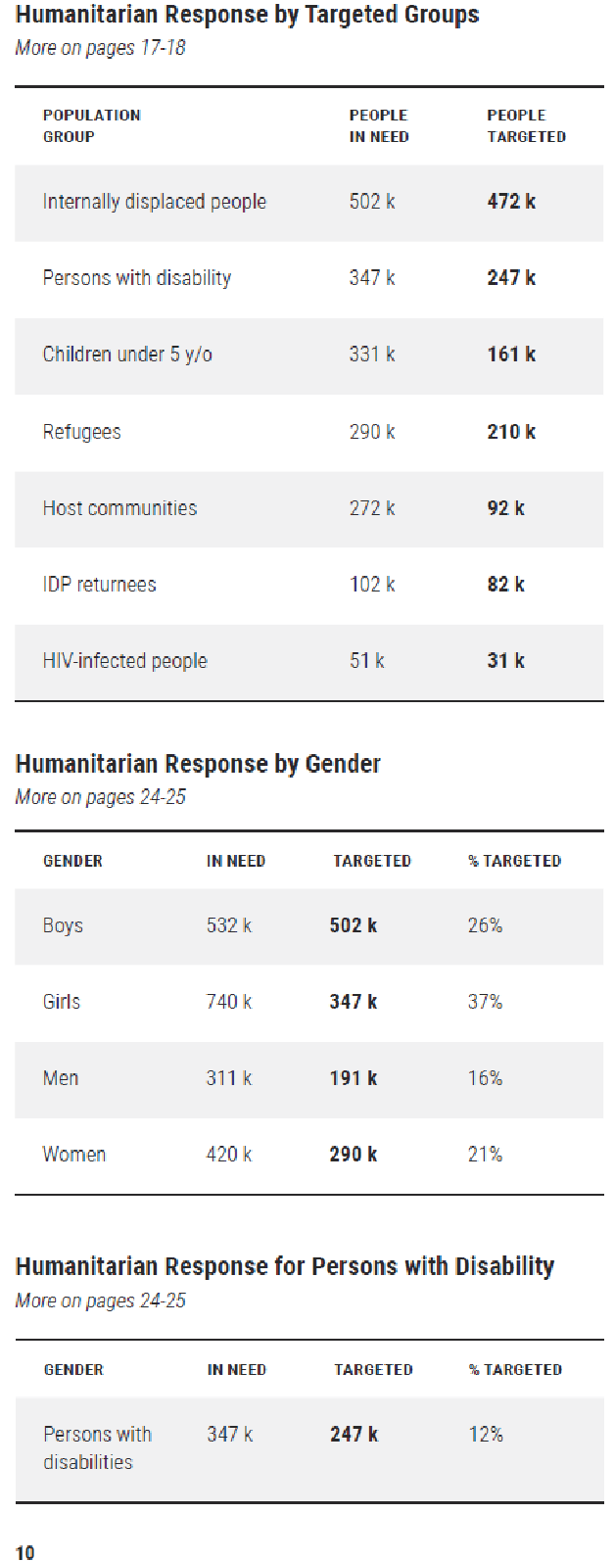
0 Executive Summary  0.6 Summarised Historic Trends | 0.6 Summarised Historic Trends  - Summarise trends of People in Need, people targeted, people reached, funding requirements vs funding received over the last five to ten years (or for years data is available for).  - If possible, show funding trends disaggregated by sector | 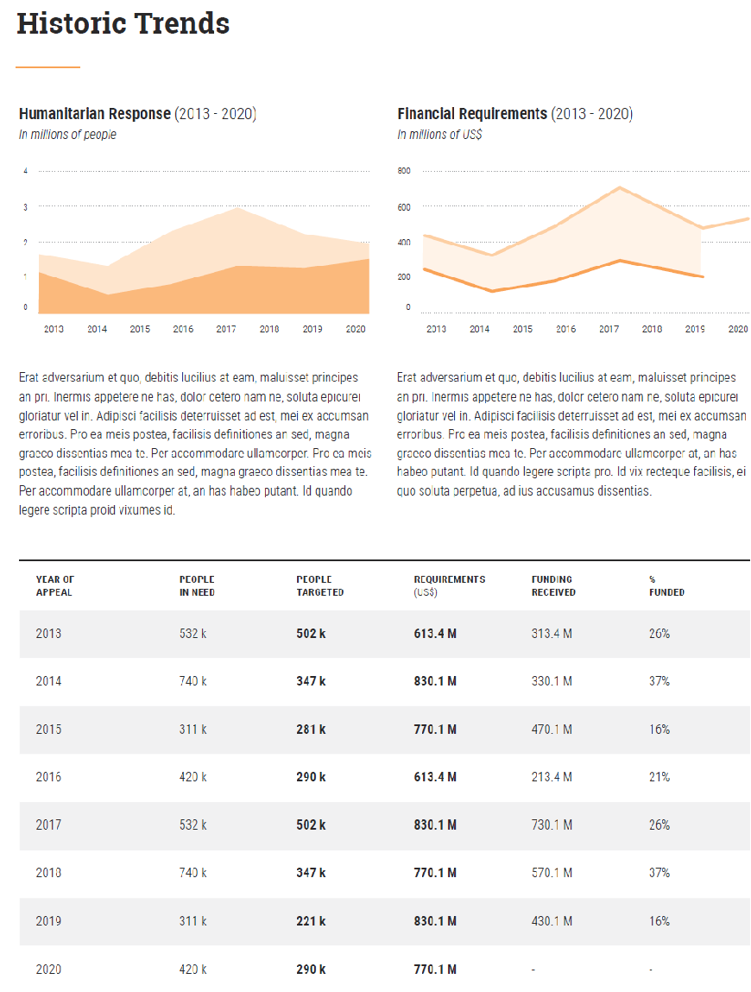
Part 1 Strategic Response Priorities | Part 1 Strategic Response Priorities  Overview  Part 1 describes the HRP scope based on the People in Need identified in the HNO. It indicates the strategic priorities to address these needs. Based on a review (of the various population and sub-population groups and geographic locations and the analysis in the HNO of the severity, magnitude, underlying causes, trends and projections of humanitarian needs, and people’s own priorities, it describes the specific objectives that will enable it to meet the strategic objectives. Please see the Step by Step Guide for a sequence of planning steps. [LINK TO BE ADDED]  The overview section should provide a summary of response priorities including selected strategic objectives while detailed analysis and planning information should be presented as part of the sub-sections, namely 1.1 and 1.2.
Part 1: Strategic Response Priorities  1.1 Humanitarian Conditions Targeted for Response | 1.1 Humanitarian Conditions and Underlying Factors Targeted  for Response  - Determine the scope of the HRP by reviewing the findings of the HNO or monitoring update. The scope of the HRP provides the main focus of the strategic objectives based on the humanitarian needs, population groups and sub-groups, and geographic locations identified in the HNO.  - Justify the strategic priorities of the HRP based on the severity, magnitude, underlying causes, trends and projections and people’s priority needs identified in the HNO.  - Determine which are the most critical protection risks that create or aggravate living standards, coping mechanisms and physical and mental wellbeing  - Severity: which needs are more severe and, if not addressed urgently, jeopardize people’s health and lives or their short-term capacities to survive (e.g. window of opportunity to protect or restore minimum self-sustenance capacity),  - Location of the people according to the type and severity of identified humanitarian needs  - Magnitude: how many people are identified for the various types of needs above.  - Nature of the needs (humanitarian conditions and related humanitarian consequences): based on the physical and well-being consequences, living standards consequences and coping mechanisms contributing to the various humanitarian conditions, examine which needs are related to people’s survival, safety, dignity and sustenance capacities in the short- and medium-term, and which needs are related to people’s ability to strengthen their livelihoods in order to better withstand stresses and shocks and build their resilience.  - Underlying causes indicate immediate, underlying and root causes of the various humanitarian needs, including vulnerabilities and capacities of affected people, communities and institutions (based on the HNO analysis). Causes that are not directly related to the crisis may indicate that the problems are structural and require long-term development responses  - Trends and projections inform expected evolution of humanitarian needs including those needs that may now appear to be less severe but could deteriorate during the timeframe of the response.  - People’s own prioritization of needs reflect affected populations’ priority needs and should inform planning interventions (relevance).  - Note: The effects of COVID-19 should be considered as part of the overall needs in the HNO, and response analysis like any other shocks or stresses affecting populations and geographic locations.  - Complementary guidance on planning steps and considerations can be found here [LINK TO BE ADDED]  Based on these considerations;  - Present response scope including population groups and sub-groups and locations targeted for response  - Present the selected strategic objectives and response approach for the targeted population groups/sub-groups and geographic locations.  - Explain multi-sectoral and inter-sectoral approaches that will be utilized to achieve strategic objectives.  - Summarize the timeframe of the planned response including contingency plans and/or anticipatory action frameworks which are integral parts of the planned response  - Articulate how to advocate for complementary coverage of such populations and needs by other actors such as development and government actors and explain what frameworks or linkages between frameworks, such as collective outcomes, have been put in place in country to ensure that the same populations’ needs, as well as underlying risks and vulnerabilities, are addressed as per the recent IASC light collective outcomes guidance note  - Summarize or visualize complementarity with Red Cross/ Red Crescent plans, development assistance frameworks, and government plans, highlighting the linkages across humanitarian-development-peace collaboration.  - Quantify the number of people targeted for each strategic objective as outlined in the complementary guidance note on target estimation. Ensure to utilize sex and age disaggregated indicators when feasible. [LINK TO BE ADDED].  - Explain adjustments compared to previous or ongoing strategic objectives responses.  - Consider including a text box to highlight the rationale for targeted sub-groups based on the HNO. Specify in each case the dimensions of age and gender (women, men, girls, and boys), disability and other diversity and vulnerability characteristics according to the context, or ‘reaching the furthest left behind’). | Extrapolate from the HNO: Table and short narrative, including PiN, Trend, Age, Gender, Disability, and other diversity characteristics, as appropriate to the context
Part 1: Strategic Response Priorities 1.1 Humanitarian Conditions Targeted for Response | 1.1 Humanitarian Conditions and underlying factors Targeted for Response  Targeted humanitarian conditions, based on the combination of living standards, well-being and coping mechanisms consequences, and causal factors, as well as severity - Use the following outputs from HNO:  - Description of population groups/sub-groups concerned  - Locations  - Nature and severity of humanitarian conditions, based on combination of humanitarian consequences faced by these population groups  - Causes and underlying factors of needs, including overarching protection risks | Extrapolate from the HNO: Table and short narrative, including PiN, Trend, Age, Gender, Disability, and other vulnerability characteristics, as appropriate to the context, and underlying factors, including overarching protection risks  [visual to be updated]  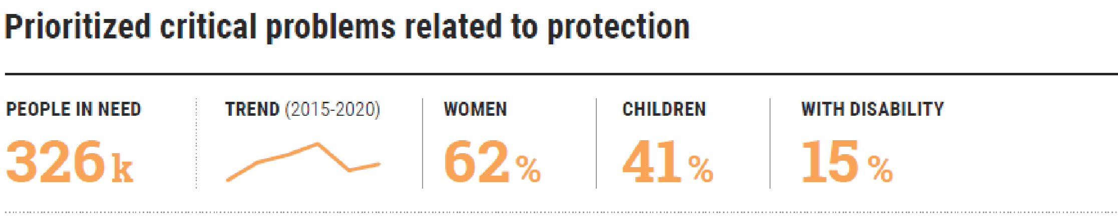
Part 1: Strategic Response Priorities: 1.2 Strategic Objectives, Specific Objectives, and Response Approach | 1.2 Strategic Objectives, Specific Objectives, and Response Approaches  - Formulate 3-4 strategic objectives addressing the humanitarian consequences living standards, coping mechanisms and physical and mental wellbeing, and its underlying factors including overarching protection risks, based on the HRP scoping and HNO analysis. There should be a direct correspondence between the humanitarian conditions including most important needs and the strategic objectives that formulate “solutions” to address these conditions and achieve the desired humanitarian outcomes. Strategic objectives ideally are formulated using an iterative approach with HRP scope providing the initial focus and response analysis informing the articulation of the response.  - Each strategic objective should be ‘SMART’ - specific, measurable, attainable, relevant and time-bound –indicating:  - Who (specifically) and how many are targeted within the population groups and sub-groups;  - Where (specifically) they are located or which geographic areas are targeted;  - What the response intends to achieve to improve the humanitarian outcomes (depending on which factor(s) causing the problem are addressed);  - The timeframe to obtain the intended improvement. Add 'If multi-year plan' to column heading if necessary.  - Where the HRP has a strategic objective related directly to resilience, see UN Common Guidance on Helping Build Resilient Societies. Additional guidance on how to formulate SMART objectives can be found here [link to be added]. Where ‘collective outcomes’ have been agreed upon, see IASC Light Guidance on Collective Outcomes to ensure reference is made in the HRP to these outcomes and other relevant plans in the country, with an explanation of how the HRP strategic objectives contribute to these outcomes.  - Develop e.g. 2-3 specific objectives per strategic objective that will enable the humanitarian community to achieve the strategic objective. Similar to strategic objectives, specific objectives are developed iteratively with the initial strategic objectives providing a starting point and response analysis informing the type and articulation of interventions.  - Determine the coordinated response approach required to deliver results against each Specific Objective by conducting a structured response analysis process considering appropriateness, relevance and feasibility of planned interventions and response modalities. Factors directly causing or aggravating humanitarian conditions and needs should inform discussions on which response activities should be initiated or scaled-up immediately, or adequately resourced at a determined stage later during the implementation period.  - Specific objectives should detail the intermediate results (how many, what and by when) necessary to achieve the overall strategic objectives. Most of them should be inter or multi-sectoral level, but some can also be sectoral.  - Based on response analysis and specific objective discussions, identify the required inter and multi-sectoral and sectoral response approaches to deliver the intended results. This includes integration, layering and combining responses within and across specific objectives.  - Determine the strategic sequencing of interventions including time-critical responses based on needs and response analysis.  - Identify if some response activities can be planned and implemented with, or by development actors over a longer timeframe. This requires a review of existing development plans, such as UNSDCF, national plans, bilateral donors and financial institutions plans etc.  - If collective outcomes have been formulated, explain possible linkages with collective outcomes as part of the humanitarian-development, and, where appropriate, peace nexus by responding to the following questions (1) are any of the strategic objectives contributing to longer-term outcomes as agreed with development and peace actors? And (2) are there responses that were identified as falling under the remit of development or peace actors which need to be ensured by these actors in order for the shared objective / collective outcome to be achieved??  - Explain how the centrality of protection is reflected in the priorities and throughout the HRP. Use the four pillars of protection mainstreaming (1- prioritise safety and dignity and avoiding causing harm, 2- meaningful access,3- accountability and 4- participation and empowerment) to inform analysis of protection concerns and how these impact response planning.  - Note how protection mainstreaming contributed to project/activity development enhancing quality programming and compliance with “do no harm” principle.  - Refer to the IASC Policy on Protection in Humanitarian Action and the Global Protection Cluster Brief on Protection Mainstreaming  - Ensure that the Strategic and Specific Objectives are aligned with the HCT Protection Strategy. See IASC Protection Policy and GPC Provisional Guidance Note on HCT Protection Strategies. In addition, see additional guidance on protection and COVID-19.  Based on the above considerations;  - Present each strategic objective including associated targets and rationale and disaggregate targets by population group, sub-group, location, sex, age and disability and other diversity characteristics.  - Explain how the strategic objectives are built around a people-centered approach and contribute to enhance their protection.  - Present each specific objective including associated and disaggregated targets by population group, sub-group, location, sex, age, and disability and other diversity characteristics.  - Describe the coordinated response approach per specific objective including how inter and multi-sectoral as well as sectoral approaches and response modalities will be used. Note if interventions will be integrated, sequenced or layered.  - Highlight time-critical interventions which should be implemented first.  - Estimate people targeted numbers for strategic and specific objectives based on complementary guidance on estimating target figures [link to be added]  - Summarize the links between the HRP and UNSDCF to explain complementarity, the sequencing of humanitarian and development activities, and the compatibility of results frameworks."  - Document detailed response analysis and decision-making flow in HRP annex 5.1. | 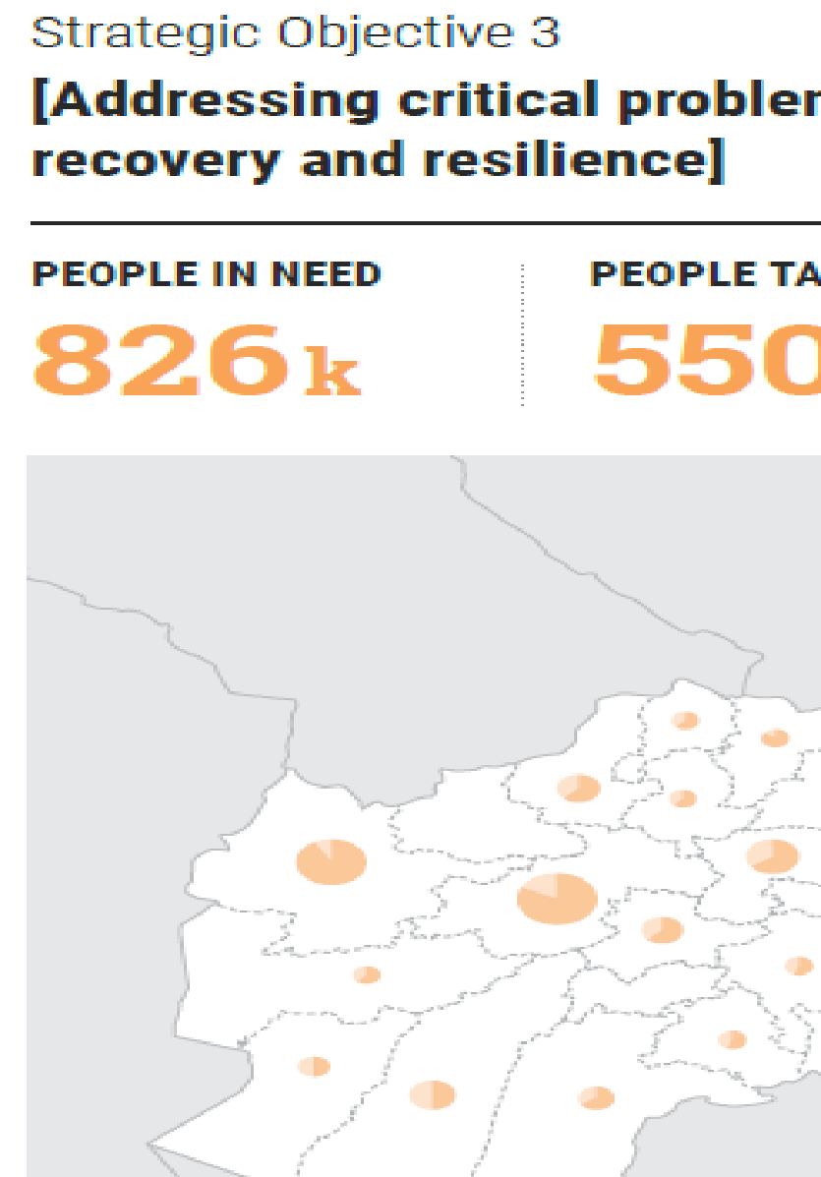  [visual to be updated]  Strategic objectives addressing humanitarian conditions, plus sub-headings:  - Rationale and intended outcome,  - Specific objective and coordinated response approach  Specific Objectives Table outlining targeted groups and target figures  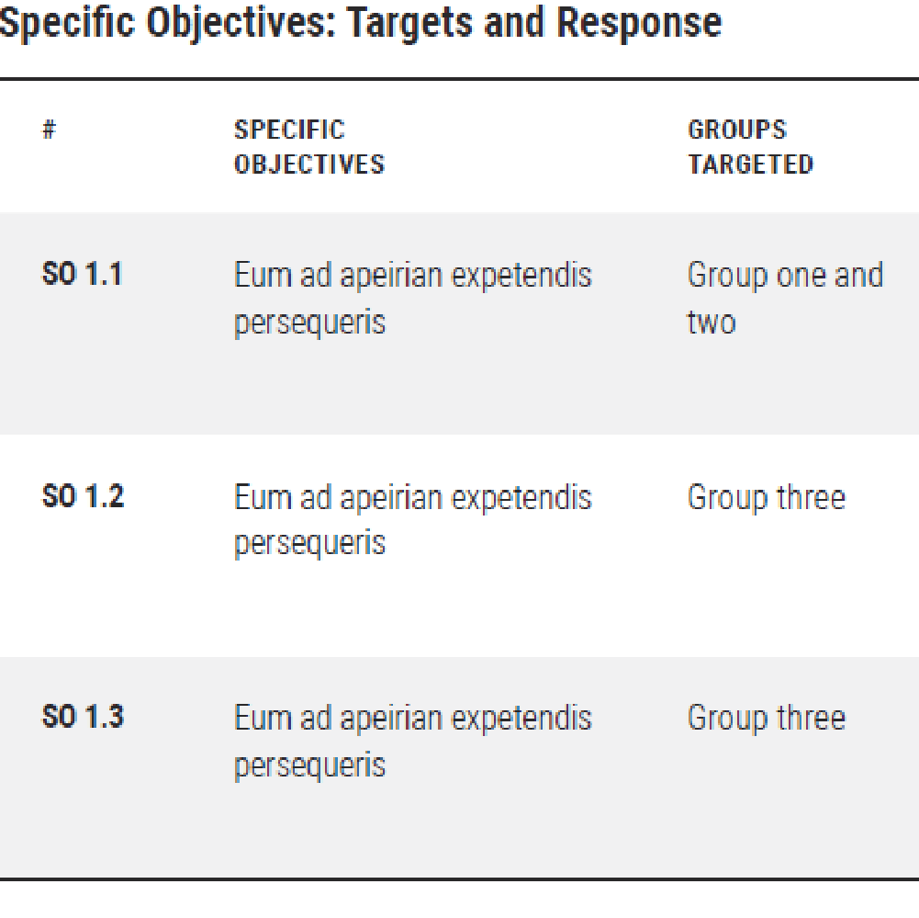
Part 1: Strategic Response Priorities – 1.3 Optional: Use of Multi-Purpose Cash | 1.3 Consolidated Overview:  Use of Multi-Purpose Cash  (optional)  - Consider appropriateness, feasibility and relevance of multi-purpose cash as a response option as part of the overall response analysis detailed in annex 5.1 (see additional guidance on appropriateness and feasibility here and highlight in particular preferences of affected populations where relevant. If MPC is deemed not appropriate or feasible, provide a brief explanation in annex 5.1  - Determine how the use of multi-purpose cash will be coordinated and will contribute to inter- and multi-sectoral and sectoral response approaches and modalities.  - Consider how planned MPC and social protection assistance complements each other  Based on above considerations as part of the response analysis document:  - Reflect considerations on appropriateness, relevance feasibility during the implementation timeframe of the HRP;  - How the use of multi-purpose cash is coordinated and might interface with other sectorally or multi-sectorally coordinated modalities;  - If applicable, add a section that presents the use of multi-purpose cash approaches across all Strategic objectives.  - Applicable standards and calculations (including calculation of Minimum Expenditure Basket)  - Consolidated financial requirements disaggregated by Multi-purpose cash portion (I.e. X % of total requirements is MPC) and targeting strategy/population.  - Indicate key partners involved in coordinated use of multi-purpose cash | 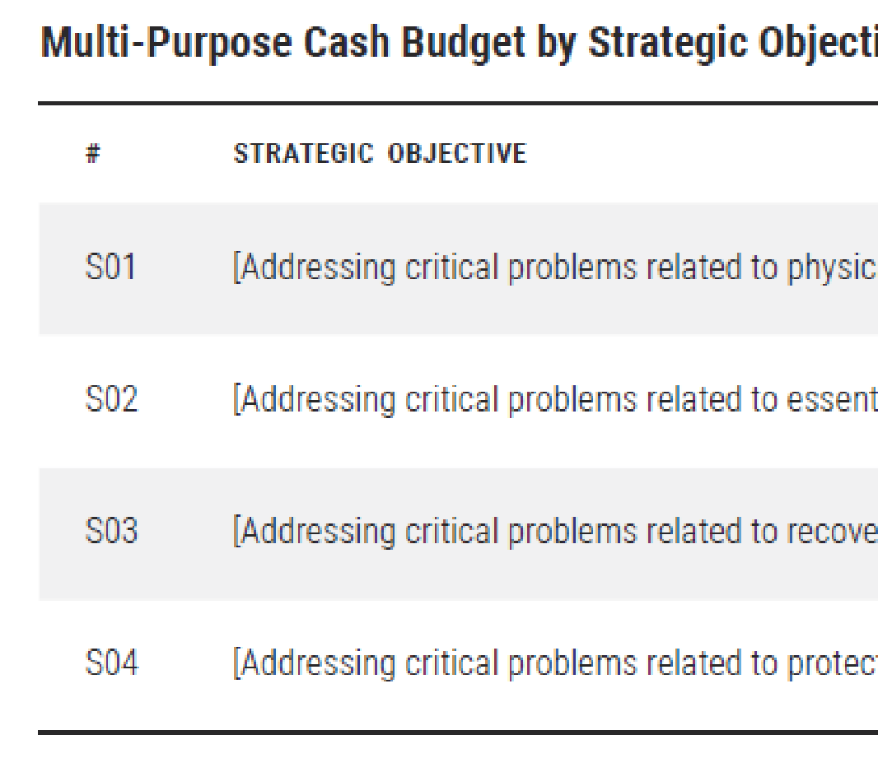
Part 1: Strategic Response Priorities 1.4 Costing Methodology | 1.4 Costing Methodology  This section should provide a comprehensive overview on costing methodology used by the response as well as cost drivers.  - Explain what costing methodology was used to cost the response,  - Summarize the reasoning and metrics behind cost estimations, whether based on activities, projects, or both, to explain increases or decreases from one planning cycle to the next. This should include features of the operating environment, targeted populations, response modalities, logistics and etc.  - As feasible, estimate the costs of sector/cluster/ stakeholder contributions to each SO, to quantify expected costs by Strategic Objective.  - Where feasible and appropriate, consider cost efficiency measures (e.g. cost of cash transfers) and compare it across modalities.  - Further information and guidance on costing is available here :  https://assessments.hpc.tools/sites/default/files/km/hrp_costing_methodology_options.pdf  - For unit-based costing in particular, at a minimum the following should be documented:  - Estimates of the unit cost of serving individuals by sector, broken down by the specific activities that may be provided. Unit costs should include weighting for different contexts to estimate the effect of contextual factors, contingencies and risks. For instance, a cost per person for WASH services would be broken down into separate estimates of the cost per person for clean water delivery, latrine provision, and hygiene promotion.  - A clear framework for combining figures from needs assessments and targeting criteria with projected unit costs to come up with a total budget envelope by sector.  - Guidance on how to adjust unit cost estimates based on anticipated risks in that response (e.g. security concerns, political risk, exchange rate risk).  - Explain/list criteria used for project vetting and/or activity inclusion/exclusion. See project selection criteria that may be adjusted to activity selection: https://docs.google.com/document/d/1Rn9eiWUQ68e0--K4ZEdaE0zqdp8pIXGvMItTebBb8xs/edit?usp=sharing
Part 1: Strategic Response Priorities 1.5 Planning Assumptions, Operational Capacity and Access | 1.5 Planning Assumptions, Operational Capacity and Access  - Analyse operational considerations that can affect the delivery of the response, particularly access issues and the operational response capacity as they affect collective response. Access impediments include bureaucratic restrictions on humanitarian personnel and supplies, denial of the existence of humanitarian needs, impediments related to seasonal factors, climate, terrain or lack of infrastructure, aid diversion and interference in the delivery of humanitarian activities, military operations, as well as attacks on humanitarian goods, facilities and personnel.  - Provide a shared analysis of humanitarian access constraints and how it might affect the implementation of planned activities. Include ways to communicate with communities and participation on constraints and capacities.  - Consider the availability and capacities of local implementing partners and of government (national and sub-national levels) and how they will contribute to or complement the planned response.  - Reflect on capacity of non-traditional actors, such as the private sector and whether they could contribute to the planned response.  - Determine planning assumptions and mitigation measures to identified operational capacity and humanitarian access issues.  Based on the above considerations, present the following;  - As much as possible, provide a breakdown of the number of organizations participating in the HRP including.  - provide a breakdown of international responders (e.g. UN, INGOs, International Red Cross/Red Crescent Movement, IFIs, etc.).  - Summarize planning assumptions for the response (where relevant, note how humanitarian access, humanitarian need and other considerations have informed planning assumptions and strategic considerations.)  - Indicate mitigation plans to address the identified operational and access issues.  - Summarize the primary changes likely to have increased or decreased the humanitarian challenges compared to the previous planning season.  - Recap primary achievements and lessons learned from the previous response, and how these influence the planned response | 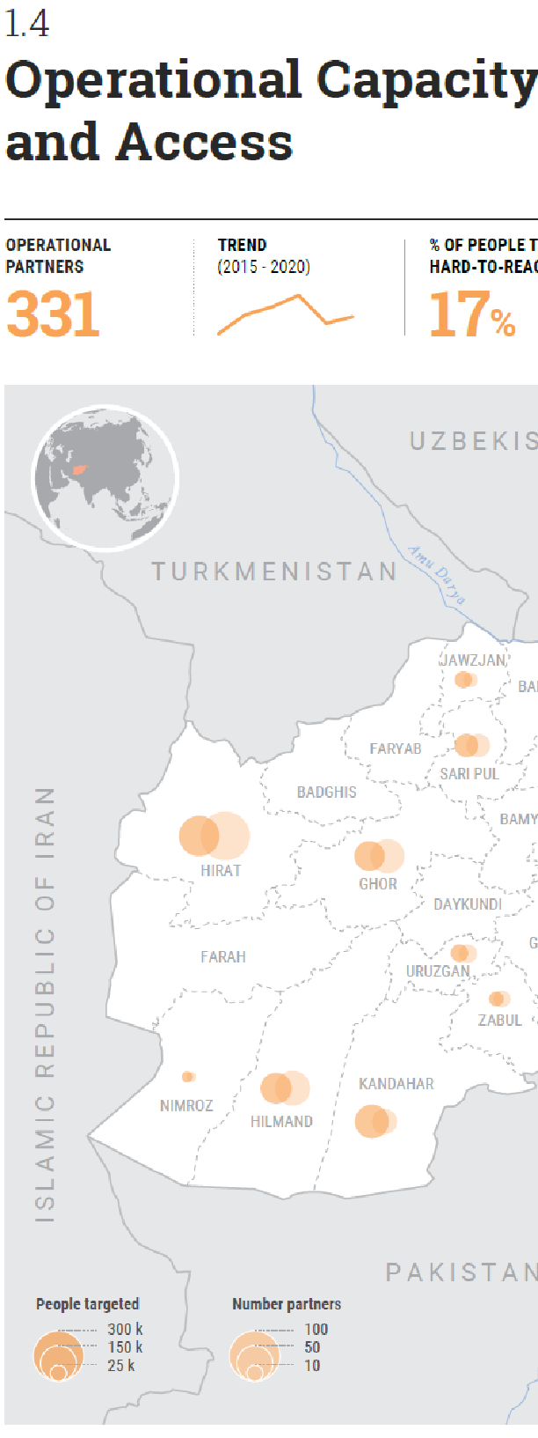  Plus tables: partners by sector, partners by type, response reach under previous HRP;
Part 1.6:  Accountability to Affected Populations | 1.6 Accountability to Affected Populations  This section describes the HCT Collective Accountability to Affected Populations (AAP) Framework, which is defined as a response-wide system to support listening to, and acting upon the voices of people, including for sexual exploitation and abuse (SEA) throughout the Humanitarian Program Cycle (HPC):  - Determine how affected people, including those with different gender, age, disability and other diversity characteristics were consulted during the planning process, and how continued engagement with them will be coordinated, and continue throughout implementation, monitoring and evaluation based on their specific needs to ensure full acceptability and accessibility to the AAP mechanism.  - Consider how community information sharing and their complaints and feedback, including from the most vulnerable, will be coordinated and used for potential course corrections in the response (include reference to an inter-agency referral system for handling sensitive complaints, including on SEA if existent)  - Examine how the response operation can meet expectations of the SG Bulletin, and IASC Protection from Sexual Exploitation and Abuse (PSEA) Strategy, including (if there is) a common code of conduct in place, harmonized PSEA awareness campaigns on the conduct expected of humanitarian workers and people’s rights to free assistance, establishment of an inter-agency community-based complaints mechanism, and ensuring victim assistance referral pathways are in place. Additional guidance on PSEA in humanitarian response planning can be found here.  Based on the above considerations, present the following;  - Summarize information on how affected populations were consulted as part of the planning process and how engagement with affected populations will continue/evolve during the implementation, monitoring and evaluation of the response.  - Present how various vulnerability characteristics such as gender, age, and disability were considered for response.  - Articulate how community feedback mechanisms have been used to inform the response as well as future adjustments that could be made through the course of the timeframe of the response  - Express plans to meet expectations of the SG Bulletin and IASC PSEA strategy including mechanisms already in place  - Refer to any HCT policies and plans on AAP and PSEA as appropriate.  Please see additional guidance on AAP in the HPC and AAP in COVID contexts. | Present key information in infographics on community perceptions including;  - Satisfaction levels  - Community engagement channels  - Community/HH priority needs as expressed by populations  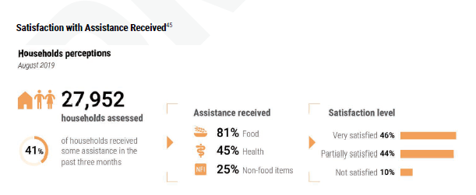
Part 2 Response Monitoring  2.1 Monitoring Approach | Response Monitoring  2.1. Monitoring Approach  This part presents a coordinated approach to response monitoring and identifies which data, indicators and other information must be monitored in order to assess progress against strategic objectives, particularly their respective specific objectives, and results in terms of improvement of humanitarian consequences).  - Determine the requirements of a monitoring framework based on consultations between the Inter-Cluster Coordination Group and Information Management Working Group.  - Develop a monitoring framework, with indicators and targets attached at different levels, i.e. Strategic objectives, Specific objectives, Cluster Objectives, Cluster Activities. Ensure that the monitoring framework allows for collection of sex and age disaggregated data.  - Seek agreement on roles and responsibilities to report at different levels.  - Identify outcome level and SMART indicators level in order to assess progress and achievement of results against the specific objectives associated with each strategic objective, and desired changes in the humanitarian condition.  Based on the above considerations, present the following;  - Present and explain the agreed upon monitoring framework, with indicators and targets attached at different levels, i.e. Strategic objectives, Specific objectives, Cluster Objectives, Cluster Activities.  - Explain how monitoring responsibilities are shared between actors and clusters.  - Explain how the measured progress and achievements will be communicated and shared with decision makers (partners, donors, government) and feedback to people of concern, media and the general public. This may be a combination of the following:  - real-time data available online in Humanitarian Insight.  - summarized data presented graphically in a Humanitarian Dashboard;  - More detailed data and analysis presented in a Periodic Monitoring Report;  - achievements and analysis in a Year-End Report.  - Present a timeline detailing the schedule of monitoring products planned for release at given moments.  - Present information on source, frequency and reporting responsibilities | 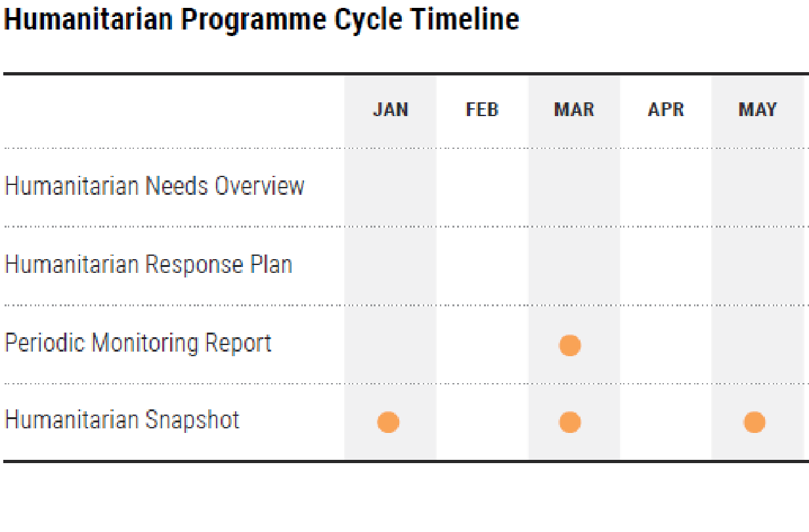  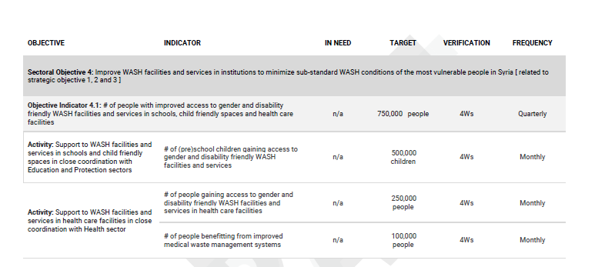
Part 2: Response Monitoring  2.2 Indicators and Targets | 2.2 Indicators and targets  Part 2.2 presents the monitoring framework for the strategic objectives and specific objectives.  - Develop ‘SMART’ (specific, measurable, attainable, relevant and time-bound) indicators to assess progress of each specific objective,  - Compile for each indicator the following parameters;  - indicator label, need, target, source, frequency, entity in charge, disaggregation, resources required  - Disaggregate indicators against relevant dimensions such as sex, age, disability and other vulnerability characteristics,  - Use the Response Planning Module to type the monitoring framework, then extract and copy into the HRP.  Based on the above considerations;  - Present relevant indicators under each objective, with their main parameters (indicator label, need, target, source, frequency, entity in charge, disaggregation, resources required). Use the landscape format for ease of presentation.  - Describe whether indicators will be disaggregated against relevant dimensions including gender, age, disability and other diversity characteristics.  - Linking to Part 1.4, highlight perception related indicators on how affected populations feel the response is progressing, meeting their priorities, and community engagement modalities.  - Use the Indicators’ Registry to harmonize the definition and construction of the indicators.  - Optionally present an annex gathering these indicators together with the cluster objectives indicators and targets, to make it the full country monitoring framework. | 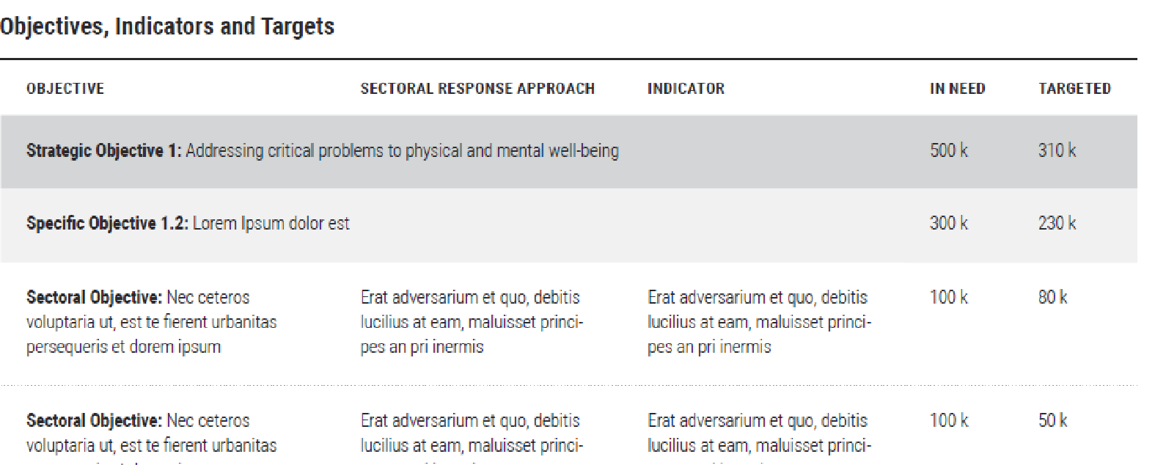
Part 3: Sectoral Objectives and Response | Part 3: Cluster/Sector Objectives  and Response  Part 3 gives complementary information on sectoral responses, indicating how these contribute to the collective response to achieve the strategic and underpinning specific objectives as well as the role played by each sector.
Part 3: Sectoral Objectives and Response –  CCCM, Early Recovery, Education, Emergency Telecommunications, Food Security, Health, Logistics, Nutrition, Protection, Shelter, WASH | 3.1 Cluster/Sector Chapters (1/2)  Note: clusters and sectors are used interchangeably.  - Based on findings of sectoral and inter-sectoral needs analysis, develop and present sectoral objectives that are linked, as  appropriate, to relevant specific objectives associated with strategic objectives and consistent with the targeted population groups/sub-groups, geographic locations, cross-cutting issues and themes (such as gender, disability and their impacts on sector services and context) and intended achievement of humanitarian outcomes.  - Clarify if the sector/cluster response will be integrated, layered or sequenced within a multi-sectoral response.  - Present key information such as PiN, people targeted, financial requirements, target vs PiN map as infographics.  - If the cluster also consists of Protection Areas of Responsibilities or sub clusters, specify what they are and their specific contribution and outputs. When relevant, they should also be presented with the same outline as cluster response plans.  - Indicate the number of targeted people, and targeted sub-groups, where relevant, with attention to age, gender and disability at a minimum.  - Explain which response modalities (CVA, in-kind or services) will be used to deliver the planned programmes and why they were selected.  - Response modalities are informed by the agreed upon strategic objectives and coordinated response approach (Part II). They should consider context, vulnerabilities and affected population preference, each sector should systematically consider the possibility of using service delivery, in-kind, cash and voucher in a complementary way for both multisector or sector specific programming  - Refer to key evidence collected and used to inform the determination of the feasibility of different response options  - State the percentage of the response delivered by  the respective modalities.  - Explain concrete people-centered approaches that are aligned to the overarching HCT Collective AAP Framework (the response-wide system to support listening to, and acting upon the voices of people, throughout the HPC). | 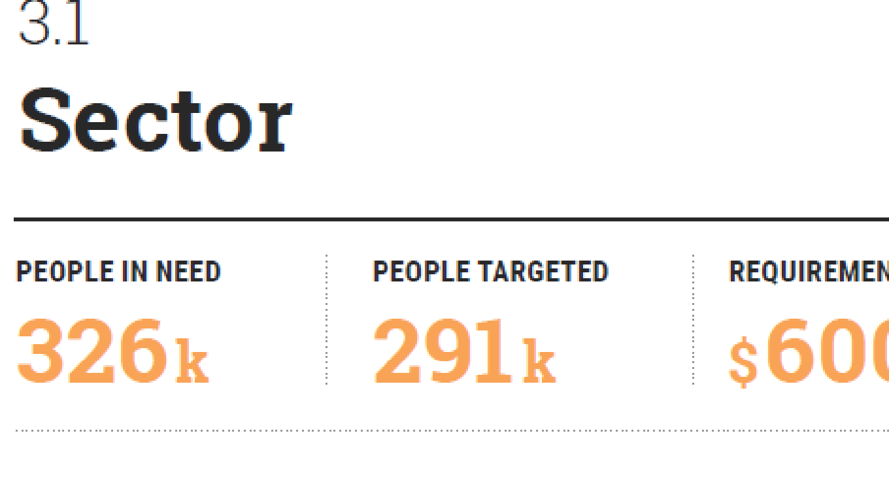  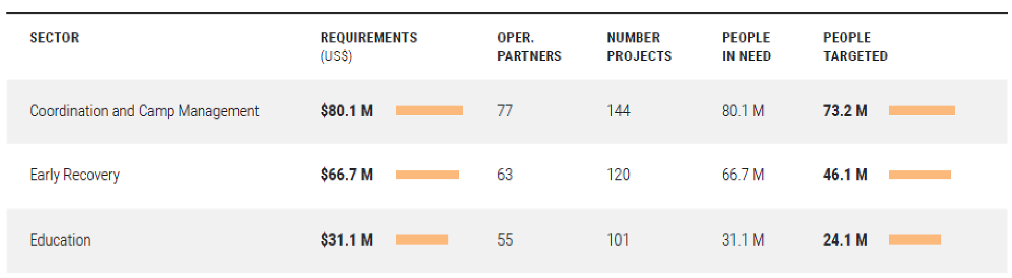  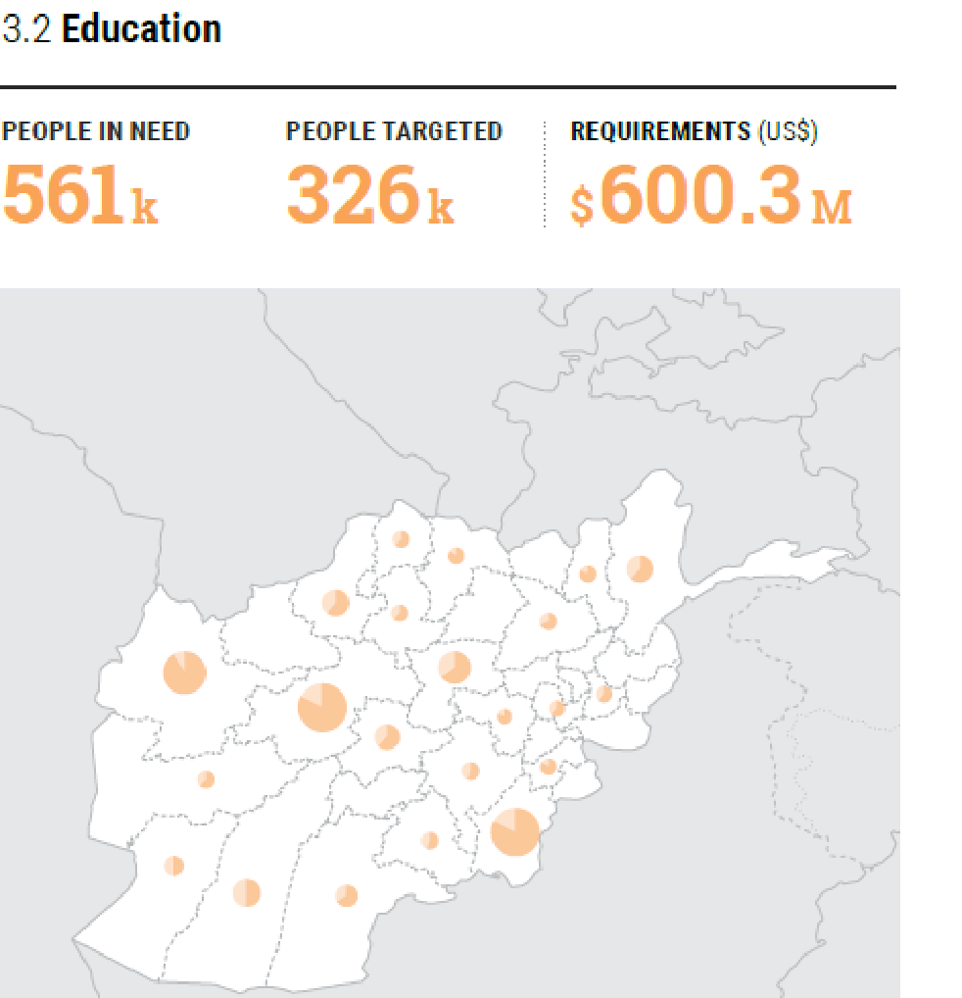
 | 3.1. Cluster/Sector Chapters (2/2)  - Where collective outcomes have been agreed, please indicate how the cluster/sectoral response will contribute to any of the outcomes  - For projectized appeals, summarize vetting criteria used for projects included in the plan. See vetting criteria examples here. | 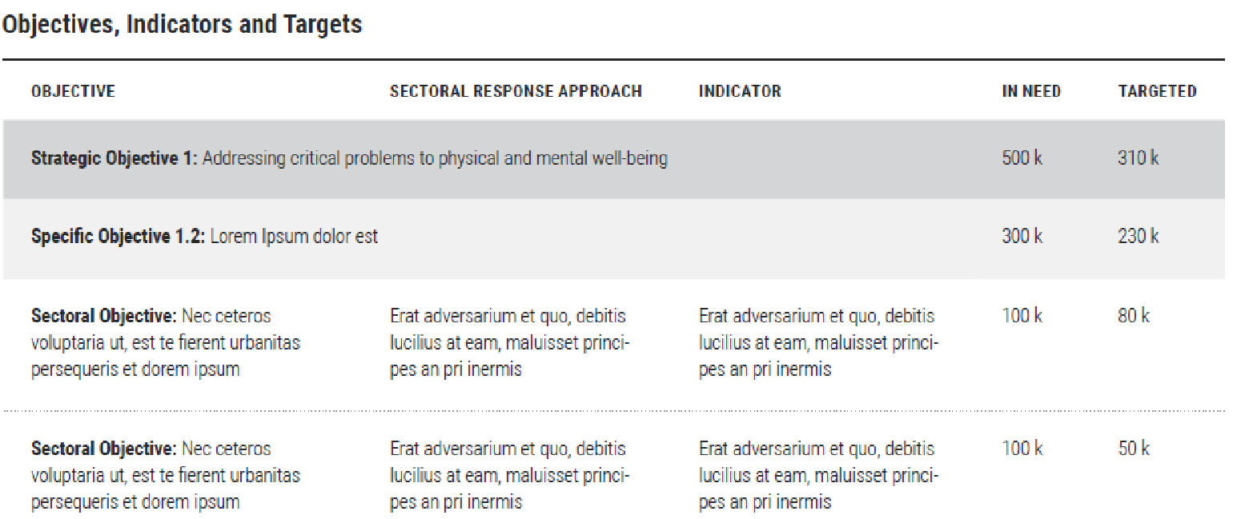  Sub-headers:  - Objective
Part 3: Sectoral Objectives and Response – Protection | - Protection (sample chapter)  Expand analysis to each Area of Responsibility that is active in the country. Add standard breakdowns for each of the AORs in next pages (minimum half a page per AoR).  Instructions for Response Planning Module specific to Protection sector and AoRs: For each HRP, one field cluster/coordination entity to be defined in RPM called “Protection”. All activities or indicators will be defined within one framework under that coordination entity.  This single field cluster will be associated in RPM with multiple ‘global sectors’, as relevant and appropriate for that plan (with the following exact labels). These sectors/sub-sectors are used for reporting purposes only, not for coordination.  o Protection  o Protection – Child Protection AoR  o Protection – GBV AoR  o Protection – MA AoR  o Protection – HLP AoR  Instructions for Project Module specific to Protection sector and AoRs (applicable only to project based plans):  In the Project Module, project owners should submit their projects to a single field cluster. The financial requirements for each project will be divided in percentages adding up to 100% across the sectors/sub-sectors mentioned above. For subsequent reporting, projects can be filtered or grouped by ‘field cluster’ which will show all projects together, or by ‘global sector’ which will show each separately. | 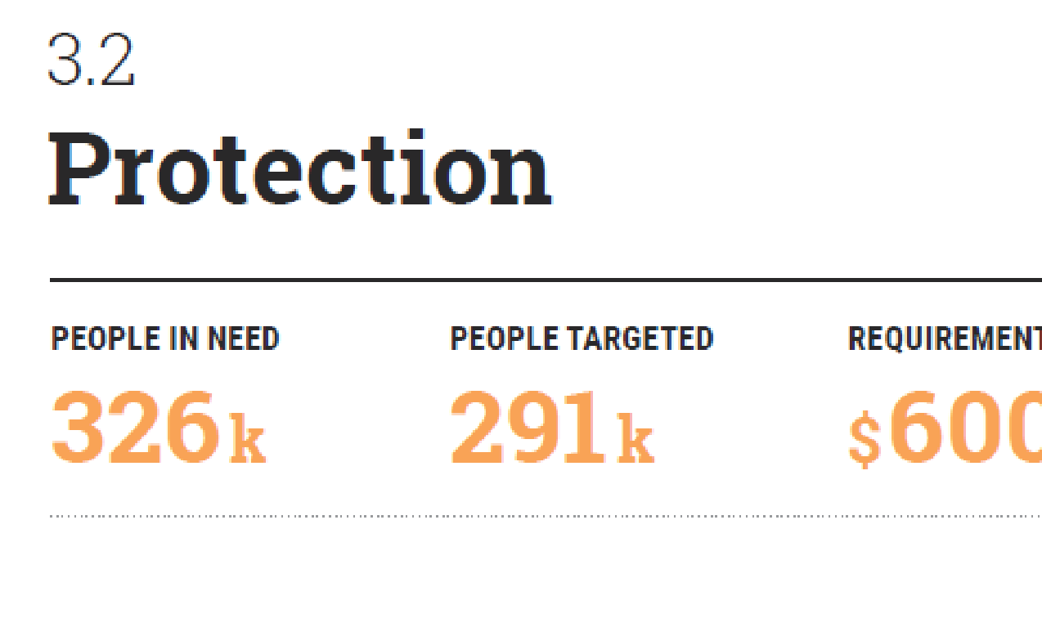  Protection sub-headers:  - objectives  - monitoring  AoRs:  - Child Protection  - Mine Action  - Gender-Based Violence  - Housing, Land, Property  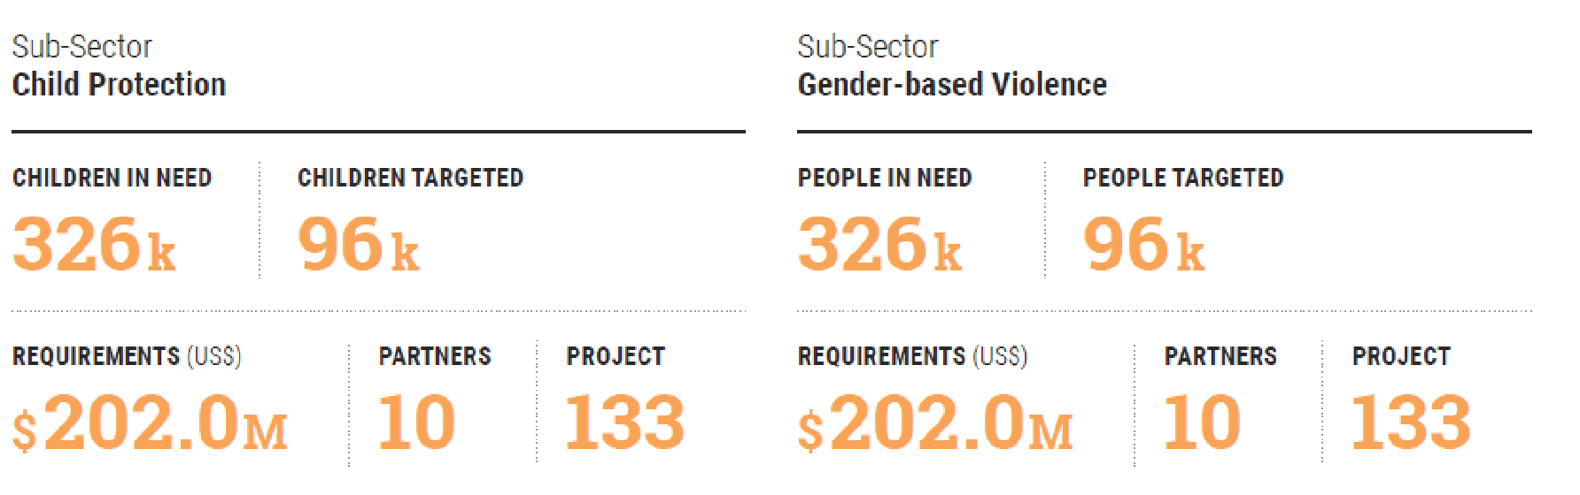  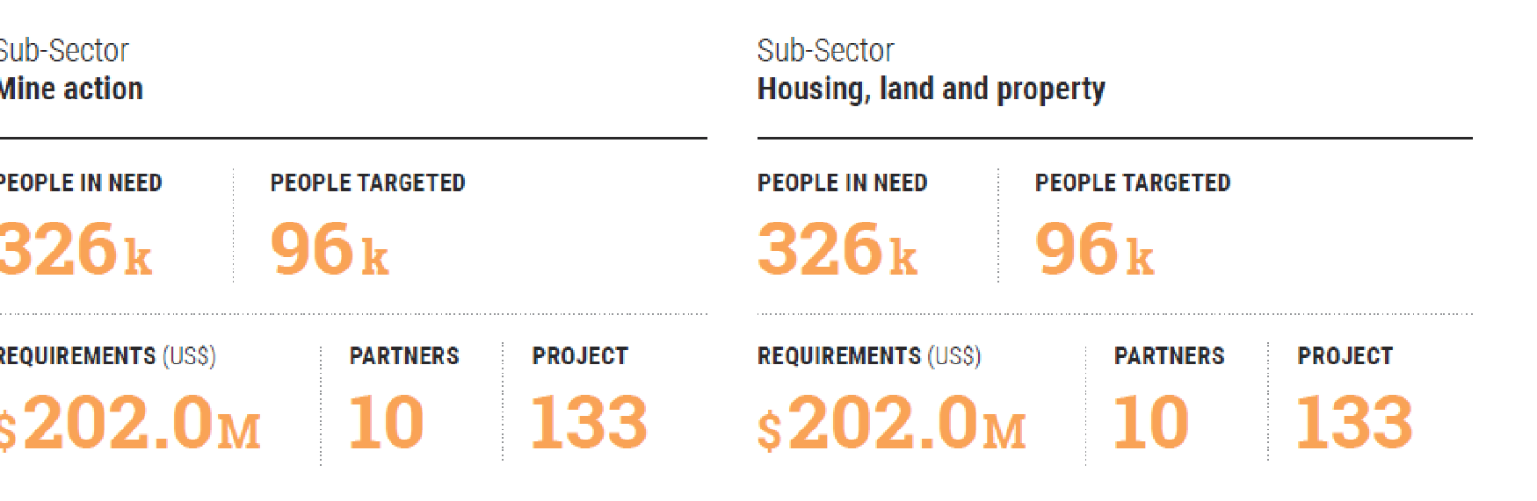
Part 4: Refugee Response Plan | Present sectoral objectives that are linked, as appropriate, to relevant specific objectives associated with strategic objectives and consistent with the targeted population groups/sub-groups, geographic locations, and intended achievement of humanitarian outcomes.  - For countries that have developed a Country RRP or that are covered under a Regional RRP, ensure alignment of this chapter with these Plans (strategy and objectives, people targeted and requirements).  - Present key information such as people targeted, financial requirements. with attention to age, gender and disability disaggregated data where possible. Explain which response modalities will be used to deliver the planned programmes. Response modalities are informed by the agreed upon strategic objectives and coordinated response approach (Part II). They should consider context, vulnerabilities and affected population preference, each sector should systematically consider the possibility of using service delivery, in-kind, cash and voucher in a complementary way for both multisector and sector specific programming  - Refer to key evidence collected and used to inform the determination of the feasibility of different response options. State the percentage of the response delivered by the respective modalities.  - Explain concrete people-centered approaches that are aligned to the overarching HCT Collective AAP Framework (the response-wide system to support listening to, and acting upon the voices of people, throughout the HPC).  - Estimate the cost of the response.  - If applicable, the unit-based costing of the refugee response within an HRP will be developed separately by UNHCR and refugee response partners.  - Where feasible and appropriate, consider cost efficiency measures (e.g. cost of cash transfers) and compare it across modalities. Cost effectiveness should be included, if possible, at monitoring level.  - Present method used to estimate sector/cluster costs in a transparent, and understandable way (e.g. using activity-based or project-based costing). Provide a short description of the predominant cost drivers—i.e. the particular features of the operating environment, target population, needs, or appropriate response modalities which will drive the average cost of providing services higher or lower. This is an essential element of the budgeting process, making it possible to understand different price tags per activity and link them to operational realities. Include costing of assessment, monitoring and evaluation activities at sector level, as appropriate  - Summarize vetting criteria used for projects/activities included in the plan. | Suggested sub-headers:  - Objectives  - Response  - Cost of response  - Monitoring
Part 5: Annexes | Part 5: Annexes  - The Annexes provide additional and transparent information on the prioritization process followed to decide on target population groups/sub-groups and numbers targeted (versus estimated numbers in need), geographic locations, humanitarian conditions and needs to address, and response approach and modalities,
Part 5: Annexes – 5.1 Response Analysis | 5.1 Response Analysis  Response analysis is a joint inter-sectoral process that facilitates the identification of appropriate, relevant and feasible interventions and modalities to respond to the humanitarian needs of population and sub-population groups, as identified in the Humanitarian Needs Overview. It consists of formally reviewing the range of interventions possible to address identified needs and their causes for the various population groups and locations to select those that will meet these needs most effectively and efficiently. More details are available in the response analysis complementary guidance available here (link to be added)  This annex provides a comprehensive overview of response analysis outputs in detail while Part 1 documents some of the most important outputs of response analysis and the optional “Multi-purpose cash” chapter presents the use of MPC as a modality to meet basic needs. The following should be documented in this annex:  - Explain the response analysis framework used to inform joint response analysis and decision-making processes.  - Clarify which factors/causes of the humanitarian conditions were targeted for the response and why (e.g. to address the immediate causes rapidly, to contribute to the sustainability of results by linking up with other interventions including development etc.).  - Summarize targeting approach used  - Explain appropriateness, relevance and feasibility of proposed response approaches and modalities and why these were chosen.  - Refer to market feasibility, people’s own priorities and how the proposed interventions relate to priority needs identified.  - Indicate gaps and limitations in the response analysis and plans to overcome them, including when and by whom.
Part 5: Annexes – 5.2 Participating Organizations | - 5.2 List participating organizations along with type and number of people targeted and funding requirements | 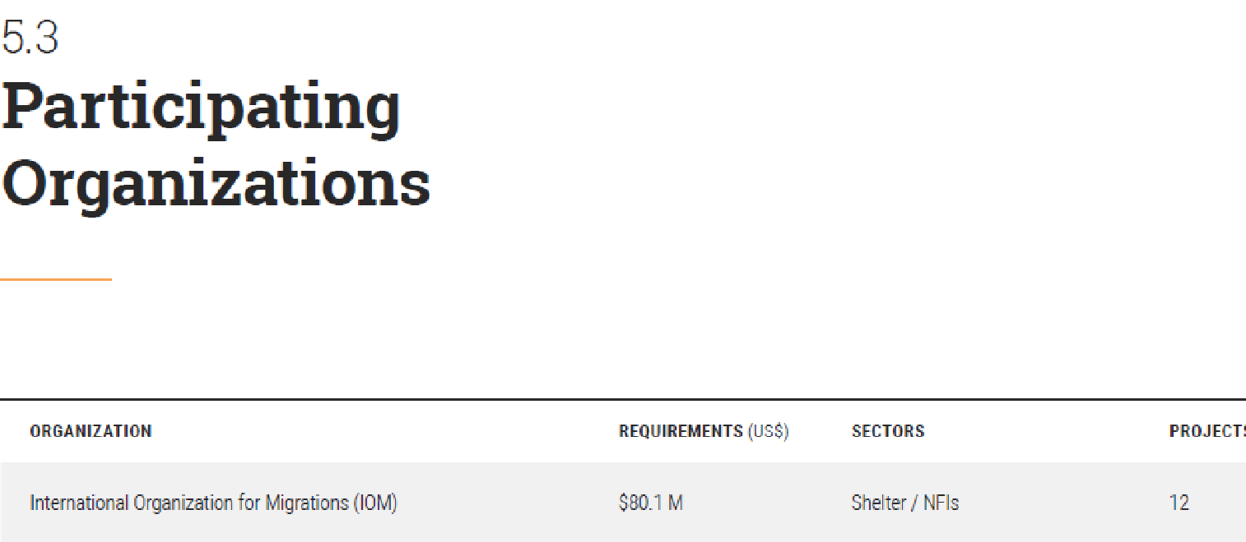
Part 5: Annexes – 5.3 Planning Figures by Sector and by Geography | 5.3 Planning Figures  - Share an Excel version of the planning figures for people in need and targeted by sector on HDX and provide the link under the table.  - Present planning figures by relevant admin level to the context, as appropriate (Governorate/District) | 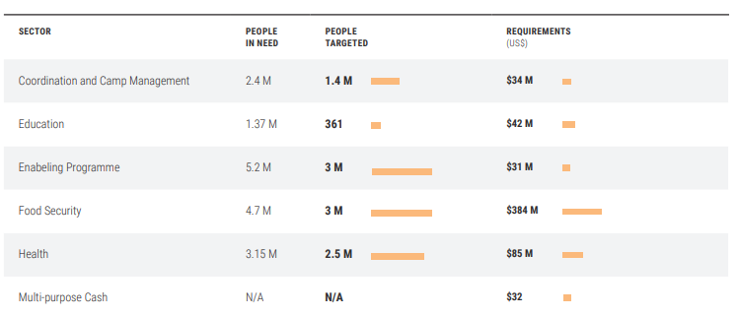
Part 5: Annexes –5.4 Results/Monitoring Framework (Optional) | 5.4 Results/Monitoring Framework (Optional)  - Present the complete monitoring framework as a single table including Strategic Objectives, Specific Objectives and associated indicators as well as sector monitoring frameworks. . | 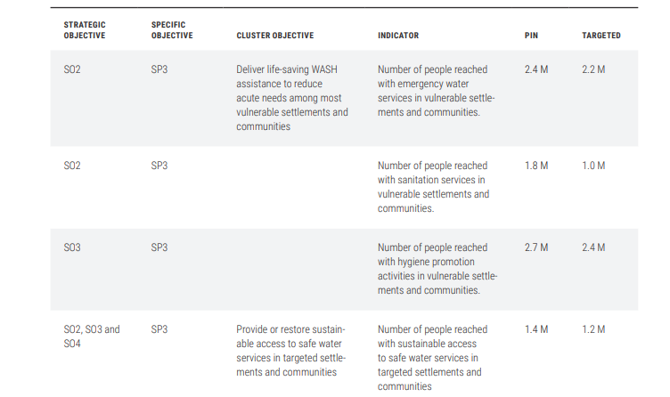
Part 5: Annexes – 5.5 What if we fail to respond? | 5.5. What if We Fail to Respond?  - Reflect the impact in terms of lack of achievement of the prioritised humanitarian outcomes, given that eventually these are the ones that reflect the hardship for people’s lives and livelihoods.  - Where relevant, note how a failure to respond will impact differently on specific sub-groups, including the most vulnerable. PSEA stressing that SEA represents a serious breach of accountability and a grave failure of the mandate to protect and assist the most vulnerable persons. | Suggested sub-headers per humanitarian condition
Part 5: Annexes – how to contribute |  | Suggested sub-headers: Contribute to the HRP, Contribute through the CERF, Contribute through country-based fund
Part 5: Annexes – acronyms |  | List
Part 5: Annexes – end notes |  | List

