GNC ADMIN GUIDE
Disclaimer: These are the guidelines regarding Admin features for GNC Website.

Access 2
How to edit and clone any content 2
Job 3
How to create job 3
Resources 4
How to upload new resources 4
How to edit resource 5
News 6
How to create News 6
How to edit News 7
Events 7
How to create Event 7
How to edit Event 9
Youtube 10
How to upload the video to Youtube 10
Download Pictures 12
Scheduling a Webinar with registration in the zoom 12
Add/Change Your Zoom Profile Picture 14

Access
To get the access to Admin panel, the user has to log in with admin credentials on the admin page.

There are Links to admin log-in page:
GNC: https://www.nutritioncluster.net/gnc_login

After you log in, you can change the password by click “Edit”, after that change the password, contact number and timezone.

IMPORTANT:
Saving Edits - Almost every change has to be confirmed after editing by clicking on the “Save” button displayed on the bottom of related edit page in the Admin panel.

How to edit and clone any content
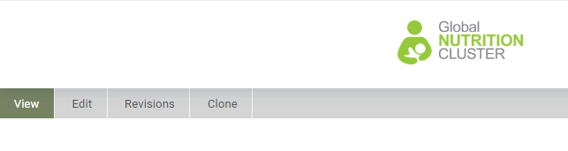

- You can edit any content (Jobs, Resource, Events and News ) just by find the content you want to edit 🡪 open 🡪 click Edit.
- You can Clone(Copy) any content (Jobs, Resource, Events and News ) just by find the content you want to clone 🡪 open 🡪 click Clone.

Job

How to create job
(See the video: https://youtu.be/Ig2QgJJfPj4)

Examples
- https://www.nutritioncluster.net/jobs_IMO_Country_Org

Jobs Title - The title of jobs that is displayed on the website
Is this job is External?
- External: if the job post on other websites (you have the link)
- Internal: if the job did not post in any other websites (You don’t have a link)
Location: Enter the job location.
Organization Name: Add the name of the organization
Deadline: Enter job date deadline after this date will disappear from GNC website

Note: if you select external no need to fill the below fields.
Body – brief about the document
if you copy from MS word or any app and you paste, follow steps below
- Select all text in the body (Ctrl + A)
- Click remove format to be same as GNC style guide.
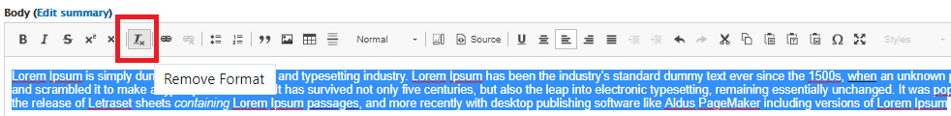

Send application to: Enter the email address
Attachment upload: job TOR or any document related to this job

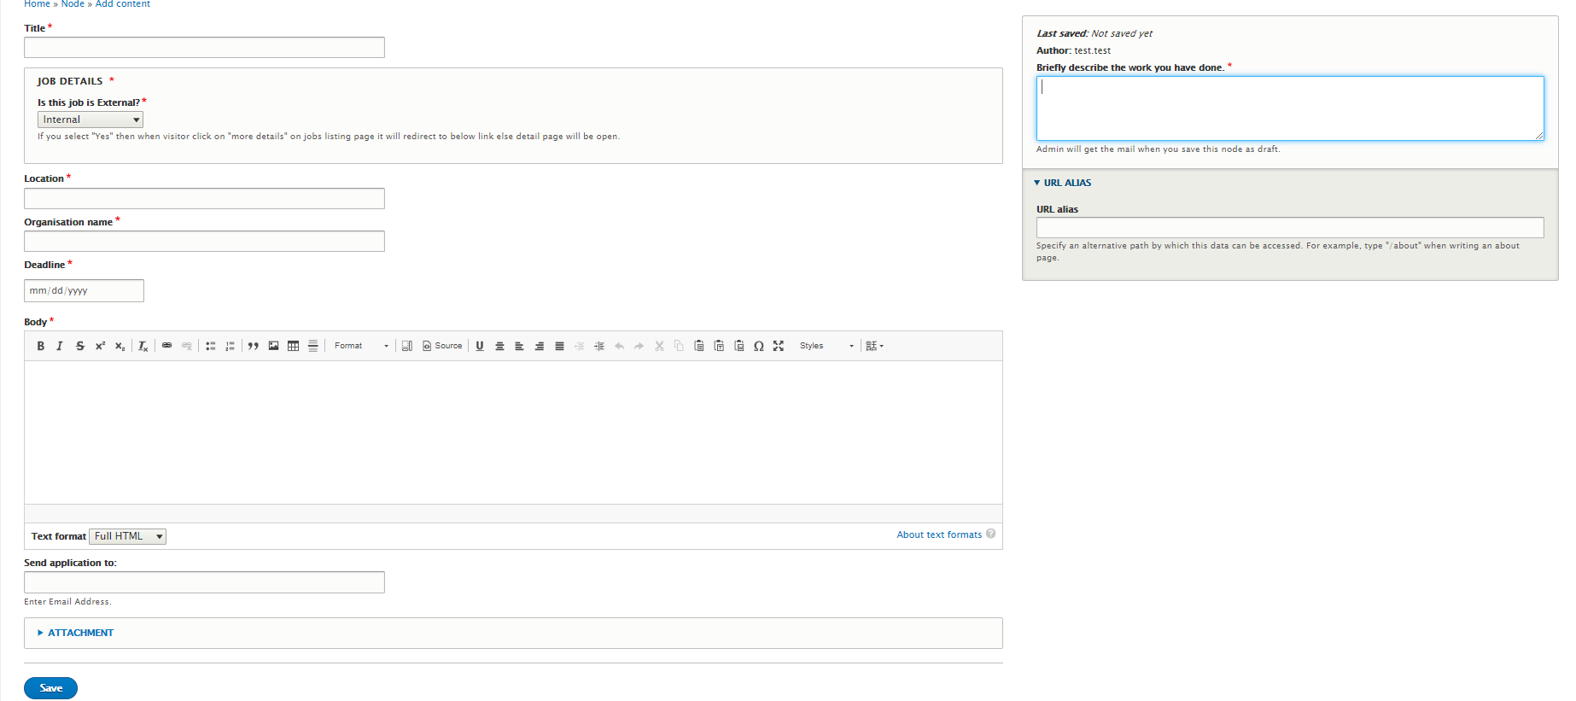

In the right, you should enter
Briefly describe the work you have done: just write a short brief
URL alias: to be displayed in the link once it’s open (job_jobtitle_Country_OrginzationName)

Resources

How to upload new resources
(See the video: https://youtu.be/rVt2NL6WUXQ)

Examples
- https://www.nutritioncluster.net/resource_Innovations_In_Nutrition_Information_Systems
- https://www.nutritioncluster.net/resource_NCC_roles_and_responsibilities
- https://www.nutritioncluster.net/calculation

Title - the title of resource that is displayed on the website
Body – brief about the document
if you copy from MS word or any app and you paste, follow steps below
- Select all text in the body (Ctrl + A)
- Click remove format to be same as GNC style guide.

Resources Attachment: Please click choose file and upload the files that are related to the title.

Note: Below fields is taxonomy and will help GNC website users find a resource by filtering them by language, country, theme and Type of resources.

Select Language: Please select the language (En, Fr, Ar, Sp,…)
Countries: Please select the county related to files and if it’s global (select Global)
Select Publication Date: refers to when the resource was created by the author.
Select HPC: please select in which HPC the file e.g. Coordination, Needs assessment and analysis, etc.…
Select Theme: Please add theme e.g. COVID-19, Infant and Young Child Feeding, etc.…
Select Type of resources: please select the type of resources e.g Checklist, Infographics & Maps, Guidelines,etc.…
Select Keyword: please select the keyword for the documents
Resources Thumbnail: Please add a picture for the document (you can use the Snipping Tool to take the first page, See the video at 10:08 minutes )

In the right, you should enter
Briefly describe the work you have done: just write a short brief
URL alias: to be displayed in the link once it’s open (resource_document title)

How to edit resource

- Go to https://www.nutritioncluster.net/resources
- Search the name of the resource
- Click Preview
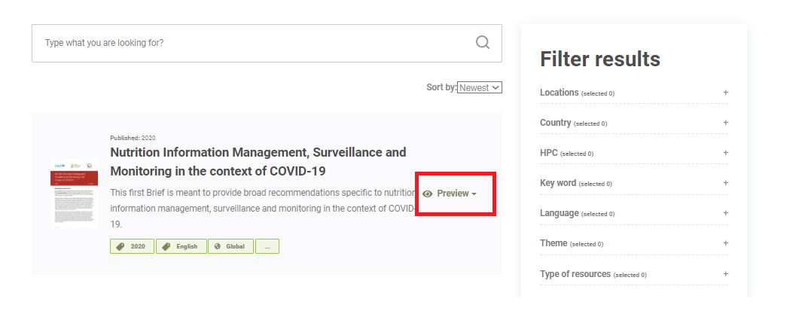
- Click edit

News

How to create News
(See the video: https://youtu.be/BdypBSAbC-I)

Examples
- https://www.nutritioncluster.net/news/Summary_CB_initiatives_in_the_Global_Clusters
- https://www.nutritioncluster.net/news_UNSCN_COVID_19_Questionnaire

News Title - The title of news that is displayed on the website
Upload News Banner - Image that is displayed on the News and Single news page
Upload Image for Update Section on Home Page - Image that is displayed on the Updates section (could be the same image for News-Banner)
Body – brief about the document
if you copy from MS word or any app and you paste, follow steps below
- Select all text in the body (Ctrl + A)
- Click remove format to be same as GNC style guide.
In the right, you should enter
Briefly describe the work you have done: just write a short brief
URL alias: to be displayed in the link once it’s open (news_news title)
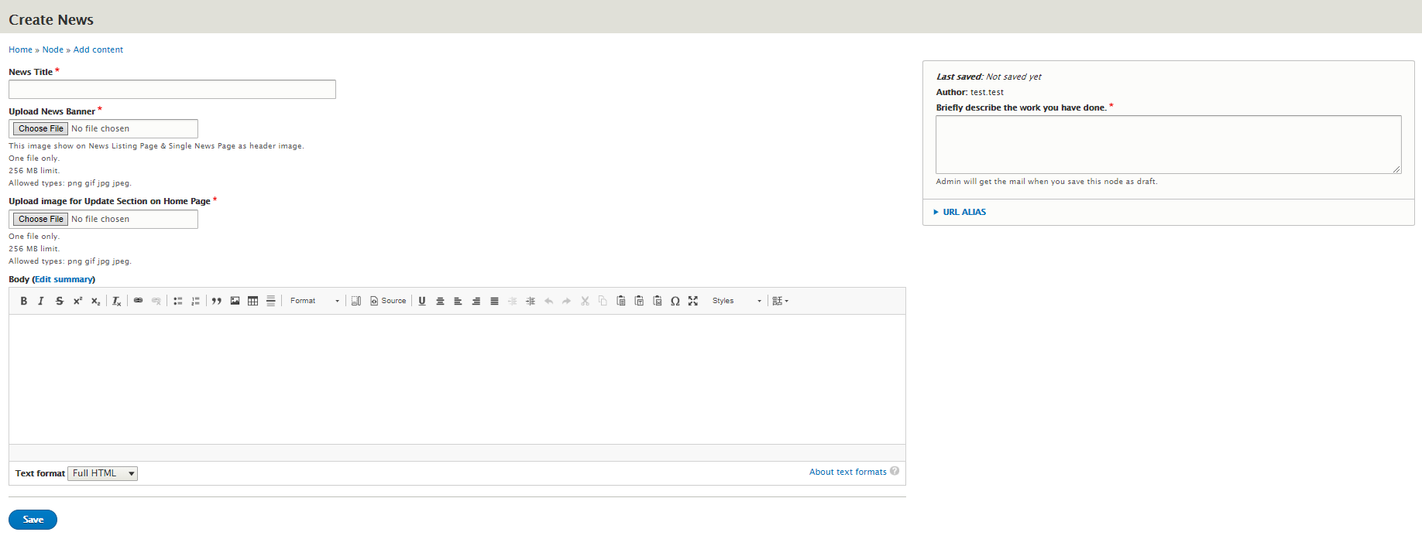

How to edit News
- Go to https://www.nutritioncluster.net/search/global
- Search the name of the news
- Click read more

Events

How to create Event
(See the video: https://youtu.be/kGuowOAC7fQ)

Examples
- https://www.nutritioncluster.net/COVID19-IYCF
- https://www.nutritioncluster.net/event_CHILD_WASTING_PROGRAMMING_IN_RESPONSE_AND_PREPARATION_TO_THE_COVID-19_PANDEMIC

Title - the title of the event that is displayed on the website
Select Category: This field is used to show events in the following pages 1. Internal Engagement 2. Capacity Strengthening
Event Category: Please select the category for the event e.g. webinar, meeting, training, etc.
Upload Event Banner - the image that is displayed on the Events page and Single Event page
Upload Image for Updates Section - the image that is displayed on the Updates sections
Start Date of event - The date that is displayed on the Single event page and is used for the calendar on the Events page
End Date of event – The end of the event
Event Link: Link that can be displayed for Event if there are any external sources related to it
URL - URL address to which user is redirected
Link Text - The name of CTA

Body – brief about the document
if you copy from MS word or any app and you paste, follow steps below
- Select all text in the body (Ctrl + A)
- Click remove format to be same as GNC style guide.

Resources: the list of resources related to the event. They are displayed on the Single Event page
Resources Section title - The title of the section that is displayed on the website
Select File Type - Dropdown list to select the type of file
Resources link - the URL address of the resource. Internal Resources can be searched from the input
Link text - the title of resource displayed on the website

Join This Event Section - it displays info regarding signing up to the event or redirects users to register for the event
Heading - the header of the section that is displayed on the website
Sub-heading - the sub-header of the section that is displayed on the website
URL - URL address to which user is redirected
Link Text - the name of the button

Media Gallery: the images or videos upload here will be displayed on the Single Event Page

To add a video click
- Add video: Media Gallery
- Select Video Source: Select YouTube
- Video ID: add only the Youtube code not the full URL(follow steps below)
  - Open Youtube video
  - Click Share
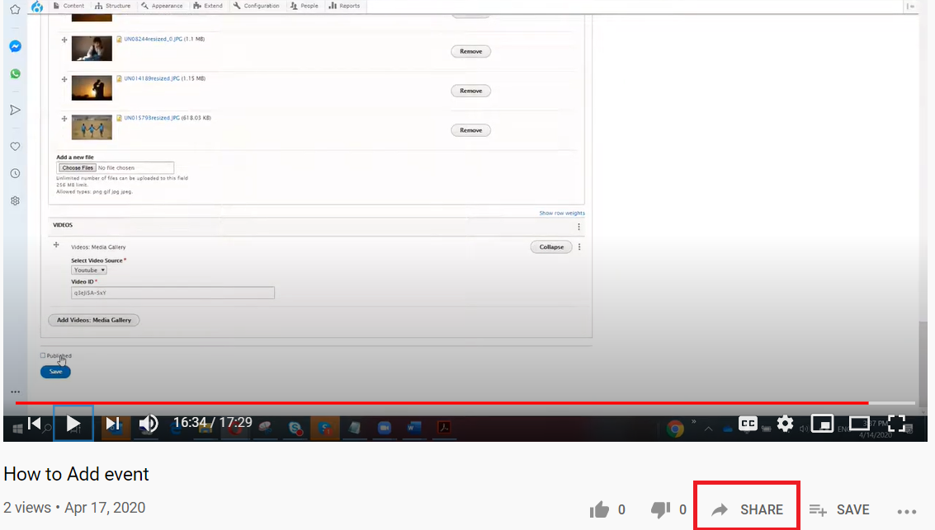

- Click Copy
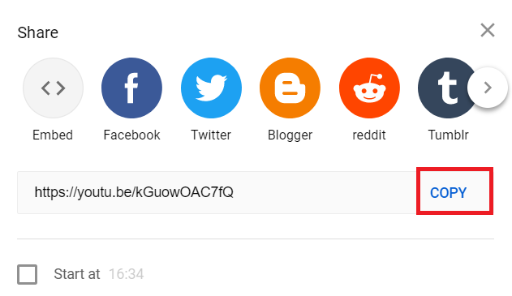
- Paste in MS word and only copy the ID
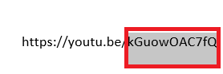
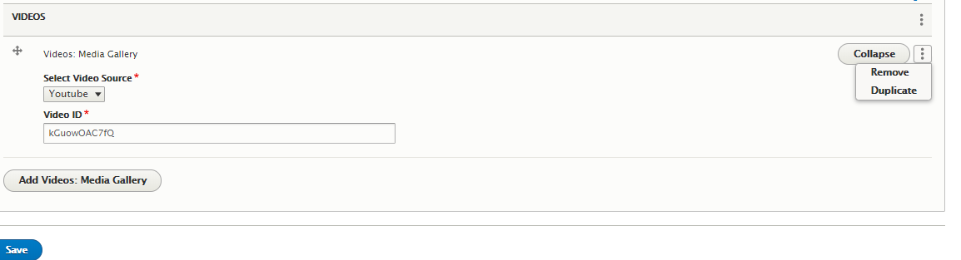
- The final input for video will be the same image below
- If you want to remove .it is in the right … click remove

In the right, you should enter
Briefly describe the work you have done: just write a short brief
URL alias: to be displayed in the link once it’s open (event_event title)

How to edit Event
- Go to https://www.nutritioncluster.net/search/global
- Search the name of the events
- Click read more

Youtube

How to upload the video to Youtube
- Share with Shabib (salqobati@unicef.org) your Gmail account and which channel you will upload the video (GNC or GTAM)
- You will receive an invitation for accepting
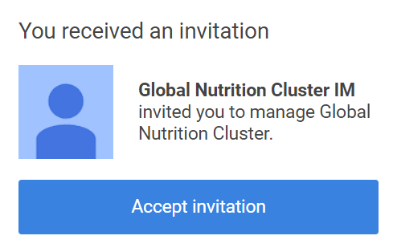
- Go to https://www.youtube.com
- Login using Gmail account ,then click in your account logo after that click switch account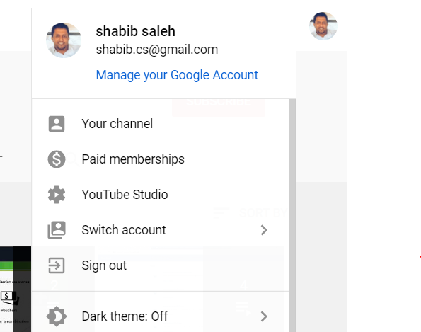

- Select the channel you want to upload the video
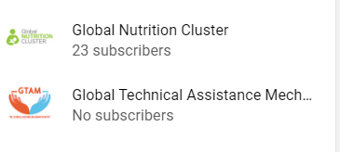
- Click Upload Video
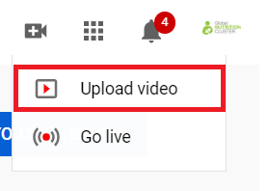
- Follow the steps in this video (https://www.youtube.com/watch?v=3Mm2HpCYzDE)

Download Pictures
- Go to Weshare: https://weshare.unicef.org/C.aspx?VP3=CMS3&VF=Home
- Click Login or register from the top right
- Strat search for pictures e.g. COVID-19, Malnutrition, etc.
- Download

Scheduling a Webinar with registration in the zoom

To scheduling a Webinar with registration in the zoom , please follow the instructions below

1. Create your zoom link by after you login using UNICEF staff login https://unicef.zoom.us | 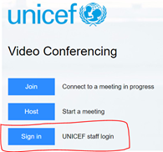
2. Click in schedule a meeting
3. Ensure you checked the registration
4. Keep other options without change unless you want to checked in the meeting options | 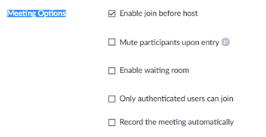
5. Click Save
6. Copy the invitation to your outlook invitation | 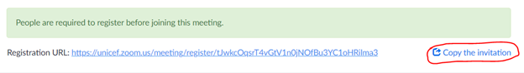
7. Once they click in the link they will find same this form | 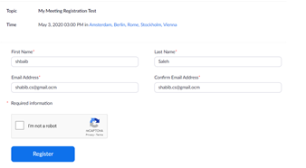
8. After registration, they will get a link to the meeting | 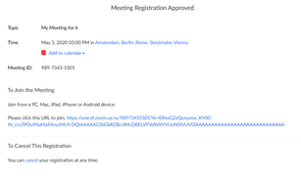

You can also watch the video: https://support.zoom.us/hc/en-us/articles/204619915-Scheduling-a-Webinar-with-Registration

Add/Change Your Zoom Profile Picture

To do this, visit https://unicef.zoom.us/ and log in as UNICEF staff login | 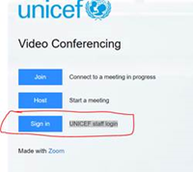
Once you log in, the site will automatically take you to https://unicef.zoom.us/profile . You can add a user photo from this profile page. | 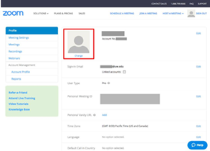
At the top of the profile page, you’ll see you name, a blank profile photo, and a link that says “change.” Click on this link to add a profile picture. Next, click on the “Upload” button to upload a new photo. Select the photo file from your computer. | 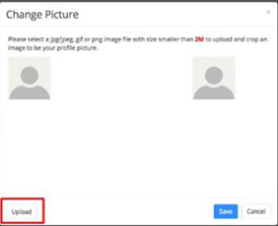
Once your photo is uploaded, you can move the square mask so the photo is centered and the zoom level is correct. Click “Save” to finish. | 