Global Cluster Coordination Group:

Basic Information Package for COVID-19 Response (June 2020)

What is the Basic Information Package?
This package of information and contacts has been put together by the Global Cluster Coordination Group.

The package:
- Intends to provide essential resources and best practice on coordinating a response to COVID-19.
- Intends to support sector and inter-sector coordination focal points in countries without a formal humanitarian response system, including Resident Coordinators Offices.
- Contains materials originally written for countries with established humanitarian coordination systems but may be adapted for all settings.

For more information please contact: gccg-globalclusters@un.org

What is in the Package?

Document | Purpose | Location
Key Messages on Coordination | Essential principles of coordination based on global guidance and good practice | Attached in the package  (Doc 2 - GCCG Covid19KeyMessages)
Contacts of Global Cluster Coordinators & links to COVID19 Sector-specific materials | Weblinks to all Global Clusters to request guidance and support and links to available resources on Global Cluster pages. | Attached in the package  (Doc 3 GCCG Contacts& Links)
Inter-Cluster/Sector Matrix on COVID-19 response | A practical matrix pinpointing specific areas of collaboration between different sectors to enhance response to COVID-19 | Attached in the package  (Doc 4- Inter-ClusterSector Matrix COVID-19 response)

(Package contents continue on next page)

Basic Information Package Contents (continued)

Document | Purpose | Location
Integrated programming for better health outcomes: a multisectoral approach | Practical guidance on coordination and strategic collaboration across two or more sectors to achieve better health outcomes through collective action | https://www.humanitarianresponse.info/en/coordination/clusters/document/integrated-programming-better-health-outcomes-multisectoral-approach
Cluster Coordination Reference Module | Reference guide for field practitioners on humanitarian coordination and the cluster approach | https://interagencystandingcommittee.org/iasc-transformative-agenda/iasc-reference-module-cluster-coordination-country-level-revised-2015
Introduction to Humanitarian Action: a brief guide for RCs | An overview of the key elements of humanitarian action and the steps to take before and immediately after a sudden-onset emergency | https://interagencystandingcommittee.org/system/files/rc_guide_31_october_2015_webversion_final.pdf
Emergency Response Preparedness (ERP) guidance | A short guide to support preparedness measures to address the potential non-health impacts of COVID-19 and its compound effect on existing risks | https://interagencystandingcommittee.org/inter-agency-standing-committee/iasc-interim-guidance-covid-19-emergency-response-preparedness
Public Health and Social Measures for COVID-19 Preparedness and Response Operations in Low Capacity and Humanitarian Settings | Outlines how key public health and social measures, needed to reduce the risk of COVID-19 spread and the impact of the disease, can be adapted for use in low capacity and humanitarian settings. | https://interagencystandingcommittee.org/health/interim-guidance-public-health-and-social-measures-covid-19-preparedness-and-response
Technical Note: Protection from Sexual Exploitation and Abuse (PSEA) during COVID-19 Response | Recommended actions and resources on reducing risks, prevention and ensuring safety from sexual exploitation and abuse while receiving humanitarian aid. | https://interagencystandingcommittee.org/other/interim-technical-note-protection-sexual-exploitation-and-abuse-psea-during-covid-19-response
Principles of Partnership | Essential principles on engaging in a more equal, constructive and transparent manner with NGOs | https://www.icvanetwork.org/system/files/versions/Principles%20of%20Parnership%20English.pdf

What are Clusters? Who are the Global Clusters?
Clusters are groups of humanitarian organizations (UN and non-UN), active in each of the eleven sectors of humanitarian action (e.g. health, logistics, shelter, etc, see diagram on the next page). Clusters have clear responsibilities for coordination in their respective area with designated leadership and accountability.

At the country level, clusters aim to support a coherent and effective humanitarian response by mobilizing operational agencies and NGOs to respond in a strategic manner. They are led or co-led by an operational agency (UN or NGO), and in some cases with a government sector lead.

At the global level, Global Clusters are hosted and supported by a designated Cluster Lead Agency (see diagram). Their role is to strengthen system-wide preparedness and technical capacity to respond to humanitarian emergencies. Global Clusters, together with their partners, provide the following types of support:
- Technical surge capacity;
- Trained experts to lead cluster coordination at the field level;
- Increased stockpiles, some pre-positioned within regions (e.g. emergency shelter materials);
- Standardised technical tools, including for information management;
- Agreement on common methods and formats for needs assessments, monitoring, and benchmarking; and
- Best practices and lessons learned from experience of previous emergencies

The Global Cluster Coordination Group brings together all the Global Clusters to support the strengthening of country-level cluster and inter-cluster coordination with the overall aim of improving the quality of humanitarian response.

Global Clusters and Cluster lead Agencies (diagram):

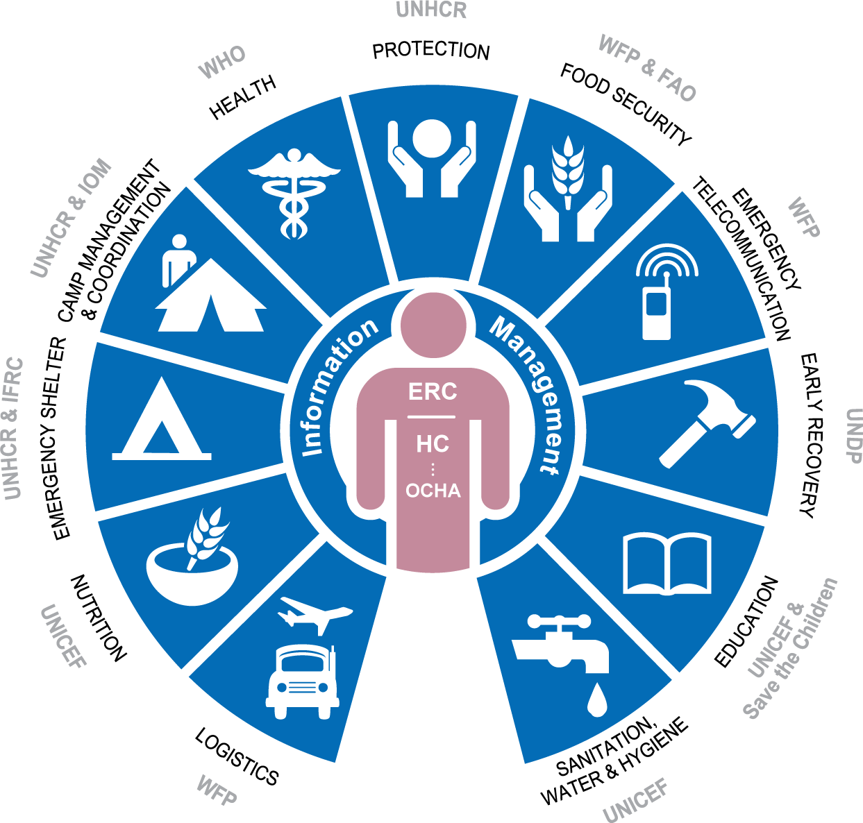

Clusters may be activated by request of the RC/HC to the Emergency Relief Coordinator and the Inter Agency Standing Committee (IASC) during humanitarian emergencies where the IASC criteria for cluster activation is met.

