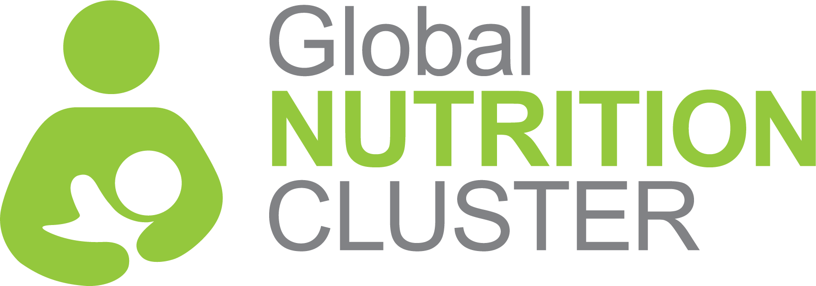
NUTRITION CLUSTER INFORMATION MANAGEMENT OFFICERS TRAINING

BACKGROUND

Coordinated humanitarian response rests on the notion that no one organization can meet large-scale humanitarian need so we must work collaboratively to achieve common goals for affected populations. The cluster approach helps ensure humanitarian action is effective, accountable, and transparent and founded on the principles of partnership.

In support of this, the Global Nutrition Cluster (GNC) Strategy 2017-2020 commits the GNC to working nationally/regionally and globally to strengthen the capacity of national coordination platforms to deliver effective and people centered responses.
This training package is part of the GNCs suite of learning materials, focusing specifically on preparing participants for working in nutrition information management through strengthened understanding of information management concepts, tools and processes and with greater confidence to provide support to the clusters through strengthened inter-personal skills.
TRAINING OUTCOMES:
COURSE GOAL
To develop knowledge and skills in nutrition cluster information management and their application to the elements of the humanitarian programme cycle to ensure IM support of all core cluster functions
- Describe Humanitarian Reform, the Transformative Agenda and cluster approach in the context of the humanitarian landscape.
- Identify roles and responsibilities within the cluster architecture, including the roles of government, the Cluster Lead Agency, Cluster Coordinators, Information Management Officers and cluster partners
- Explain key nutrition in emergencies interventions, including terminology, and apply it to information management processes within nutrition cluster
- Describe the Humanitarian Programme Cycle and list IM processes involved at each stage.
- Understand concepts of IM and how it applies to nutrition in emergencies and nutrition cluster
MAIN COURSE THEMES
- IM in the global context
- Nutrition cluster foundations
- Nutrition cluster IM in the Humanitarian Programme Cycle
- Nutrition cluster IM toolkit
TARGET AUDIENCE
This is a mid-level course which assumes a solid expertise in IM in general (including Excel skills, mapping, website management) and understanding of humanitarian concepts.
Priority participant groups for this course include:

Those currently serving as nutrition cluster/sector information managers at national, regional or sub-national levels, including representatives from Government bodies

Standby Partner personnel with information management profile, who are likely /interested to being deployed to support IM for nutrition coordination platforms (clusters or sectors).
LANGUAGE
The training is in English only

