Hand-out: Identify and adapt your message
Steps |  | Instructions
Establish purpose and key factors |  | - Define the intent of your visualization: identify function (from exploratory to explanatory) and tone (from analytical to emotive/abstract purpose).  - Identify parameters: resolution, format, interactivity, frequency, rules, technical, resources available, etc.
Prepare and know your data |  | You need to know your source material to tell good stories about data.  - Learn about the numbers and metrics. Figure out where they came from and how they were estimated, see if they even make sense.  - Examine closely the data. Does it fit purpose, is it complete? Determine physical properties and architecture of your data, identify data types (categorical nominal or ordinal, quantitative interval or ratio).  - Quality check: transform your data for quality (missing or incorrect values, duplicates, uncommon characters, date issues, decide if you keep or get rid of outliers). Transform your data for analysis (derive values, standardize, normalize, convert or calculate accordingly). Parse and merge, decide on resolution, filter/exclude data, aggregate/roll-up, select sample, apply statistical test, etc.  - Try not to jump right into design, you are not here yet.
Determine your message |  | - Plan. Know what you want to say. Select among all the data and possible numbers what is important, interesting or new.  - Boil down the key results to a few most important lessons. Lead with those lessons.  - Recognize that function does restrict forms it is acceptable to use for each story and set of data. Focus on key messages and tailor your visualization accordingly. Cut the noise.
Know your audience |  | - The role of your audience defines the level of abstraction required. What decisions do they make? What questions do they need answered? For high level decision makers, focus on strategic view, long term perspectives, high level overview and simple summary. For analysts, focus on query driven analysis, precision required and emphasis on trends and correlations. For operations managers, focus on current status and issues and be event driven (alerts, spikes, issues, etc.)  - Think about what your audience cares about. Express your results in those terms  - Understand who is making the decision. What are their training, experiences, attitudes, biases? Prepare a story that reflects this understanding.  - Identify your audience data comfort and skills: How sophisticated are they with manipulating or using data? Do they enjoy digging into numbers? What is their numeracy level?  - How familiar are they with the metrics you will present? Do they understand where the data comes from? Are they familiar with the terminology used?
Understand the decision |  | - All analysis supports decision making. Going back to the decision can help the communication stay on track. Knowing how data can best support decision making will help shaping the message.  - Think about what your analysis says about the decision. Make it obvious how people should use the information.
Understand the decision making process |  | - The institution’s decision making process matters. It generally entails choosing issues that requires attention, setting goals, identifying or designing suitable options and choosing among alternative options  - Provides decision makers with just enough information to allow them to choose between options.  - Be available if decision makers need your personal opinion or more details
Choose the right metrics |  | - Information discrimination: Do not treat all information equally. Use only the data relevant to the message or information that will drive action.  - Find the core themes based on the essence of the problem. This will give you the logic and argument for discarding extraneous information. The success of your presentation will come down to your ability to distinguish between useful, productive information and interesting but extraneous information.  - Metric without goal is a waste. Set objectives first, then after the metrics.  - This is not about “what people would like to know”, but rather “What would they do if they knew this important and actionable information”  - Do not leave all the processing to the reader.  Characteristic of good metrics include:  - Actionable: it is clear the course of the problem or necessary actions when the metric goes up, down, flat or off target.  - Common interpretation: People in the organization recognize what the metric means  - Transparent, simple calculation : How the metric is generated is shared and easy to understand  - Accessible, credible data: The data can be acquired with modest effort from a source that people trust.  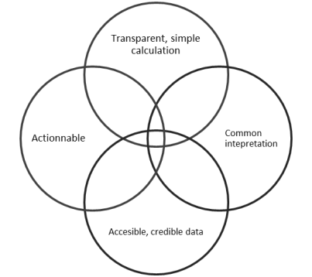
Draft your graph |  | - Sketch your graph on paper. Iterate.  - Recognize that a single best solution never exists.

