Hand-out: Levels of measurement

Level of measurement refers to ways in which variables or numbers are defined and categorized. The most widely recognized categorization discerns nominal, ordinal, interval and ratio variables:

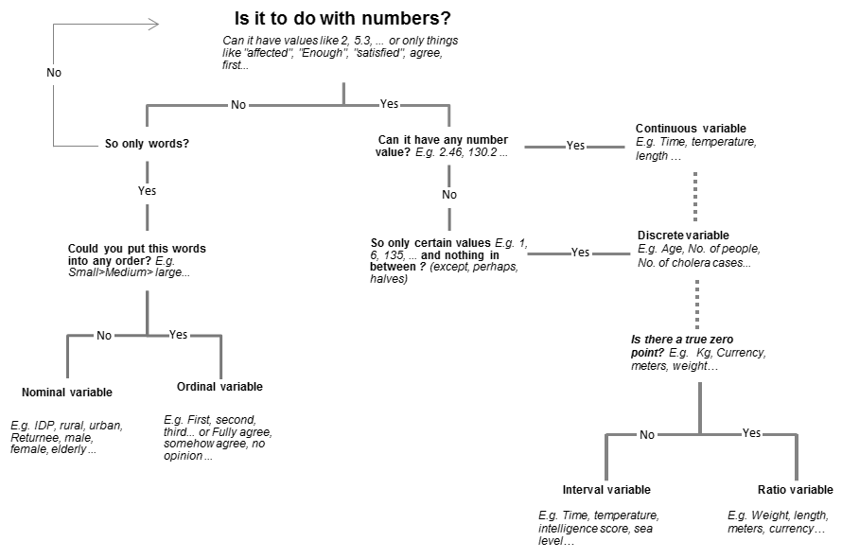

There is a hierarchy implied in the levels of measurement. The lower the level, the less restrictive the assumptions about the objects being measured. Conversely, with each higher level, the richness of information and the scope of permissible statistical operations increase. Analytically, it is desirable to strive for the highest possible level of measurement.

In emergency needs assessment, the choice of measurement level is opportunistic. Due to external and internal constraints, (speed, resources, cost, likely measurement error, or when the underlying object is changing rapidly), compromises between a more informative (higher) level and a less operationally burdensome (lower) level are necessary. If, with the same amount of effort, a higher level is achievable, it is preferred. In other words, one ought not to unnecessarily reduce the measurement level in data collection instruments, secondary data sources and data entry.

Processing |  | Nominal |  |  | Ordinal |  |  | Interval |  |  |  |  | Ratio |  |  |  | Legend
Frequency distribution, mode |  |  |  |  |  |  |  |  |  |  |  |  |  |  |  | OK for processing

Median and percentile

Add or substract
Mean, standard deviation |  |  |  |  |  |  |  |  |  |  |  |  |  |  |  | Can’t be processed

Multiply or divide

Ratio, coefficient of variation

Nominal level | Example | Processing
- The categories of variables differ in name only, not in value. Numbers are used to label and classify observations. Numbers have no arithmetic properties and do not represent quantities.  - Data cannot be arranged in an ordering scheme. | The variable “sex” has two categories: male and female. The researcher can assign a 1 to the category “male” and a 2 to the category “female”, or vice versa. The only meaning these numbers have is to distinguish one category from the other. Other example: Marital status, affected group type, etc. | Nominal measurement allows only limited statistical manipulations and is considered the weakest of all measurements. Nominal data can be summarized only with a mode (the most frequent category) and a percentage distribution, but you cannot arrange the data in numerical order or perform more advanced transformations and statistics. It makes no sense to speak of the "mean sex".

Ordinal level | Example | Processing
- There is an order relationship among the categories.  - In other words, a category assigned a 1 can be considered higher than a category assigned a 2, which would be higher than category 3.  - While there is a rank order in the numbers assigned to the categories of the variable, the distance between the categories is not equal or not known. | Communities rank their priority needs after a disaster. The preferences are assigned priority order such as:  Priority order Needs  1 Water supply  2 NFI  3 Food  From such results, we know the order of preference but nothing about how much more one item is preferred to another: “Food” is not 3 times less preferred / needed than “Water supply”. | Distances between attributes do not have any meaning. The numbers are comparable only in terms of relative magnitude, not actual or true magnitude.  Because of lack of equal distances, arithmetic operations (add, subtract, multiplied, divide) are impossible (ie, poor + fair + good is meaningless).  Statistical manipulations, like mode, median, frequency distribution, percentile, and various non-parametric statistical tests are possible. However, mean, standard deviation, or a Pearson product-moment correlation cannot be used because the distance or interval between the categories is not known.
Interval level | Example | Processing
- There is an order relationship among the objects measured. Each object is mapped to a value on a continuous variable.  - This is the first truly quantitative level of measurement. Differences in values are measureable and meaningfully comparable. For example, moving from 2 to 4 is the same as moving from 5 to 7.  - However, there is no natural zero starting point. Negative values can be used. | Temperature measured in most scales (Celsius, Fahrenheit, etc.) is an interval variable. Differences are meaningfully comparable. However, there is no natural zero point (except when measured in Kelvin). Years are a discrete (and therefore also categorical) and almost interval variable. Almost, because the year zero does not exist, therefore 4AD - 2AD = 2 years ≠ 1AD - 1BC = 1 year. Blood pressure is another example. | The central tendency of an interval variable can be represented by its mode, its median, or its arithmetic mean. Standard deviations and percentages or counts (for ranges or categories as a result of rounding) can also be used. Many parametric statistics are usable such as OLS regression, analysis of variance and factor analysis.  Ratios between numbers on an interval scale are not meaningful (e.g. 90° is not twice as hot as 45°) and operations such as multiplication or division cannot be carried out directly. However, ratios of differences can be expressed, for example one difference can be twice another.
Ratio level | Example | Processing
- The fourth and highest level of measurement possesses all of the features and properties of the interval level, together with a fixed origin or zero point.  - Ratio scales permit to compare both differences in scores and the relative magnitude of scores, and how much one attribute is to another. Phrases such as "four times" and "twice" are meaningful at the ratio level. | Weights, time, lengths, heights, mass, age, distance, salary, energy and electric charge and many more are example of measures that are ratio scales, because the distance between the categories is known and constant and the ratio is meaningful.  For instance the difference between 5 and 10 minutes is the same as that between 10 and 15 minutes, and 10 minutes is twice as long as 5 minutes. | Virtually all statistical operations can be performed on ratio scales. Because numbers have a zero point, they can be added, subtracted, multiplied, and divided in a meaningful way.  The central tendency can be represented by its mode, its median its arithmetic, geometric and harmonic mean.  Range, standard deviation, coefficient of variation, Pearson product-moment correlation and many other parametric statistics can be used.

This applies to a situation with one variable only. When coding binary variables (e.g. gender) by 1 and 0 (e.g. female0, male1), the mean of 0.56 in the gender variable then is legitimate; it simply says that 56 percent of the sample records with non-missing values were about males, 44 percent about females. When nominal variables are crossed with other nominal variables, more demanding statistics are feasible. Example: Displaced persons: unharmed, injured, dead, by province. Odds ratio for displaced persons to die between Province A and Province B.
The numbering of ordered categories can be in opposite directions. The most desirable or most relevant or most intense category can be assigned the number 1, etc. Conversely, the least desirable category is assigned 1, etc. The choice is arbitrary, but must be followed consistently within a dataset.

