Nutrition Cluster Information Management Training
  - M & E Framework Exercise: YEMEN
Escalating conflict has severely exacerbated Yemen’s pre-existing humanitarian crisis. Partners now estimate that 21.2 million people need some kind of humanitarian assistance. However, the severity of needs varies greatly, as outlined in the 2016 HNO.
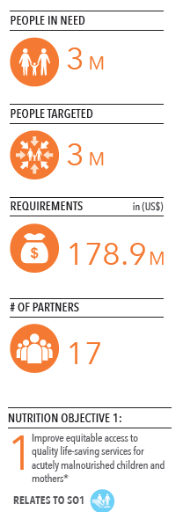  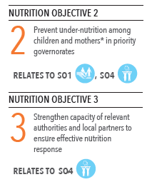 | Response summary  In 2016, Nutrition Cluster partners intend to reach all 3 million people in need of nutrition services – including roughly 2 million acutely malnourished children under 5 and pregnant or lactating women (PLW), in addition to 1 million who are at risk of malnutrition and require preventive services. This represents nearly twice as many people as targeted in 2015 – a reflection of growing malnutrition and declining service availability. The cluster will maintain an approach grounded in community management of acute malnutrition (CMAM). Cluster partners in early 2016 approved a major CMAM scale-up plan that will boost service availability across the country.  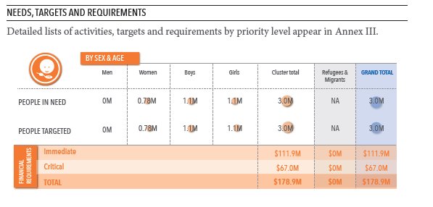  YHRP activities have been reviewed to include only the most essential programmes: treatment of severe and moderate acute malnutrition, nutrition screening, micronutrient supplementation and blanket supplementary feeding. Recognizing the indispensable role of families and community members in CMAM, partners will also provide counselling on infant and young child feeding practices for care-takers and build capacity of local technical authorities. Partners have identified ten top-priority governorates in which they intend to reach all health facilities providing nutrition services; in second- and third-priority governorates, the target is to reach up to 70 per cent of health facilities. | Operational capacity  Partners completed a capacity evaluation during the YHRP process in order to determine the degree to which 2015 targets could be realistically expanded. In the relatively few areas where access remains a serious challenge, partners have agreed to scale up by supporting existing health facilities, deploying mobile teams or establishing temporary treatment centres.  Delivery results in 2015 strongly indicate the cluster’s ability to sustain larger operations this year. Altogether, partners reached nearly three times as many people in 2015 as they had originally intended, mainly as a result of a wide-reaching micronutrient supplementation programme. Performance in other activities – including SAM treatment and targeted supplementary feeding for PLW – was likewise strong, reaching nearly 100 per cent of targets by the end of the year.  The number of active partners has also expanded somewhat, with one new partner in the cluster and more expected in the coming months. Capacity building programmes and local partnerships (to include organizations working with women and marginalized address, gender and GBV and legal aid support)– important components of the overall 2016 plan – also constitute critical investments in operational capacity. Active sub-national clusters are functioning in Aden, Hudaydah and Ibb.

