Nutrition Cluster Information Management Training
  - IM in the Humanitarian Landscape
Event: | Typhoon Haiyan | 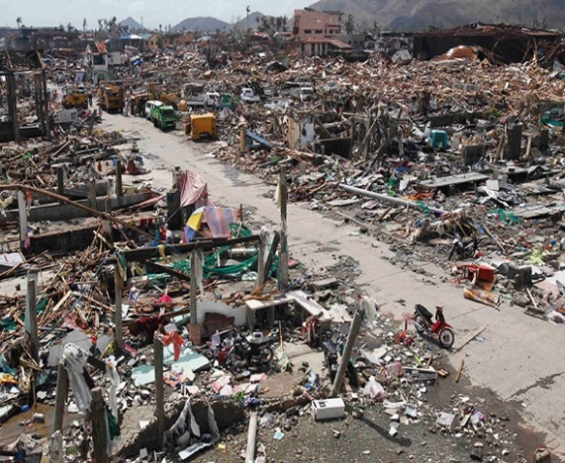
Location: | Philippines
Date: | 8 November 2013
No. Affected: | 18 million
Adapted from UNOCHA news release November 2013
The United Nations and its humanitarian partners are supporting the Philippine Government to assess damage caused by Typhoon Haiyan (known locally as Yolanda). The super typhoon made landfall on the eastern coast of the Philippines at 4.30 a.m. local time (8 November) and is currently making its way across the country.
The super typhoon has ripped roofs off houses and uprooted trees. Telecommunication and electricity supplies have been interrupted and air and seaports are closed. At least 18 million people live in the worst-affected regions of Western, Central and Eastern Visayas.
A UN Disaster Assessment and Coordination (UNDAC) team was deployed to the Philippines ahead of the storm. The team will work closely with the Government and regional authorities to assess the needs of affected communities and to help formulate response plans.
The storm, which is hundreds of kilometres wide, is affecting a vast area of the central Philippines including many islands and other isolated environments. Gathering urgently needed information about what people need, where the greatest needs are, what kind of damage the storm has done and where is emerging as a massive logistical task.
“We are working closely in support of [the] Government and local authorities to assess the life-saving needs of the people affected by this typhoon,” said Dr. Julie Hall, acting Resident and Humanitarian Coordinator in the Philippines.
The Humanitarian Country Team and partners have complemented Government preparedness efforts by pre-positioning stocks to respond to life-saving needs of affected people. “The Humanitarian Country Team and partners are fully prepared to support and assist the Government in response to this latest typhoon,” said Dr. Hall. “We will continue to support their efforts as we wait to see exactly the extent of the damage caused by Typhoon Haiyan.”

Nutrition Cluster Information Management Training
  - IM in the Humanitarian Landscape
Event: | Conflict, Syrian Refugees | 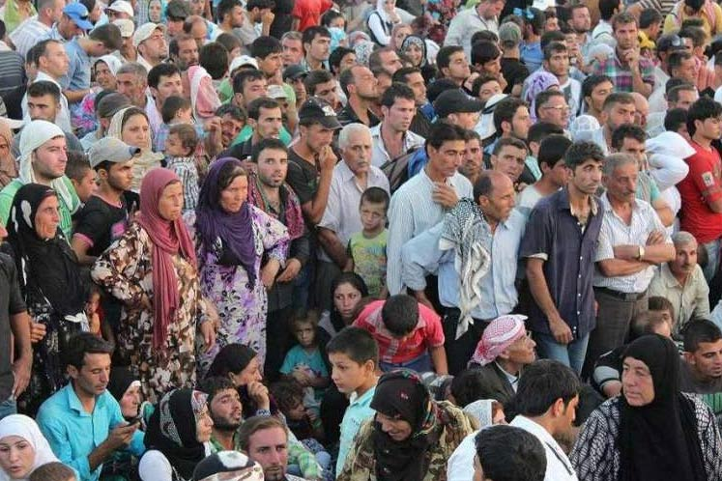
Location: | Jordan
Date: | 2011-present

Syria is one of the most complex and dynamic humanitarian crises in the world today. Since March 2011, over a quarter of a million Syrians have been killed and over one million have been injured. 4.8 million Syrians have been forced to leave the country, and 6.5 million are internally displaced, making Syria the largest displacement crisis globally.
Recognising the magnitude of the humanitarian crisis inside Syria, the systemic gaps in coordination, and following the adoption of UN Security Council resolutions 2139, 2165 and 2191, humanitarian actors operating inside Syria from Damascus and from neighbouring countries launched the “Whole of Syria” (WOS) approach to develop a principled, predictable and coherent response to prioritized humanitarian needs through in-country and cross border operations.
When new humanitarian needs arise, OCHA works with a host of partners, including Government and local authorities, non-governmental and international organizations and UN humanitarian agencies, focal points for thematic areas (clusters), local communities and OCHA field officers, to assess who is in need and what they require, and to determine the most appropriate way of meeting those needs. OCHA also supports the Humanitarian Coordinator (HC), to ensure that he or she is able to effectively coordinate humanitarian programmes at the strategic level and engage in high-level advocacy to ensure that relief reaches people in need, on time.
A Cross-Border Task Force in Jordan operates under RC/HC’s stewardship, has been established as a senior strategic and decision-making body to oversee strategic coordination of cross border activities as part of the WOS approach. Comprising both country focused and region partners, the Cross Border Task Team aims to develop common policies and response strategies to deliver humanitarian assistance in Syria through cross border assistance. With OCHA Jordan’s support, an Inter-Sector/Cluster Working Group (ISCWG), along with five sector working groups (WASH, Health and Nutrition, Food Security, Logistics, and NFI/Shelter), complement the work of the Cross-Border Task Force.

Nutrition Cluster Information Management Training
  - IM in the Humanitarian Landscape
Event: | Ebola Crisis | 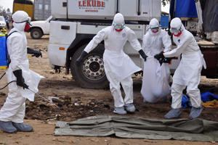
Location: | Sierra Leone, Liberia, Guinea
Date: | 2014-2015
Adapted from UNOCHA news release September 2014
The UN and its humanitarian partners have launched a central contribution to the response to the outbreak of Ebola in West Africa. “The Ebola crisis is unprecedented,” said Dr. David Nabarro, the UN System Senior Coordinator for Ebola. “It requires an exceptional, international response to address both the health crisis and the broader societal, economic and political threats to the countries affected.”
Almost 5,000 people have been infected with Ebola since the outbreak started in West Africa in March 2014. Tragically, more than 2,400 people have died across Guinea, Liberia, Nigeria, Senegal and Sierra Leone. Health experts believe the outbreak is accelerating, with some reports suggesting the number of cases is doubling every three weeks.

“It’s clear that if not dealt with effectively now, Ebola could become a major humanitarian crisis in countries currently affected”, said UN Humanitarian Chief Valerie Amos. “These countries were building their economies and institutions. Now their capacity to deliver the necessities of daily life for their people is on the brink of collapse. The Ebola outbreak poses a serious threat to their post-conflict recovery. (…) We must act now, if we want to avoid greater humanitarian consequences in future”.
A growing number of international partners are coming together including authorities in affected and at-risk countries, civil society, private sector, non-governmental organizations, multilateral organizations, international financial institutions and UN Member States.
“We will do everything we can to support national governments, UN agencies, NGOs and other partners as they work on healthcare, food security, sanitation and protection issues,” said USG Amos. “They are an essential part of the response if we are to stabilize this outbreak and mitigate its long-term effects.”
The West Africa outbreak has a higher caseload than all other previous Ebola crises combined and more than 22 million people are living in areas where active ebola transmission has been reported.

Nutrition Cluster Information Management Training
  - IM in the Humanitarian Landscape
Event: | Conflict, IDPs and food security crisis | 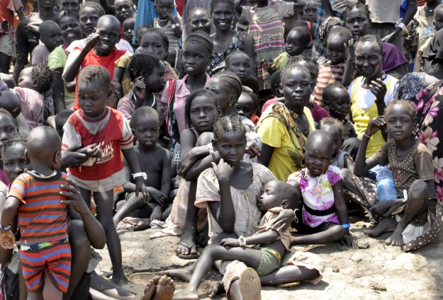
Location: | South Sudan
Date: | 2013-present
No. Affected: | 2.3 million

Since December 2013, conflict has devastated the lives of millions of South Sudanese and displaced more than 2.3 million people. About 1.69 million of them have been displaced internally in South Sudan and over 648,000 are refugees in neighbouring countries.
When new humanitarian needs arise, OCHA works with a host of partners, including Government and local authorities, non-governmental and international organizations and UN humanitarian agencies, focal points for thematic areas (clusters), local communities and OCHA field officers, to assess who is in need and what they require, and to determine the most appropriate way of meeting those needs. OCHA also supports the Humanitarian Coordinator for South Sudan (HC), to ensure that he or she is able to effectively coordinate humanitarian programmes at the strategic level and engage in high-level advocacy to ensure that relief reaches people in need, on time.
South Sudan is one of the most logistically challenging places in the world and has one of the most underdeveloped communications technology infrastructures. The challenge of providing concrete data in South Sudan is well known. The last census of the area was conducted in 2008 and all population data since that time has been based on projections. The National Bureau of Statistics projected that by mid-2015 the population of South Sudan would be 11.6 million. While these projections may have been partially reliable prior to the conflict, the degree of displacement during the conflict has made it immensely difficult to track the movement of people.
At the same time, due to insecurity and logistical constraints, many of the remote locations in which IDPs are sheltering have not been accessible and displacement figures are therefore also rough estimates. Another challenge generated by the absence of accurate baseline data is the scarcity of sex and age disaggregated data.
3.9 million people –nearly one in every three people in SouthSudan – were severely food insecure and 3.6 million were considered to be ‘stressed’, in September 2015. An estimated 30,000 people were facing catastrophic food insecurity in Unity State, leading to starvation, death, and destitution. Livelihoods have been decimated by the conflict and economic decline, with livestock looted, killed and disease-prone and crops destroyed or planting delayed due to violence, displacement and unfavourable weather. Nearly one in every three pregnant and lactating women is malnourished.

Nutrition Cluster Information Management Training
  - IM in the Humanitarian Landscape
Event: | Food Insecurity | 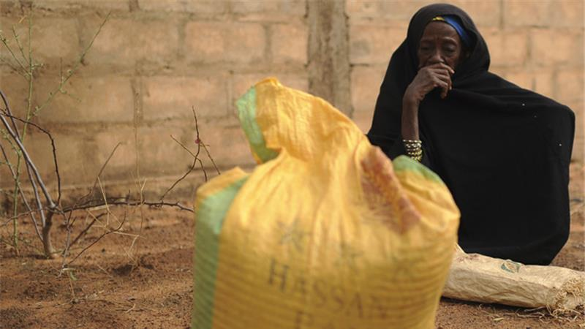
Location: | Sahel
Date: | 2011-present
In the Sahel, abject poverty, fast population growth, climate change, recurrent food and nutrition crises, armed conflicts and violence converge dangerously and undermine the lives and assets and future prospects of millions of families across the region.

In 2016, the region will remain one of the world’s main humanitarian operations. The Sahel Humanitarian Response represents no less than a tenth of the humanitarian response globally. The needs are immense. Some 23.5 million people -one in six - are expected to be food insecure, of which at least 6 million will need urgent food assistance. One in five children under five suffers from acute malnutrition. Armed conflicts, extremist violence, and military operations have driven 4.5 million people into displacement, a threefold increase in less than two years. Africa’s fastest growing displacement crisis is unfolding across the Lake
Chad Basin, where the lives and livelihoods of some 30 million are threatened by Boko Haram, today’s most deadly armed group.

The Regional Humanitarian Coordinator supports humanitarian work in nine countries across the Sahel region (Burkina Faso, Chad, Cameroon, the Gambia, Mali, Mauritania, Niger, Nigeria and Senegal) and is based in Dakar, Senegal.
When new humanitarian needs arise in a country, OCHA works with a host of partners, including Government and local authorities, non-governmental and international organizations and UN humanitarian agencies, focal points for thematic areas (clusters), local communities and OCHA field officers, to assess who is in need and what they require, and to determine the most appropriate way of meeting those needs. OCHA also supports the country-level Humanitarian Coordinator (HC)/ Resident Coordinator (RC), to ensure that he or she is able to effectively coordinate humanitarian programmes at the strategic level and engage in high-level advocacy to ensure that relief reaches people in need, on time.

