Guidance for creation of a country nutrition cluster website
on the humanitarianresponce.info platform
This guidance is developed by the Global Nutrition Cluster (GNC) to support Nutrition Cluster IMOs in developing the structure and content of the country nutrition cluster website on the humanitarianresponce.info (HR.info) platform version 2. At the country level, HR.info is designed to provide a platform for sharing operational information between clusters and IASC members in a given Humanitarian crisis. In order to promote coherence of the use of common platform for information sharing across cluster and within the humanitarian response, the GNC recommends that country clusters to use the HR.info as the primary platform for information exchange and for hosting country cluster website. The HR.info provides a predictable set of core features that is repeated on all sites that makes development of country websites/pages standard across countries and it allows cluster to standardise the contents and presentation on websites.
Preparation steps
Before creating a country nutrition cluster website, the following steps should be conducted to gain editing right on HR.info:
- Register on https://humanitarian.id/ - if you have not done so yet. Humanitarian ID is integrated into HR.info and this information is used for login. Once you have registered, you will need to create your Global profile which will include details or information of where you are normally located. If you are in a country/emergency, you should "Check-in" for that country/emergency. While performing the “check-in”, you will see a copy of your profile that you can edit for that country/emergency (if different from your global profile, i.e. if you are on surge). Once you have checked-in, you will then have access to the contact list specific to the country or the emergency you are responding to and at the same time other responders will be able to easily find you. When you leave a country/emergency, remember that you need to “check-out” of your specific emergency, this will remove your details from the contact list.
- Contact OCHA country office to request editor rights for the HR.info platform. For this step, you will need to provide OCHA with your affiliation (E.g. nutrition cluster IMO, in country X) and humanitarian ID (which is the email address you used for the registration above). There are three types of user profiles:
  - Manager has adequate rights to manage the website content and do the overall maintenance, including the management of users (by adding editing or removing users from the site); modification of the page layout, management of the menu navigation items displayed in the left of the page, adding of new pages, adding or creation of new context to manage content and addition of dynamic content like views, boxes, sections and rearranging them according to their needs. Managers are usually OCHA IMOs responsible for managing country website, however Cluster IMOs are often given Manager role as well, as this allows respective cluster IMOs to add other users who can upload documents, give manager rights to their replacement, etc.
  - Editors are site users who are given rights to manage the website content by adding, editing or removing the existing content, in order to keep the overall website up-to-date. This type of role is often given to the Cluster IMOs to upload the specific cluster content (i.e. documents, meeting minutes, maps, etc.) and to edit uploaded documents as needed. Editors cannot modify the page layout or manage the website users but they can delete the content uploaded by other editors or site users within the website.
  - The contributor role is given to the trusted users and such users have the capability to add new content to the site but those content are not published on the site right away. A content added by a contributor would need to be approved by the moderator or the site manager and then gets uploaded to the site or discarded.
- Login to your HR.info country website with your humanitarian ID once the editorial/manager rights have been assigned to you.

Manage content
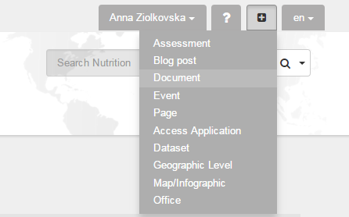
- Once you are logged in as an editor to the operational site, you will see a ‘+’ button to upload different types of contents on the upper right-hand corner of the page. Below is the list of the most often used types on content.
  - Assessment – Use to publish assessment reports. We recommend that nutrition cluster IMO upload here all nutrition assessment/survey reports (SMART, IYCF, MICS, DHS, etc.). You can also update other assessment conducted by or in collaboration with other sectors/cluster, however, when uploading the report conducted in collaboration with other clusters (i.e. Health and Nutrition), only do so if the report has not already been uploaded by other cluster IMO. You do not need to upload inter-cluster assessment reports such as the MIRA as they will be uploaded by OCHA IMO. Please note that all assessments should be uploaded using “Assessments” type of content label, otherwise they will not be shown in the assessments registry.
  - Document – This can be used for publishing all cluster documents, including tools and resources, training materials, etc. Do not use it to add infographics such as maps and dashboards, assessment reports, meeting minutes and agendas.
  - Event – Use this to create all events including cluster and working group meetings announcement and use it to add meeting agendas and minutes. Note, that you will need to create an event in advance for it to be displayed in the calendar, this means meeting agenda has to be uploaded once it is ready and a few days in advance. Once you have final meeting minutes you need to open this event, edit it and add meeting minutes. Note: make sure to name your documents in a constant easy readable manner as the meeting minutes on the website will be displayed as you named them, ex. Nutrition Cluster Meeting Minutes 2015-10-20.
  - Map/Infographic – Use this to upload maps, dashboards and other infographic.
  - Page – This can be used for creating additional pages with free text if needed. For example, you may want to create a page for each sub-national cluster, or for each Working Group where the relevant information will be posted. We recommend that once such decision is made in the cluster, the OCHA IMO is contacted and how best to implement this proposal is discussed with the OCHA IM focal point. Note, that in some cases, it may be possible to create a page and link it as a child page under Nutrition Cluster on the left side menu, but this can only be done with OCHA country support and agreement. Do not forget to discuss with OCHA page layout for the new pages.
  - Contact – This can be used to add contacts. However, note that an IMO or a cluster IM focal point can no longer add contacts to the website directly as they are now powered by Humanitarian ID. In order to add a new contact, you will need to encourage him/her to go to Humanitarian ID and register and check in himself/herself for the relevant emergency. The IMO or the IM focal point needs to ensure that all coordination team members at national and sub-national level are registered on Humanitarian ID website and linked to the particular emergency, it is only then that the names of the respective individuals will be displayed under “Key contacts” block.
- Embedding iframes. If Tableau or other software are being for the production of dashboards, once the dashboard is posted online, you have an option to embed it as an iframe to your website on the HR.info, however this would require special permission as trusted users, as without this permission, using iframe is recognised by the platform as a security breach. Therefore you are advised to contact your OCHA country office or HR.info team in Geneva directly to embed the iframe for you.
- If you need to edit or delete an event/document/map/assessment that you have already added to the page, you need to find it first. The easiest way to change your content is by clicking on the “content” tab in your page. Search for your content by using the filters (Published & Type). Once you have found the content you would like to change, click on “edit” or “delete”.
Website structure customisation
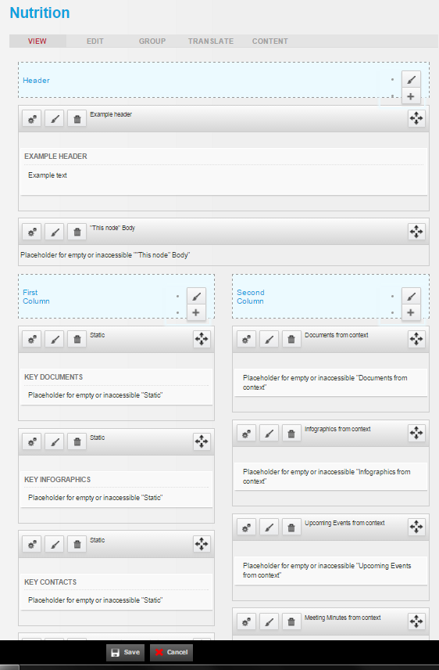
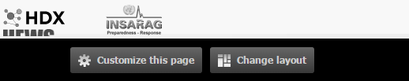
- Choose your cluster, sub-cluster, sector or working group page (most often Nutrition) in the menu on the left. You will be redirected to the page that you can edit by clicking on “Customize this page” on the bottom of the page.
- By default the page layout is Sutro (long “Header” block on the top, followed by two same size columns and followed by a footer at the bottom of the page) and we recommend to keep it this way. As editor you cannot modify the page layout.
- Click on “Customize this page” button to edit the page content.
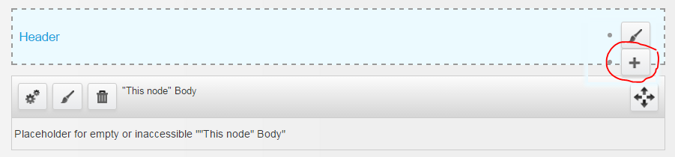
- To add content to the “Header” choose “+” button on the right of the header and select “Custom content” (free text).
  - As a “Title” type “About the Country X Nutrition Cluster”.
  - As a “Body” enter descriptive information about your cluster, such as
    - when and why the cluster was created, its main objectives;
    - structure of the cluster at national and sub-national levels, including lead and co-lead agencies, Strategic Advisory Group and technical working groups;
    - list of cluster partners (recommended if less than 20);
    - we also recommend to add cluster logo to the description.
- In the two columns below by default you will have blocks for the following content:
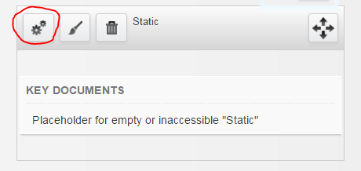
  - Key documents is a static box, it means that each time you want to update it, you should do it manually using the steps bellow. You can assign any document that is already uploaded to the website as a key document by clicking on the “Settings” button on the left of the key documents block and starting typing name of your document. Keep number of key documents as five maximum. We recommend the following documents to be assigned to this block as key documents:
    - cluster terms of reference;
    - cluster response plan – it can be the humanitarian response plan (uploaded by OCHA) or the specific cluster work/response/action/scale up plan that you developed for the cluster;
    - most resent nutrition situation analysis document;
    - the latest nutrition cluster bulletin;
    - important advocacy statement;
    - you may want to replace one or few of the key documents above with contact list or reporting template, depending on your particular context.
  - Key infographics is a static box. You can assign any map or dashboard that is already uploaded to the website as a key infographics by clicking on the “Settings” button on the left of the key documents block and starting typing name of your document. Keep number of key infographics as five maximum. We recommend the following documents to be assigned as key infographics:
    - the latest nutrition cluster operational presence map (produced by the cluster or OCHA);
    - the latest nutritional status map;
    - the latest “progress towards targets” dashboard;
    - the latest programme dashboards.
  - Key contacts is a static box. Only contacts that are already registered on Humanitarian ID and checked in to your emergency can be added as key contacts. To do so you need to click on the “Settings” button on the left of the key contacts block and start typing name of the contact you want to add. We recommend the following contacts to be assigned as key:
    - Nutrition Cluster Coordinator and IMO, in addition you may want to list other members of coordination team (co-chair, deputy coordinator, etc.);
    - Nutrition Cluster Subnational Coordinators;
    - Chair of the SAG and chairs of all Working Groups.
  - Assessments from context – this block is updated automatically once you upload new “Assessment” (see section “Manage content” on how to do so). Five latest uploaded assessments are displayed here by default.
  - Documents from context – this block is updated automatically once you upload new “Document” (see section “Manage content” on how to do so). Five latest uploaded documents are displayed here by default.
  - Infographics from context – this block is updated automatically once you upload new “Map/Infographic” (see section “Manage content” on how to do so). Five latest uploaded infographics are displayed here by default
  - Upcoming events from context – this block is updated automatically once you create an “Event” elsewhere (see section “Manage content” on how to do so). Five nearest events are displayed by default.
  - Meeting minutes from context - this block is updated automatically once you upload meeting minutes to the relevant “Event” (see section “Manage content” on how to do so). Five latest uploaded meeting minutes are displayed by default.
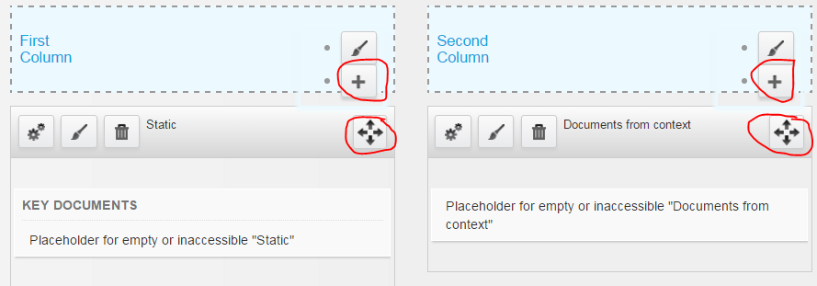
- You can add additional blocks (for example fts chart) to the page by using “+” button on the right side of each column.
- You can move your blocks around by using the four sided arrow on the right of the block you want to move.
- To add content to the “Footer” choose “+” button on the right of the footer and choose the relevant type of content you want to add. You can for example add logos of all partners (choose “free text” for this).
Additional support
- There is an online help section on the HR.info platform where you can find answers to many of your questions: https://www.humanitarianresponse.info/en/help
- You can always ask OCHA IMO in country who is responsible for managing the website for support or training on the use and editing of the website.
- You may also want to contact the HR.info team in Geneva at info@humanitarianresponse.info.
- You can ask for support from the Global Nutrition Cluster Coordination Team (gnc@unicef.org).

We would refer to cluster, sub-cluster, sector or working group in the document as “Cluster” but you need to replace it with relevant coordination mechanism in your country.

