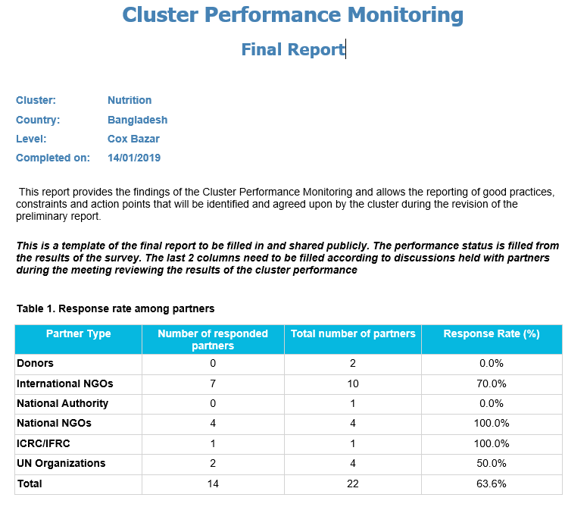
Table 2 - Action plan

Core Functions | Performance status | Performance status  Constraints: unexpected circumstances and/or success factors and/or good practice identified | Follow-up action when status is unsatisfactory or weak or where support required | Timeline. When? | Responsible. By who?
1.1 Providing a platform that ensures service delivery is driven by Humanitarian Response Plan and strategic priorities | Good | 1. Coordination between local and national government bodies. The coordination mechanism between the nutrition partners and government bodies (Civil surgeon, RRRC, DC) needs to be strengthened and coordination with health sectors and the national government counterparts has been discussed, follow up required.  2. The level of decision making power of staff attending cluster meetings  3. Acute malnutrition prevention | Support IPHN in seconding a senior person for the Cox’s Bazar sector coordination who has decision making role  Develop a ToR for an NGO co-coordinator and ensure nomination process and selection of a partner  Partners to ensure that participants of the cluster meetings are high level nutrition staff that can take immediate decision to ensure progress (especially SAG meetings).  Conduct intercluster (WASH, FS, Nutrition, health) workshop to develop better ways of working with partners | March 2019  March-May 2019  Continuous  Q3 2019 | Sector Coordinator  Sector Coordinator with the SAG  Sector partners  Sector partners
1.2 Developing mechanisms to eliminate duplication of service delivery | Good | 1. Duplication and lack of coordination of nutrition services  2. Duplication of resources and services. Better coordination between funding agencies and the nutrition sector partners needed | One nutrition partner per camp providing a comprehensive CMAM package where a partner has capacity (taking into account also what partners’ working for other sectors where possible). The process has begun, and it needs to be strengthened.  Regular information meetings with donors (local representatives in Cox’s BAzar) | 2019 planning  2020 roll out  Quarterly | Sector partners, lead ny the coordinator  Sector Coordinator (and SAG maybe)
2.1 Preparing needs assessments and analysis of gaps (across and within Clusters, using information management tools as needed) to inform the setting of priorities | Satisfactory | 1. The number and type of assessments are satisfactory however, the results of the assessments are not fully utilized by nutrition sector partners.  2. All nutrition sectors partners are involved in sector assessments planning and implementation. Results and reports are shared to all partners. | Strengthening the use of the recommendations of the survey outcomes.  Establish mechanism to prioritize key findings and formulate an action plan of critical recommendation with timelines and responsible person. This will be monitored regularly and revised accordingly.  A good practice to continue, however the main cooperating sectors (health, WASH and FSL) should be involved in the assessments and have access to the survey reports. | After every survey  After every survey / or monthly  Continuous | Sector partner  AWG to establish such mechanism  Sector
2.2 Identifying and finding solutions for (emerging) gaps, obstacles, duplication and cross-cutting issues | Satisfactory | 1. Geographical coverage has improved however there need to improve programme quality.  2. Nutrition commodities sold in the market hence programme quality compromised.  3. Cross cutting issue. There is need to improve and put more focus on all cross-cutting issues. The sector needs to actively engage relevant sectors to address malnutrition taking into consideration the different age groups, gender and protection issues. | See action above  Work with relevant sectors and government to diversity the diet and meet other non-food needs for the beneficiaries (can be also a part of the inter-cluster workshop above)  Conduct a dedicated sector meeting where to agree on the way forward with cross cutting issues (including disability, age, gender, orphans, waste disposal, reusable eco-friendly packaging materials, | ASAP  ASAP | Sector Coordinator and partners  Sector partners
2.3 Formulating priorities on the basis of analysis | Good
3.1 Developing sectoral plans, objectives and indicators that directly support realization of the overall response’s strategic objectives | Satisfactory | The strategic plan and the work plan needs to be developed. And the work has started. | Develop a nutrition cluster strategy/plan and agree its funding with donors | Q2 2019 | SAG and partners
3.2 Applying and adhering to common standards and guidelines | Good
3.3 Clarifying funding requirements, helping to set priorities, and agreeing Cluster contributions to the HC’s overall humanitarian funding proposals | Satisfactory | Not agreed, partners are not regularly updated their funding status to the sector | Adapt and use GNC financial tracking tool and advocate to national level to provide such information | March 2019 | IMWG, all partners
4.1 Monitoring and reporting on activities and needs | Good
4.2 Measuring progress against the Cluster strategy and agreed results | Good | Lack of web-based central data collection, reporting, monitoring and real time visualization platform | - Construction of NIMS framework  - Agreement on minimum set of nutrition indicators for emergency  - Implementation of central emergency nutrition information management system | July 2019 | IPHN, Nutrition Sector, Unicef, IMWG
4.3 Recommending corrective action where necessary | Satisfactory | Absence of regular sector bulletins | Initiate quarterly nutrition sector bulletins | Q3 2019 | IMWG
5.1 National contingency plans identified, updated and shared | Satisfactory | NS EPRP developed in 2018 with a broad representation of partners involved. NS EPRP was shared with partners but not national contingency; this is uncertainty about if / how the national contingency plan to this context). UNICEF supported implementing partners with monsoon-preparednes have developed a mobile ness. Individual organisations did their own preparedness planning. CARE has provided a training programme based on the EPRP. Some implementing partnutrition team approach in preparation. Lack of clarity about how to respond to host community in disasters; what geographical areas does the EPRP cover? | Review and update NS EPRP: clarify some sections (inc. post disaster assessment); review against national contingency plans; clarify response to host community in emergency situations; include reference to coordination with WASH and health; ensure different emergencies are considered and addressed; ensure vulnerable groups are considered and addressed; how, practically, would Rohingya displaced out of existing catchment be provided with nutrition services (role of permanent / emergency mobile nutrition teams). Include partners in the review.  Develop and establish plan for training and preparing partner organisation/ staff on how to implement the EPRP  Consider funding of nutrition emergency preparedness and response. | End of April 2019  End of April  End of April | Sector Coordinatorto organise a taskforce; maybe 1 or 2 lead individuals / partners  Above taskforce  NSCT and UNICEF (plus above taskforce)
5.2 Cluster roles and responsibilities defined and understood | Satisfactory | NS role defined in NS EPRP. The NS EPRP was discussed in NS meetings with partners.
5.3 Early warning reports shared with partners | Satisfactory | Uncertainty of what early warning reports exist in for the Rohingya response. | Regularly share early warning reports from national and local levels with partners | Continuously | Sector Coordinator
6.1 Identify concerns, and contributing key information and messages to HC and HCT messaging and action | Satisfactory | Good: Issue of RUTF/RUSF agreed at NS level.  Lack of CIC nutrition awareness (issue agreed as NS level) | Finalise key messages to be communicated with the CICs (consider how they can help with the issue of RUSF/RUTF being sold) | End of February | Taskforce already identified
6.2 Undertaking advocacy on behalf of Cluster, Cluster members and affected people | Good | Good: NS successfully advocated for RUSF/RUTF for Rohingya response.  CICs appear to have a poor understanding of nutrition  Some IEC materials are only available in Bangla and are not always contextually appropriate (N.B. there are high levels of illiteracy) | Orientation of CICs on nutrition management  Translation of IEC materials into Rohingya and contextualise for the Rohingya | March 2019  Ongoing | Sector Coordination Team  IYCF and CMAM TWG
7.1 Mechanisms to consult and involve affected people in decision-making agreed upon and used by partners | Satisfactory | Unexpected circumstances:  There are some mechanisms in place to consult with AP e.g. formal/informal group discussion with community leaders, target population, religious leader (Before the assessment) during data collection we are collecting their views. However, due to different external and internal reasons ( lots of misconception on relocation and repatriation) in KTP RC sector could not manage data collection from the AP.  Feedback mechanism channel (e.g. complaint box) not well adapted. Need to figure out the best tools regarding the feedback mechanism according to the context  Good practice: UNHCR has hotline number to receive feedback from the beneficiary | Sector Coordinator to establish an AAP TF (possibly under CMAM WG)  Consult with affected population to develop a common feedback and response mechanism (Can be conducted FGD, KII with community leader, CIC and other relevant stakeholders)  Nutrition sector to develop a common framework on feedback and response mechanism considering the emergency context  Develop appropriate and relevant feedback and response mechanism tools, including appropriate translation (based on consultation with AP) | February 2019  By July 2019 | Sector Coordinator  AAP TF (?)
7.2 Mechanisms to receive, investigate and act upon complaints on the assistance received agreed upon and used by partners | Satisfactory | There are no functional, adequate and effective response mechanisms in place to response on feedback/complaints (e.g. there are some suggestions /complaints box in some camps, but not functional) | Advocate for establishment of a joint AAP system with other sectors | Q4 2019 | AAP TF (?)
7.3 Key issues relating to protection from sexual exploitation and abuse have been raised and discussed | Satisfactory | Lack of integration/coordination between GBV working group and protection sector. | Invite GBV focal point to conduct an orientation to partners on GBV at cluster meeting and discuss actions needed  PSEA training by the GBV focal points at both camp and Cox’s Bazar level | Q1 2019  Q2 2019 | Sector Coordinator  GBV focal point

